|  |  |
| --- | --- |
|  | Lovena Ujoodha 2110_22856  Mr Ajit Gopee  BSE 21BFT 3 |

**Table of Contents**

**Introduction** 3

**Room Reservation Organisation Chart** 4

**Description** 5

**Business rule** 7

**Logical ERD** 8

**Physical ERD** 9

**Data Dictionary** 10

**Sample Data** 13

**Ms Access Database** 17

Relationship 17

Tables of Room Reservation System 18

Forms in Room Reservation System 27

Query Guest 39

Report Invoice 66

**Oracle SQL** 67

**Introduction**

PARADISE HOTEL

Our hotel is a 3-star small hotel found at Pointe aux Cannoniers. It was established in 2001 by Mr Ronnie Salvatore. We have an estimate 15000 clients and an income of Rs 20millions per year. We try to provide best clientele to clients and have amazing outdoor activities.





# **Room Reservation Organisation Chart**

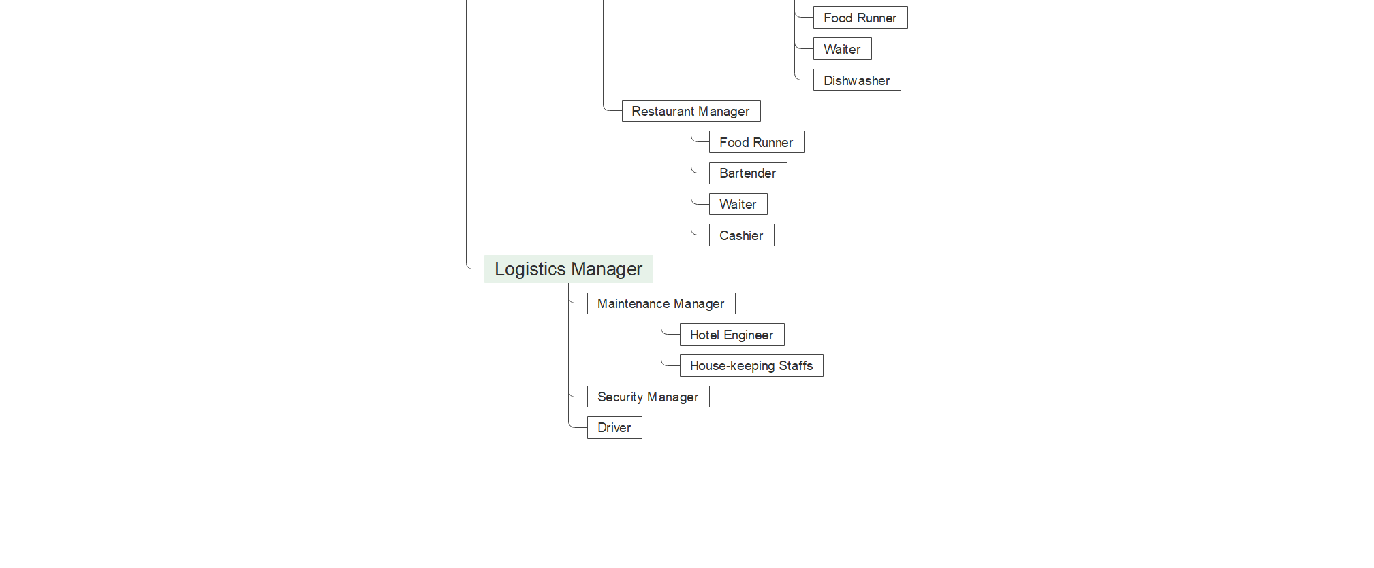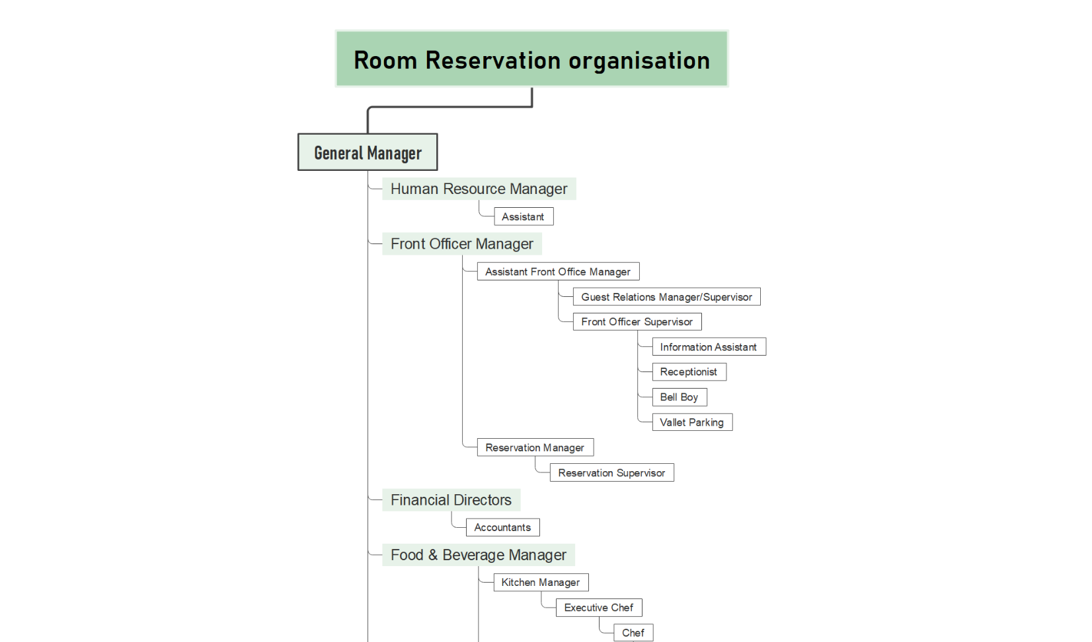

# **Description**

**Main ideas**

* Advanced booking
* a  [confirmation letter](https://setupmyhotel.com/formats/fo/115-reservation-confirmation-letter-for-hotels.html) to guests
* provide the specified room type to the guest and the guest must agree to pay all relevant [charges](https://setupmyhotel.com/homepage/hotel-management-glossary/charge.html).
* reservation team report to the [general manager](https://setupmyhotel.com/homepage/hotel-management-glossary/general-manager.html).

**Activities carried out in reserving a room:**

1. **Forecasting – forecast future revenue**
2. **Rate Floating -** hotel's rates availability on online and offline channels without any rate parity.
3. **Availability - t**o maintain the hotels available on all online and offline channels.
4. **Guest satisfaction -** The hotel can plan its activities and be prepared to receive guests. They are able to provide the necessary services and facilities like [security](https://setupmyhotel.com/homepage/hotel-management-glossary/security.html), transfers, preference of rooms to known guests, providing [complimentary](https://setupmyhotel.com/homepage/hotel-management-glossary/complimentary.html) and any particular service asked by the guest at the time of making the reservation.
5. **Scheduling of staff -** Hotel staff may be scheduled more accurately to [void](https://setupmyhotel.com/homepage/hotel-management-glossary/void.html) understaffing or overstaffing problems.

[**Communication**](https://setupmyhotel.com/homepage/hotel-management-glossary/group-reservations.html) **with the hotel** - connect with the hotel via a telephone, email, online, social media. The reservation request may be made in person, over a telephone, in a mail, though the internet, social media, mobile apps, instant messaging systems(WhatsApp, Facebook, [Messenger](https://setupmyhotel.com/homepage/hotel-management-glossary/messenger.html) through [global distribution system](https://setupmyhotel.com/homepage/hotel-management-glossary/global-distribution-system.html) or through an inter sell agency.

**How reservation works** - Once a hotel is contacted by a guest about reserving space its staff must intelligently formulate the reservation request and complete a computerised reservation record in the hotel management software.

**In formulating the reservation request, the three most important factors are**:

a) the expected date of [arrival](https://setupmyhotel.com/homepage/hotel-management-glossary/arrival.html) and [departure](https://setupmyhotel.com/homepage/hotel-management-glossary/departure.html)

b) the desired room types

c) the number of rooms needed.

Using this information, the hotel staff can search the room availability file via the designated arrival date. If the date is not closed the reservation agent proceeds by checking room type and the number of rooms available.

Along with this preliminary data, a reservation record will usually be judged complete when it includes the following information:

* [Guest’s Profile Data](https://setupmyhotel.com/train-my-hotel-staff/sales-and-marketing/515-guest-profiles.html).
* Arrival date and time and departure date.
* Room type requested.
* Type of bed(optional)
* Billing Instruction
* Any other Details or special remarks.

A reservation can either be accepted or denied or turned away based on the availability of rooms in the day(s) in question. An acceptance would lead the receptionist into the confirmation phase. If either the hotel or the guest wishes to alter or [cancel](https://setupmyhotel.com/homepage/hotel-management-glossary/cancellation.html) the reservation, this can be done only through a mutual agreement. If a guest fails to inform the hotel about their [cancellation](https://setupmyhotel.com/homepage/hotel-management-glossary/cancellation.html) the hotel property may decide to retain the advance deposit received from the guest earlier to [cover](https://setupmyhotel.com/homepage/hotel-management-glossary/cover.html) up for any [loss](https://setupmyhotel.com/homepage/hotel-management-glossary/loss.html) of accommodation revenue.

**The confirmation establishes:**

* A check on the entered reservation request data and satisfaction of the reservation request.
* An agreement of [room rates](https://setupmyhotel.com/homepage/hotel-management-glossary/room-rate.html).
* An agreement of method of payment.
* A statement of the hotel’s [cancellation](https://setupmyhotel.com/homepage/hotel-management-glossary/cancellation.html) procedure.
* Once the reservation has been accepted and confirmed many changes to reservation record can occur prior to the guest’s arrival. Changes in the arrival or departure dates, number of rooms required, adding pickup details, reconfirmation. Any time a change in a reservation record is required, the reservation record must be pulled and updated according to the [guest request](https://setupmyhotel.com/homepage/hotel-management-glossary/guest-request.html) to keep the reservation-related data up to date.

**Problems with current-based system:**

* Booking

Customers will have to wait for a long period of time to make booking and at the time of booking get to know that there is no room left.

* Payment monitor

It is quite difficult to keep track of each transaction that have taken placed in the hotel and it is difficult to calculate the total for each bill manually.

* Room monitor

It is a lot of work to keep track of which room is occupied or not and also which type of room.

**Solutions**

* Booking

The online booking system will be able to enter data more quickly and be able to keep track of previous booking information.

* Payment monitor

The field total will be able to calculate the total for the bill of each guest. The transaction information will be kept easily.

* Room monitor

The system will already contain data on which room is available and also which type of room. This information can also be updated easily.

# **Business rule**

Booking – Guest

* Each booking must be made by only one guest.
* One guest can make one or many bookings.

Booking – Employee

* Each booking must be entered by only one employee.
* One employee can make one or many bookings.

Booking – Room

* Each booking can belong to one or many rooms.
* Each room must belong to one and only one booking.

Room – Room Type

* Each room must include one and only one room type.
* One room type can have one or many room.

Guest – Bill

* One guest can pay one or many bills.
* Each bill must be paid by one and only one guest.

Bill – Transaction Mode

* Each bill can have one or many transactions mode.
* One transaction can have one or many bills.

Employee – Role

* Each employee must have one and only one role.
* One role can belong to one or many employees.

# **Logical ERD**

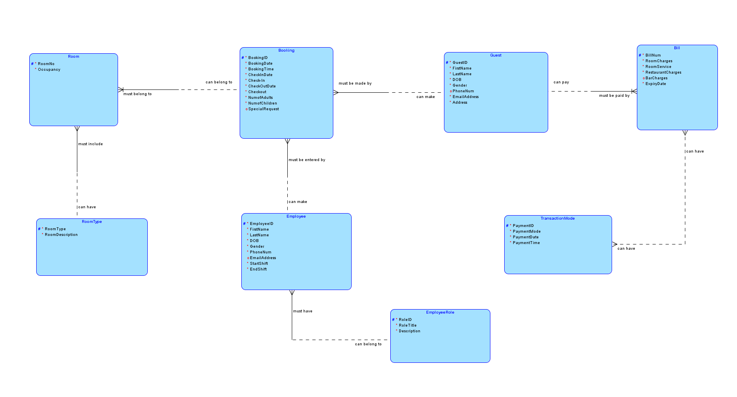

# **Physical ERD**

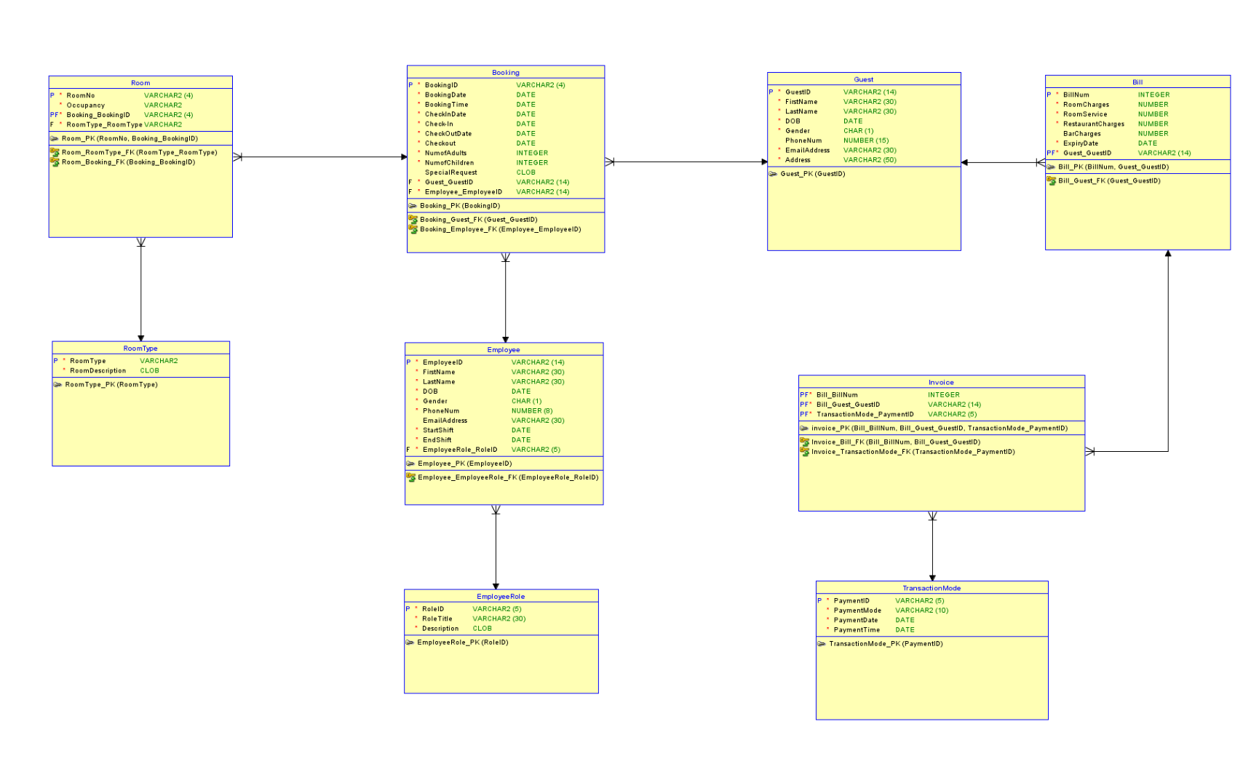

# **Data Dictionary**

Booking

|  |  |  |  |  |  |
| --- | --- | --- | --- | --- | --- |
| **Field Name** | **Data Type** | **Field Size** | **Constraints** | **Description** | **Example** |
| BookingID | Varchar | 4 | Primary Key | Unique record of each booking | 4011 |
| BookingDate | Date | 8 | Not Null | Date when booking was made | 01.05.2022 |
| BookingTime | Time | 4 | Not Null | Time when booking was made | 1:00PM |
| CheckInDate | Date | 8 | Not Null | Check-in Date in Hotel | 01.07.2022 |
| CheckIn | Time | 4 | Not Null | Check-in Time in Hotel | 2:00PM |
| CheckOutDate | Date | 8 | Not Null | Checkout Date in Hotel | 03.07.2022 |
| Checkout | Time | 4 | Not Null | Checkout Time in Hotel | 2:00PM |
| NumofAdults | Integer | 2 | Not Null | Number of adults | 2 |
| NumofChildren | Integer | 2 | Not Null | Number of children | 0 |
| SpecialRequest | Text | 100 | Null | Special request if any | Birthday Cake for dinner on 09.07.2022 |
| GuestID | Varchar | 14 | Foreign Key | Unique record of each guest | 0271195927397M |
| EmployeeID | Varchar | 14 | Foreign Key | Unique record of each employee | 0050770481934M |

Guest

|  |  |  |  |  |  |
| --- | --- | --- | --- | --- | --- |
| **Field Name** | **Data Type** | **Field Size** | **Constraints** | **Description** | **Example** |
| GuestID | Varchar | 14 | Primary Key | Unique record of each guest | 0271195927397M |
| FirstName | Varchar | 30 | Not Null | First Name of guest | Elodie |
| LastName | Varchar | 30 | Not Null | Last Name of guest | Macquet |
| DOB | Date | 8 | Not Null | Date of birth of guest | 27.11.95 |
| Gender | Char | 1 | Not Null | Gender of guest (M or F) | F |
| PhoneNum | Number | 15 | Null | Phone number of guest | +23057693013 |
| EmailAddress | Varchar | 30 | Not Null | Email address of guest | elodiemac@outlook.com |
| Address | Varchar | 50 | Not Null | Address of guest | Curepipe, Mauritius |
| BookingID | Varchar | 4 | Primary Key | Unique record of each booking | 4011 |

Employee

|  |  |  |  |  |  |
| --- | --- | --- | --- | --- | --- |
| **Field Name** | **Data Type** | **Field Size** | **Constraints** | **Description** | **Example** |
| EmployeeID | Varchar | 14 | Primary Key | Unique record of each employee | 0050770481934M |
| FirstName | Varchar | 30 | Not Null | First Name of employee | Sheena |
| LastName | Varchar | 30 | Not Null | Last Name of employee | Mukhish |
| DOB | Date | 8 | Not Null | Date of birth of employee | 05.07.1970 |
| Gender | Char | 1 | Not Null | Gender of employee | F |
| PhoneNum | Number | 15 | Not Null | Phone number of employee | +23057732901 |
| EmailAddress | Varchar | 30 | Null | Email address of employee | s.mukhish@gmail.com |
| StartShift | Time | 4 | Not Null | Start shift of employee | 12PM |
| EndShift | Time | 4 | Not Null | End shift of employee | 8PM |
| RoleID | Varchar | 5 | Foreign Key | Unique record of each employee role | H010R |
| BookingID | Varchar | 4 | Primary Key | Unique record of each booking | 4011 |

Room

|  |  |  |  |  |  |
| --- | --- | --- | --- | --- | --- |
| **Field Name** | **Data Type** | **Field Size** | **Constraints** | **Description** | **Example** |
| RoomNo | Varchar | 4 | Primary Key | Unique record of each room | 5078 |
| Occupancy | Varchar | 20 | Not Null | Occupancy of room | **CO - Check-Out** |
| BookingID | Varchar | 4 | Foreign Key | Unique record of each booking | 4011 |
| RoomType | Varchar | 20 | Foreign Key | Unique record of each room type | Suite |

Room Type

|  |  |  |  |  |  |
| --- | --- | --- | --- | --- | --- |
| **Field Name** | **Data Type** | **Field Size** | **Constraints** | **Description** | **Example** |
| RoomType | Varchar | 20 | Primary Key | Unique record of each room type | Suite |
| RoomDescription | Text | 255 | Not Null | Description of the room | King size bed |

Bill

|  |  |  |  |  |  |
| --- | --- | --- | --- | --- | --- |
| **Field Name** | **Data Type** | **Field Size** | **Constraints** | **Description** | **Example** |
| BillNum | Varchar2 | 4 | Primary Key | Unique record of each Bill Number | 0001 |
| RoomCharges | Number | 6 | Not Null | Unique price of one room | Rs 10 000 |
| RoomService | Number | 6 | Not Null | Price of food and beverages ordered to room | Rs 1 000 |
| RestaurantCharges | Number | 6 | Not Null | Price for eating at the hotel restaurant | Rs 4 000 |
| BarCharges | Number | 6 | Null | Price of drinks served at the bar | Rs 2 000 |
| ExpiryDate | Date | 8 | Not Null | Expiry Date of bill |  |
| GuestID | Varchar | 14 | Foreign Key | Unique record of each guest | 0271195927397M |

Invoice

|  |  |  |  |  |  |
| --- | --- | --- | --- | --- | --- |
| **Field Name** | **Data Type** | **Field Size** | **Constraints** | **Description** | **Example** |
| BillNum | Varchar2 | 4 | Foreign Key | Unique record of each receipt | 0001 |
| GuestID | Varchar | 14 | Foreign Key | Unique record of each guest | 0271195927397M |
| PaymentID | Varchar | 5 | Foreign Key | Unique record for each payment made | CC846 |

Transaction Mode

|  |  |  |  |  |  |
| --- | --- | --- | --- | --- | --- |
| **Field Name** | **Data Type** | **Field Size** | **Constraints** | **Description** | **Example** |
| PaymentID | Varchar | 5 | Primary Key | Unique record of each payment | CC838 |
| PaymentMode | Varchar | 30 | Not Null | Method of payments | Credit card |
| PaymentDate | Date | 8 | Not Null | Date of payment | 22.06.22 |
| PaymentTime | Time | 4 | Not Null | Time of payment | 3:00 PM |

Employee Role

|  |  |  |  |  |  |
| --- | --- | --- | --- | --- | --- |
| **Field Name** | **Data Type** | **Field Size** | **Constraints** | **Description** | **Example** |
| RoleID | Varchar | 5 | Primary Key | Unique record of each employee role | R005T |
| RoleTitle | Varchar | 30 | Not Null | Role title | Receptionist |
| Description | Text | 200 | Not Null | Description of role title | Checking booking details |

# **Sample Data**

|  |  |  |  |  |  |  |  |  |  |  |  |
| --- | --- | --- | --- | --- | --- | --- | --- | --- | --- | --- | --- |
| BookingID | GuestID (FK) | EmployeeID (FK) | BookingDate | BookingTime | CheckInDate | Check-In | CheckOutDate | Check Out | NumOfAdults | NumOfChildren | SpecialRequest |
| 4011 | 0271195927397M | 0050770481934M | 01.05.2022 | 1:00PM | 01.07.2022 | 2:00PM | 03.07.2022 | 3:00PM | 2 | 0 | Birthday Cake for dinner on 09.07.2022 |
| 4012 | 0200988170520S | 0170995471903R | 03.05.2022 | 9:05AM | 05.07.2022 | 2:00PM | 10.07.2022 | 3:00PM | 2 | 2 |  |
| 4013 | 0051091676806P | 0140581937202L | 03.05.2022 | 3:49PM | 06.07.2022 | 2:00PM | 25.07.2022 | 3:00PM | 2 | 3 | Anti-allergy bedding |
| 4014 | 0090192974707M | 0181197743600S | 05.05.2022 | 2:18PM | 06.07.2022 | 2:00PM | 11.07.2022 | 3:00PM | 3 | 0 |  |
| 4015 | 0171198582805D | 0250383009267M | 07.05.2022 | 12:45AM | 08.07.2022 | 2:00PM | 25.07.2022 | 3:00PM | 2 | 0 |  |
| 4016 | 0180376519361L | 0111200872401P | 08.05.2022 | 8:04AM | 11.07.2022 | 2:00PM | 17.07.2022 | 3:00PM | 2 | 0 | Late checkout |
| 4017 | 0140889765480M | 0250789937202L | 08.05.2022 | 9:13PM | 12.07.2022 | 2:00PM | 19.07.2022 | 3:00PM | 2 | 2 |  |
| 4018 | 0171291564597L | 0220697743600S | 08.05.2022 | 9:32PM | 12.07.2022 | 2:00PM | 19.07.2022 | 3:00PM | 2 | 3 |  |
| 4019 | 0150186654321S | 0150395872401P | 09.05.2022 | 7:19PM | 12.07.2022 | 2:00PM | 24.07.2022 | 3:00PM | 1 | 0 |  |
| 4020 | 0091189776854P | 0140585937201T | 11.05.2022 | 5:15AM | 12.07.2022 | 2:00PM | 23.07.2022 | 3:00PM | 2 | 3 |  |
| 4021 | 0050575086544M | 0280490009267M | 12.05.2022 | 4:27PM | 13.07.2022 | 2:00PM | 17.07.2022 | 3:00PM | 2 | 0 | Early check-In |
| 4022 | 0190890759379B | 0300599177659J | 14.05.2022 | 5:00PM | 14.07.2022 | 2:00PM | 26.07.2022 | 3:00PM | 2 | 2 |  |
| 4023 | 0170487752965F | 0051170896457C | 16.05.2022 | 2:45PM | 14.07.2022 | 2:00PM | 22.07.2022 | 3:00PM | 2 | 2 |  |
| 4024 | 0010195763963P | 0030299536726G | 17.05.2022 | 6:54PM | 16.07.2022 | 2:00PM | 21.07.2022 | 3:00PM | 2 | 0 | Room with a view |
| 4025 | 0020492653290L | 0111099471903W | 17.05.2022 | 7:30PM | 19.07.2022 | 2:00PM | 25.07.2022 | 3:00PM | 2 | 3 |  |

Booking

Guest

|  |  |  |  |  |  |  |  |  |
| --- | --- | --- | --- | --- | --- | --- | --- | --- |
| GuestID | BookingID | FirstName | LastName | DOB | Gender | PhoneNum | EmailAddress | Address |
| 0271195927397M | 4011 | Elodie | Macquet | 27.11.95 | F | +23057693013 | elodiemac@outlook.com | Curepipe, Mauritius |
| 0200988170520S | 4012 | Neil | Smulders | 20.09.88 | M |  | n.smulders@gmail.com | Bonnyville, Canada |
| 0051091676806P | 4013 | Panayotis | Pasto | 05.10.91 | M |  | pana.perso@live.gr | Athena, Greece |
| 0090192974707M | 4014 | Julia | Macy | 09.01.92 | F | +27810005933 | macyjulia2@hotmail.com | Cape Town, South Africa |
| 0171198582805D | 4015 | Martin | Dawkins | 17.11.98 | M | +445556374009 | d.marti98@gmail.com | Bristol, England |
| 0180376519361L | 4016 | Marine | Lemouche | 18.03.76 | F | +33700555279 | marinelamoucheduc@yahoo.fr | Aix-en-Provence, France |
| 0140889765480M | 4017 | Carlos | Manchos | 14.08.89 | M | +33798384823 | carlosmanchos@hotmail.com | Montalbo, Spain |
| 0171291564597L | 4018 | Maria | Lafolas | 17.12.91 | F | +34824807491 | marialafolasmanchos@gmail.com | Montalbo, Spain |
| 0150186654321S | 4019 | Fernito | Serra | 15.01.86 | M |  | fernito@serra.ch | Bergamo, Switzerland |
| 0091189776854P | 4020 | Marcelino | Papi | 09.11.89 | M | +39382555682 | marcelinobin@compn.it | Pisa, Italy |
| 0050575086544M | 4021 | Svea | Munchauzen | 05.05.75 | F |  | s.munchauzen@gmail.com | Hamburg, Germany |
| 0190890759379B | 4022 | Avneel | Baria | 19.08.90 | M | +91955553283 | avneelbariabwn@gmail.com | Chandigarh, India |
| 0170487752965F | 4023 | Paola | Fernandes | 17.04.87 | M |  | Pa.fern1@hotmail.com | Lisboa, Portugal |
| 0010195763963P | 4024 | Alice | Patinson | 01.01.95 | F | +445555827465 | alice.patin@mailthu.uk | Birmingham, England |
| 0020492653290L | 4025 | Marc | Leblanc | 02.04.92 | M | +33655576981 | marclebg@free.fr | Bourges, France |

Employee

|  |  |  |  |  |  |  |  |  |  |  |
| --- | --- | --- | --- | --- | --- | --- | --- | --- | --- | --- |
| EmployeeID | RoleID (FK) | BookingID  (FK) | FirstName | LastName | DOB | Gender | PhoneNum | EmailAddress | StartShift | EndShift |
| 0050770481934M | R005T | 4011 | Sheena | Mukhish | 05.07.1970 | F | +23057732901 | s.mukhish@gmail.com | 12PM | 8PM |
| 0170995471903R | B101B | 4012 | Anusha | Roovha | 17.09.1995 | F | +23054981034 | a.roovha@gmail.com | 7AM | 3PM |
| 0140581937202L | H010R | 4013 | Eric | Luc | 14.05.1981 | M | +23058194844 | ericluc1@hotmail.com | 7AM | 3PM |
| 0181197743600S | M100S | 4014 | Tanishta | Seesurn | 18.11.1997 | F | +23059717499 | tseesurn@gmail.com | 3PM | 11PM |
| 0250383009267M | D111W | 4015 | Kneeny | Mireles | 25.03.1983 | M | +2302509213 | Kneeny.m25@outlook.com | 7AM | 3PM |
| 0111200872401P | R005T | 4016 | Jase | Perinoo | 11.12.2000 | F | +23058091732 | jase.p11@gmail.com | 7AM | 3PM |
| 0250789937202L | B001B | 4017 | Cedrick | Luc | 25.07.1989 | M | +23058192321 |  | 12PM | 8PM |
| 0220697743600S | C111C | 4018 | Grace | Stone | 22.06.1997 | F | +23059776543 |  | 7AM | 11PM |
| 0150395872401P | C001C | 4019 | Jase | Parker | 15.03.1995 | F | +23059123452 |  | 7AM | 3PM |
| 0140585937201T | B110M | 4020 | Paul | Tiblanc | 14.05.1985 | M | +23058165434 |  | 12PM | 8PM |
| 0280490009267M | H010A | 4021 | Laurie | Carrington | 28.04.1990 | F | +23057543990 | lauriecar@outlook.com | 3PM | 11PM |
| 0300599177659J | H007E | 4022 | Tavish | Jhurry | 30.05.1999 | M | +23059710491 | tavish.05@hotmail.com | 12PM | 8PM |
| 0051170896457C | M100S | 4023 | Sarah | Cooper | 05.11.1970 | F | +23057723523 |  | 7AM | 3PM |
| 0030299536726G | G002M | 4024 | Gina | Glover | 03.02.1999 | F | +23058238913 | glovgi@yahoo.com | 12PM | 8PM |
| 0111099471903W | H001M | 4025 | Lian | Wedley | 11.10.1999 | M | +23054542342 |  | 12PM | 11PM |

Room

|  |  |  |  |
| --- | --- | --- | --- |
| RoomNo | BookingID (FK) | RoomType(FK) | Occupancy |
| 5078 | 4011 | Suite | **CO - Check-Out** |
| 2034 | 4012 | Quad Room | **CO - Check-Out** |
| 2051 | 4013 | Family Room | OCC- Occupied |
| 1089 | 4014 | Triple Room | **CO - Check-Out** |
| 5022 | 4015 | Deluxe Room | **DND - Do Not Disturb** |
| 2056 | 4016 | Double Room | **LC - Late Check out** |
| 3004 | 4017 | Family Room | **OCC - Occupied** |
| 3005 | 4018 | Family Room | **OCC - Occupied** |
| 1004 | 4019 | Single Room | **OCC - Occupied** |
| 4055 | 4020 | Family Room | **OCC - Occupied** |
| 5098 | 4021 | Suite | **EC - Early Check-in** |
| 2099 | 4022 | Quad Room | **OCC - Occupied** |
| 3001 | 4023 | Quad Room | **OCC - Occupied** |
| 6048 | 4024 | Room with a view | **DND - Do Not Disturb** |
| 3088 | 4025 | Family Room | **OCC - Occupied** |

RoomType

|  |  |
| --- | --- |
| RoomType | RoomDescription |
| Single Room | Single bed, air conditioned, room service, mini fridge, internet access |
| Double Room | 2 single beds, air conditioned, room service, mini fridge, internet access |
| Triple Room | 1 single bed, 1 double bed, air conditioned, room service, mini fridge, internet access |
| Quad Room | 2 single beds, 1 large double bed, air conditioned, room service, mini fridge, internet access |
| Family Room | 1 single bed, 1 double bed, air conditioned, room service, mini fridge, internet access, balcony with pool view, 2 bathrooms |
| Deluxe Room | King size bed, air conditioned, room service, mini fridge, internet access |
| Suite | King size bed, air conditioned, room service, mini fridge, high-speed internet access, coffee machine, backyard access |
| Room with a view | Single bed, air conditioned, room service, mini fridge, internet access, balcony with beach view |

|  |  |  |  |  |  |  |
| --- | --- | --- | --- | --- | --- | --- |
| BillNum | GuestID (FK) | RoomCharges | Roomservice | RestaurantCharges | BarCharges | ExpiryDate |
| 0001 | 0271195927397M | Rs 10 000 | Rs 1 000 | Rs 4 000 | Rs 2 000 | 03.01.2023 |
| 0002 | 0200988170520S | Rs 6 000 | Rs 3050 | Rs 3 780 | Rs 2 300 | 10.01.2023 |
| 0003 | 0051091676806P | Rs 15 000 | Rs 2 500 | Rs 2 895 |  | 25.01.2023 |
| 0004 | 0090192974707M | Rs 24 000 | Rs 1 565 | Rs 3 600 | Rs 5 560 | 11.01.2023 |
| 0005 | 0171198582805D | Rs 10 000 | Rs 500 | Rs 2 430 | Rs 2 380 | 25.01.2023 |
| 0006 | 0180376519361L | Rs 30 000 | Rs 5 000 | Rs 7 800 | Rs 2 340 | 17.01.2023 |
| 0007 | 0140889765480M | Rs 15 000 | Rs 2 050 | Rs 3 890 |  | 19.01.2023 |
| 0008 | 0171291564597L | Rs 10 000 | Rs 1 500 | Rs 2 570 | Rs 6 000 | 19.01.2023 |
| 0009 | 0150186654321S | Rs 38 000 | Rs 7 000 | Rs 10 00 | Rs 15 680 | 24.01.2023 |
| 0010 | 0091189776854P | Rs 9 000 | Rs 760 | Rs 4 050 |  | 23.01.2023 |
| 0011 | 0050575086544M | Rs 50 000 | Rs 8 000 | Rs 15 00 | Rs 25 000 | 17.01.2023 |
| 0012 | 0190890759379B | Rs 12 000 | Rs 3 550 | Rs 5 580 | Rs 3 000 | 26.01.2023 |
| 0013 | 0170487752965F | Rs 25 000 | Rs 4 555 | Rs 6 740 |  | 22.07.2023 |
| 0014 | 0010195763963P | Rs 13 000 | Rs 2500 | Rs 3 350 | Rs 3 590 | 21.07.2023 |
| 0015 | 0020492653290L | Rs 25 000 | Rs 590 | Rs 6 700 | Rs 4 570 | 25.07.2023 |

Bill

Invoice

|  |  |  |
| --- | --- | --- |
| BillNum (FK) | PaymentID (FK) | GuestID (FK) |
| 0001 | CC846 | 0271195927397M |
| 0002 | CA920 | 0200988170520S |
| 0003 | CC492 | 0051091676806P |
| 0004 | DC937 | 0090192974707M |
| 0005 | CA648 | 0171198582805D |
| 0006 | CC274 | 0180376519361L |
| 0007 | CC683 | 0140889765480M |
| 0008 | DC765 | 0171291564597L |
| 0009 | CA903 | 0150186654321S |
| 0010 | DC153 | 0091189776854P |
| 0011 | CA827 | 0050575086544M |
| 0012 | CC689 | 0190890759379B |
| 0013 | CC892 | 0170487752965F |
| 0014 | CA273 | 0010195763963P |
| 0015 | DC273 | 0020492653290L |

TransactionMode

|  |  |  |  |
| --- | --- | --- | --- |
| PaymentID | PaymentMode | PaymentDate | PaymentTime |
| CC846 | Credit card | 03/07/2022 | 3:00 PM |
| CA920 | Cash | 10/07/2022 | 2:30 PM |
| CC492 | Credit card | 25/07/2022 | 1:00 PM |
| DC937 | Debit card, Cash | 11/07/2022 | 3:00 PM |
| CA648 | Cash | 25/07/2022 | 2:45 PM |
| CC274 | Credit card | 17/07/2022 | 2:15 PM |
| CC683 | Credit card, Cash | 19/07/2022 | 2:38 PM |
| DC765 | Debit card | 19/07/2022 | 2:54 PM |
| CA903 | Cash | 24/07/2022 | 3:00 PM |
| DC153 | Debit card, Credit Card | 23/07/2022 | 1:55 PM |
| CA827 | Cash, Credit Card | 17/07/2022 | 2:49 PM |
| CC689 | Credit card | 26/07/2022 | 2:00 PM |
| CC892 | Credit card | 22/07/2022 | 3:00 PM |
| CA273 | Cash, Credit Card | 21/07/2022 | 2:10 PM |
| DC273 | Debit card | 25/07/2022 | 2:28 PM |

|  |  |  |
| --- | --- | --- |
| RoleID | RoleTitle | Description |
| B001B | Bartender | Prepare and serve drinks to guests |
| B101B | Bell Boy | Carry guest’s bags to their room |
| B110M | Bar Manager | Manage bar supplies and manage staff member |
| C001C | Executive Chef | Prepare dishes and manage kitchen staff |
| C111C | Chef | Set up menu and prepare high quality dishes |
| D111W | Dishwasher | Ensure dining equipment are clean and prepared for guest |
| G002M | General Manager | Improve and increase departmental profits |
| H001M | Human Resource Manager | Supervise the hotel hiring process |
| H007E | Hotel Engineer | Troubleshoot and repair hotel equipment |
| H010A | Accountant | Makes critical financial decisions and manage hotel finances |
| H010R | Housekeeping | Ensure hotel rooms are cleaned |
| M100S | Maintenance Staff | Inspect and repair various hotel infrastructure |
| R005T | Receptionist | Welcoming guest, check booking details |
| S003M | Security Manager | Ensure safety of the hotel, the guest and staff member |

EmployeeRole

# **Ms Access Database**

## Relationship

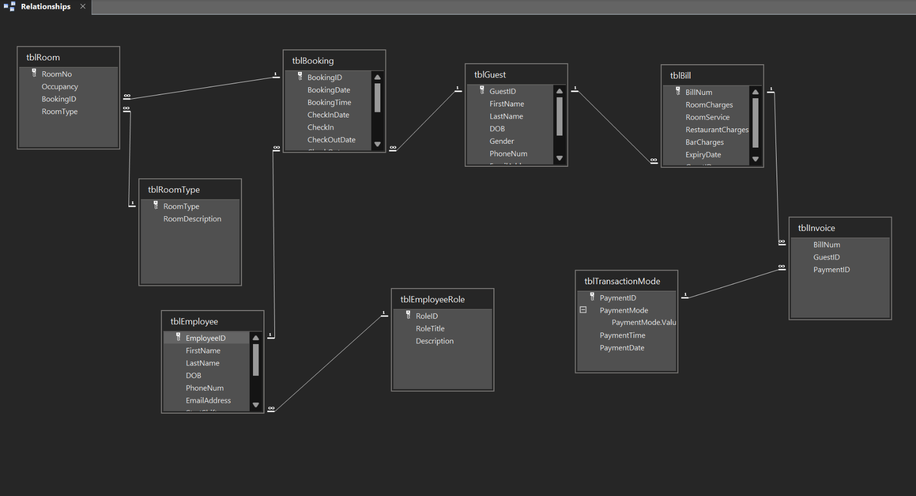

## Tables of Room Reservation System

Booking

In design View

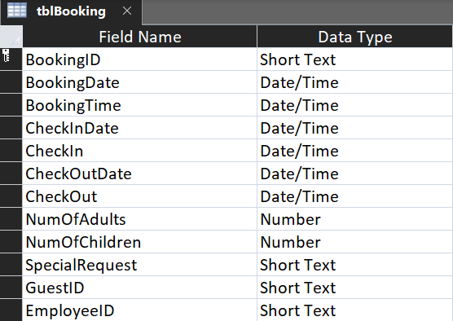

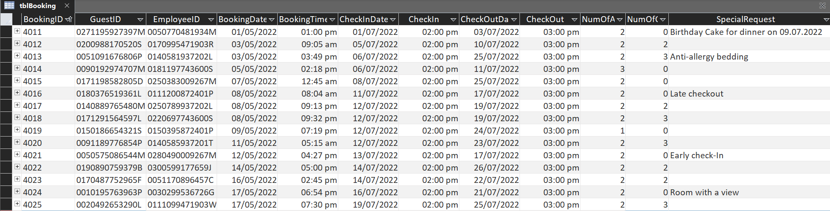In datasheet View

Guest

In design View

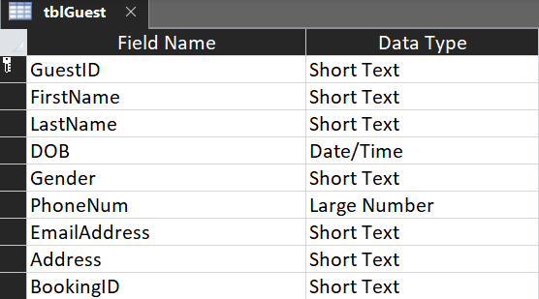

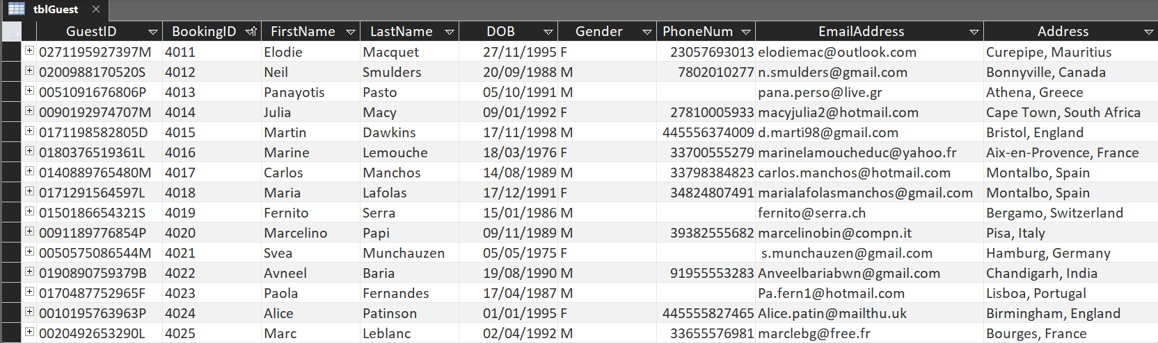In datasheet View

Employee

In design View

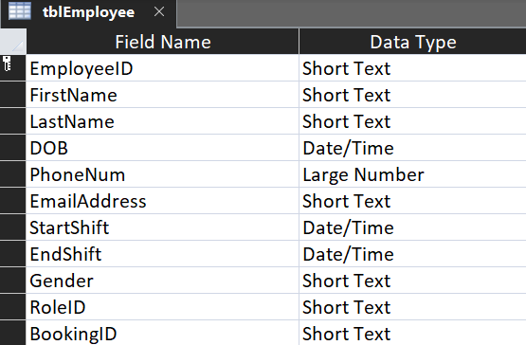

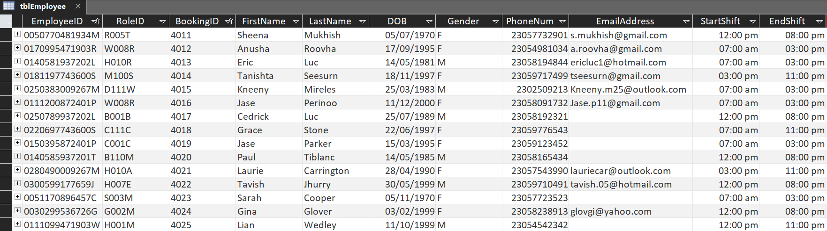In datasheet View

Room

In design View

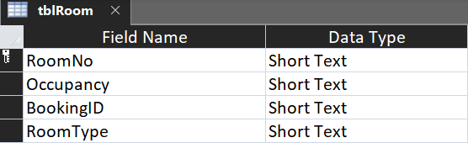

In datasheet View

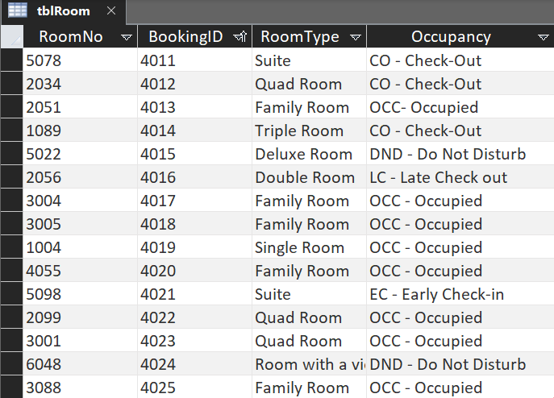

RoomType

In design View

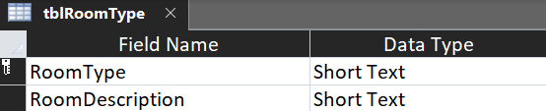

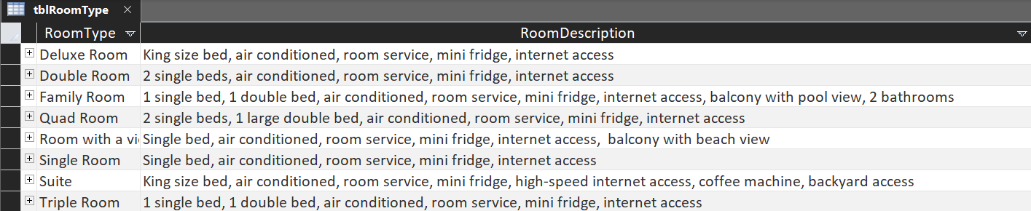In datasheet View

Bill

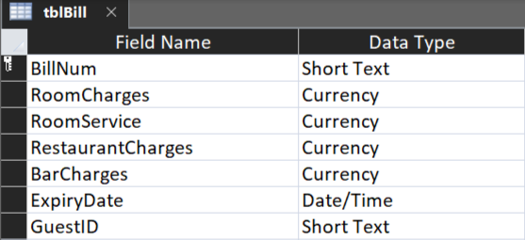In design View

In datasheet View

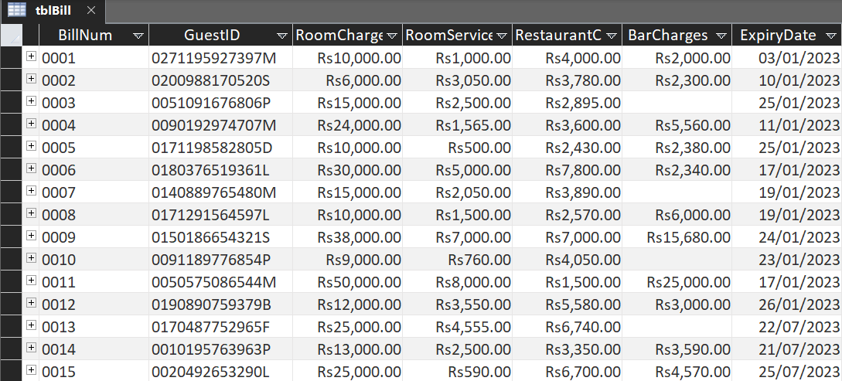

Invoice

In design View

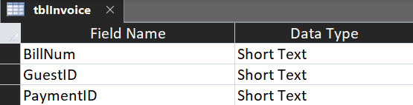

In datasheet View

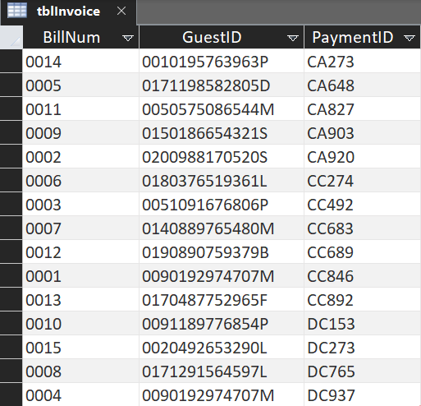

TransactionMode

In design View

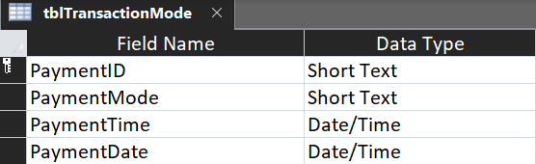

In datasheet View

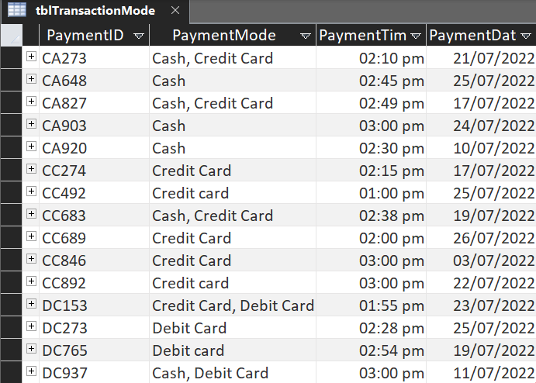

EmployeeRole

In design View

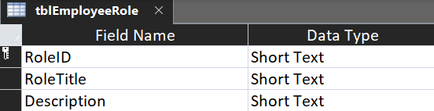

In datasheet View

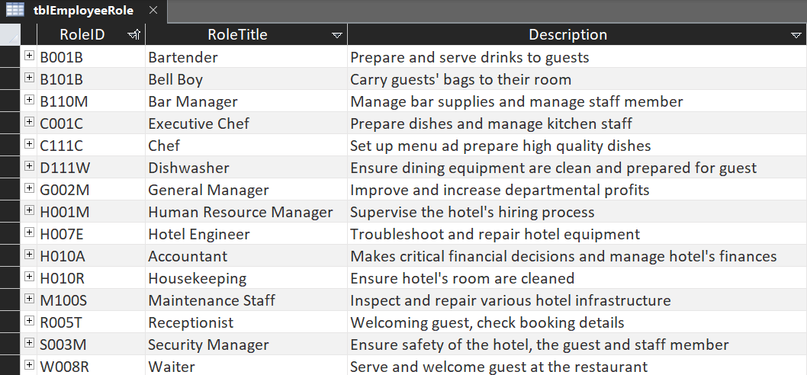

## Forms in Room Reservation System

Booking

Design View

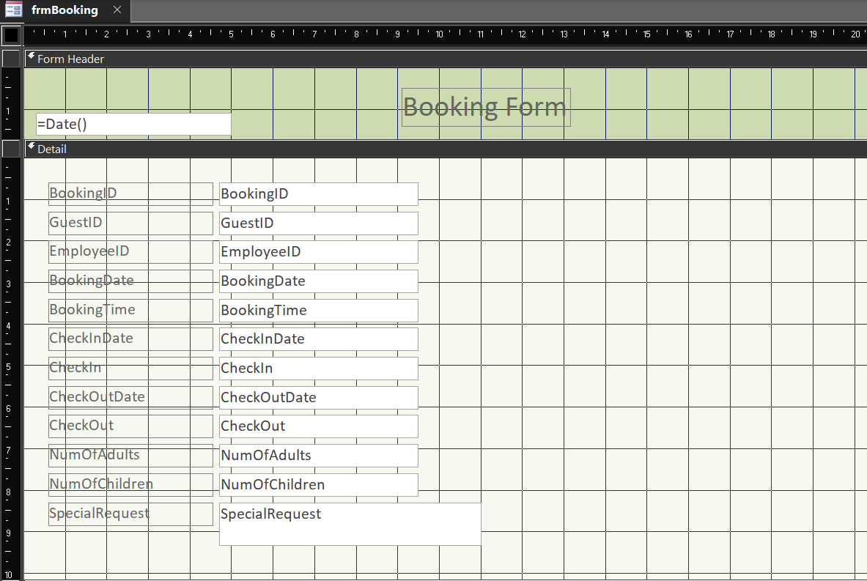

Form View

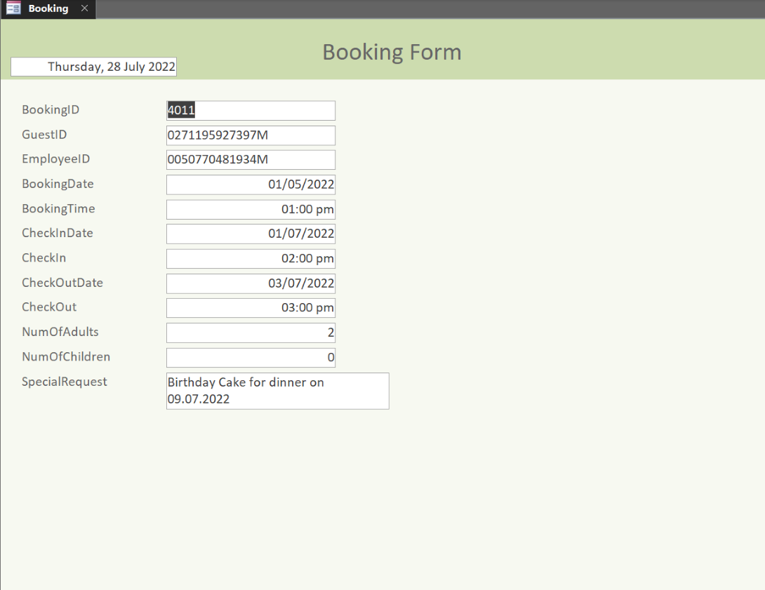

Guest

Design View

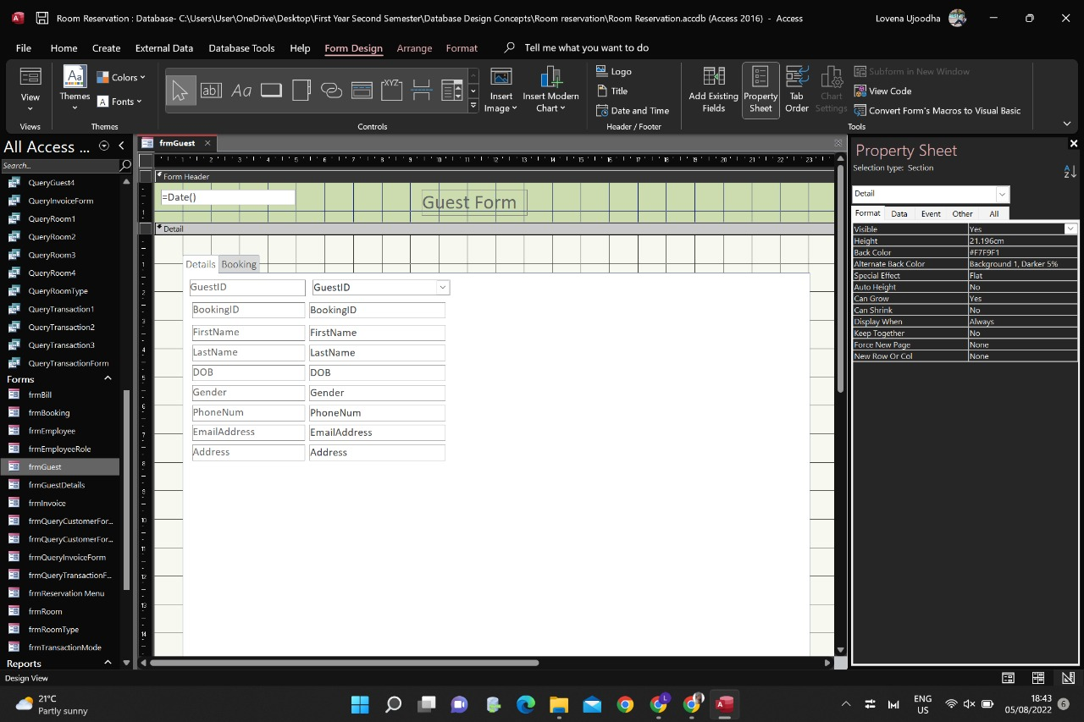

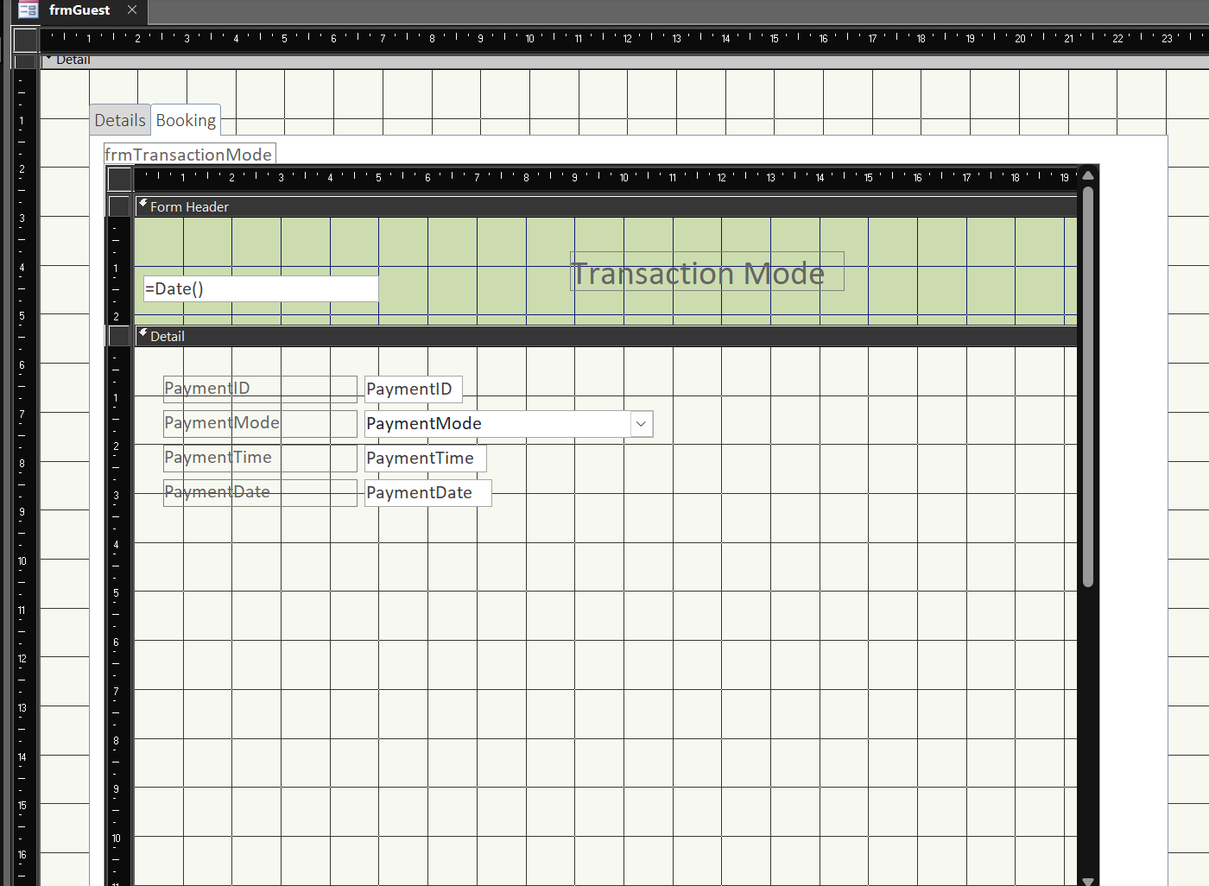

Form View

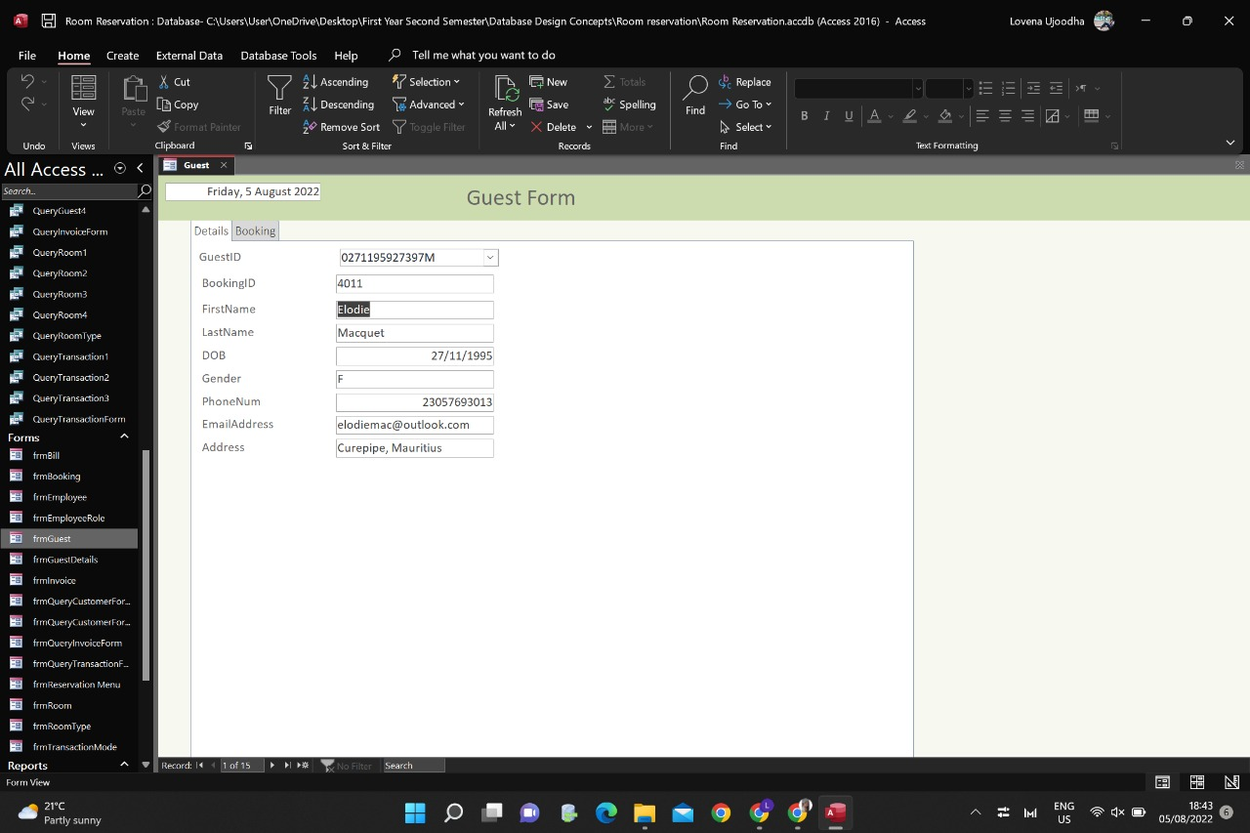

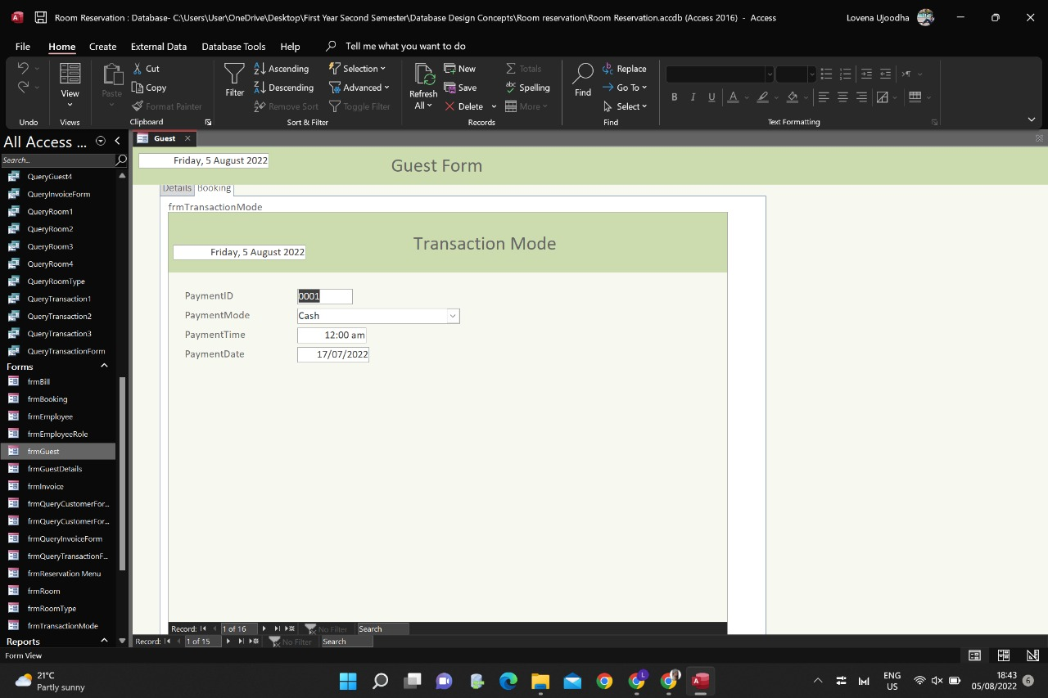

Employee

Design View

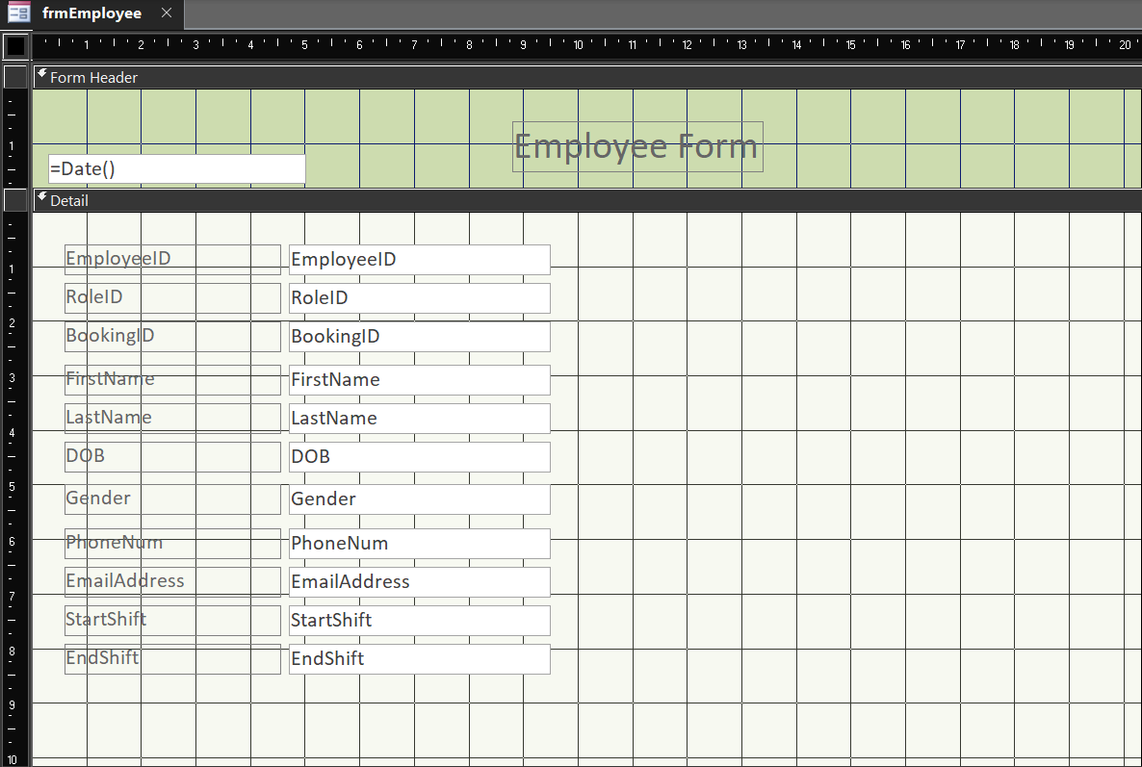

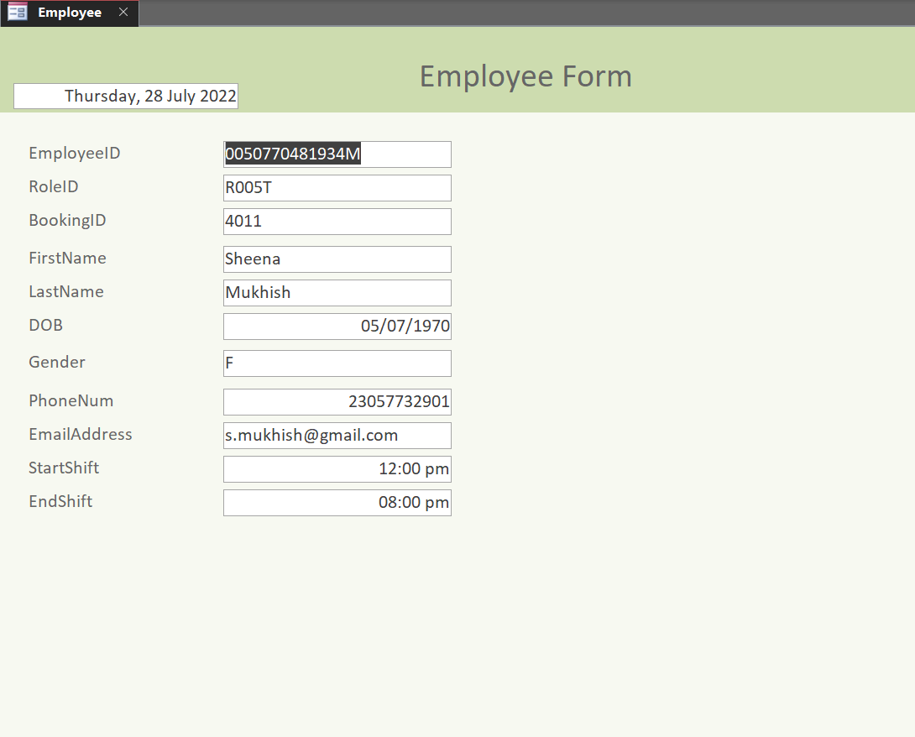Form View

Room

Design View

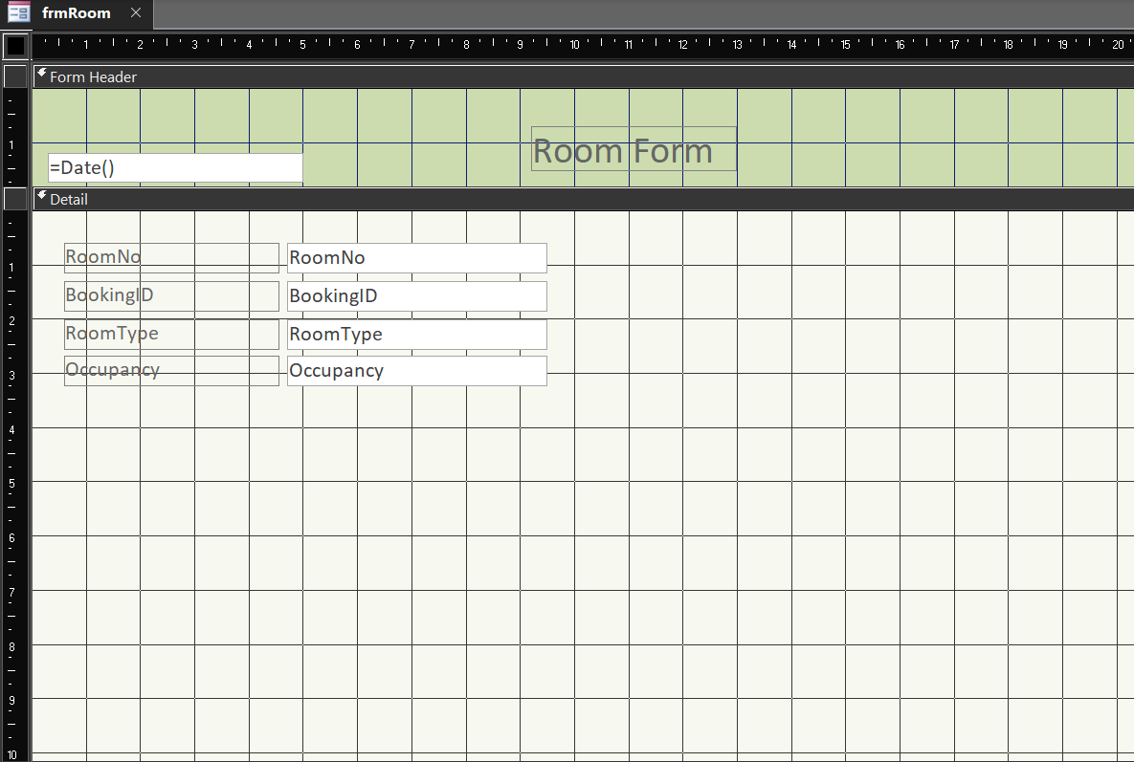

Form View

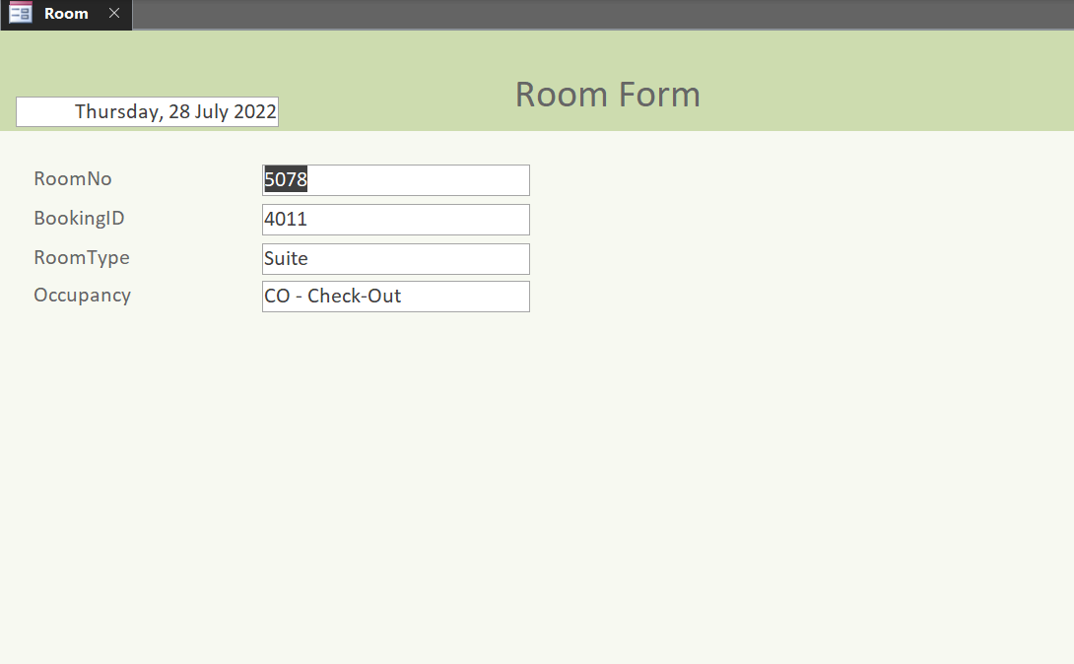

RoomType

Design View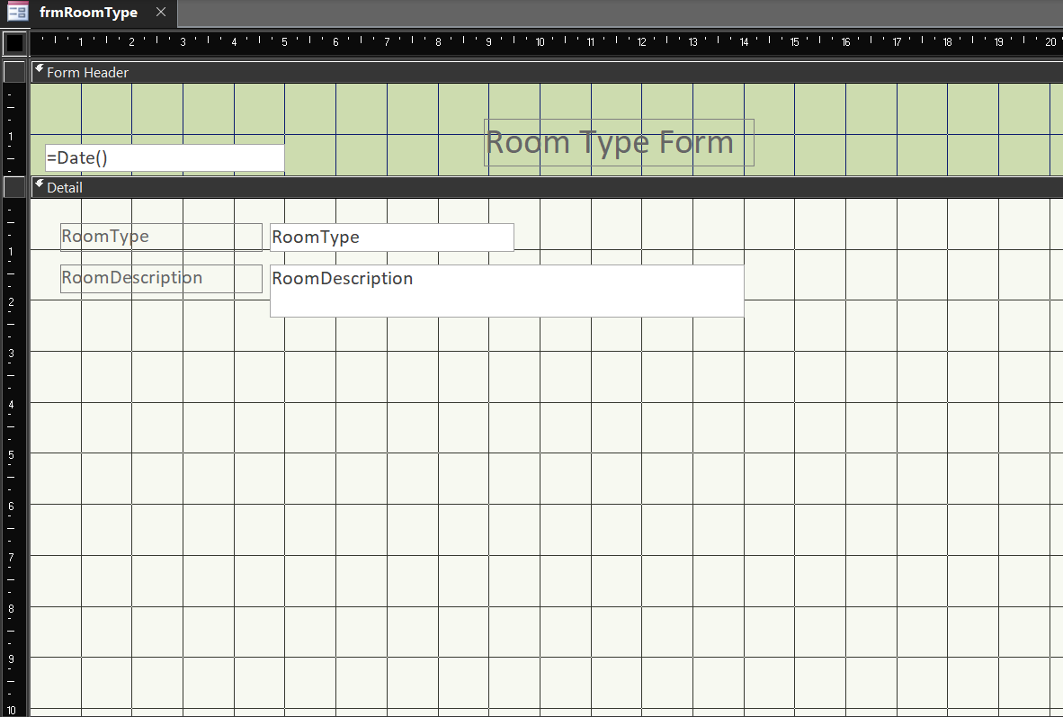

Form View

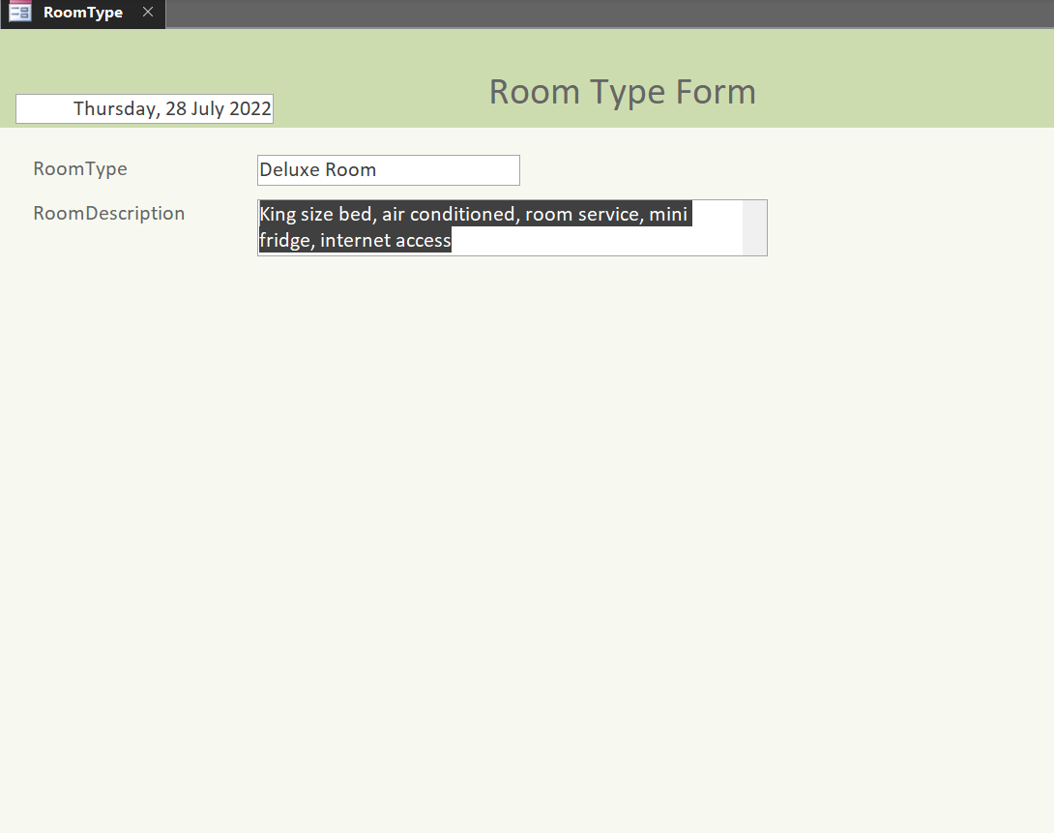

Bill

Design View

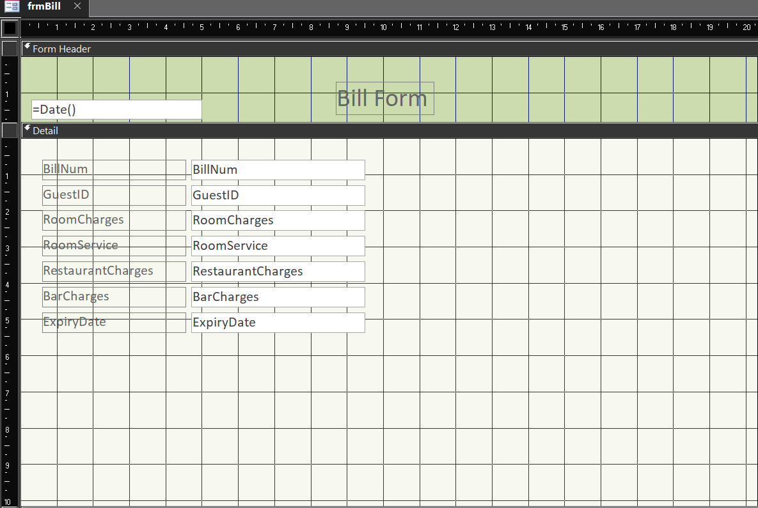

Form View

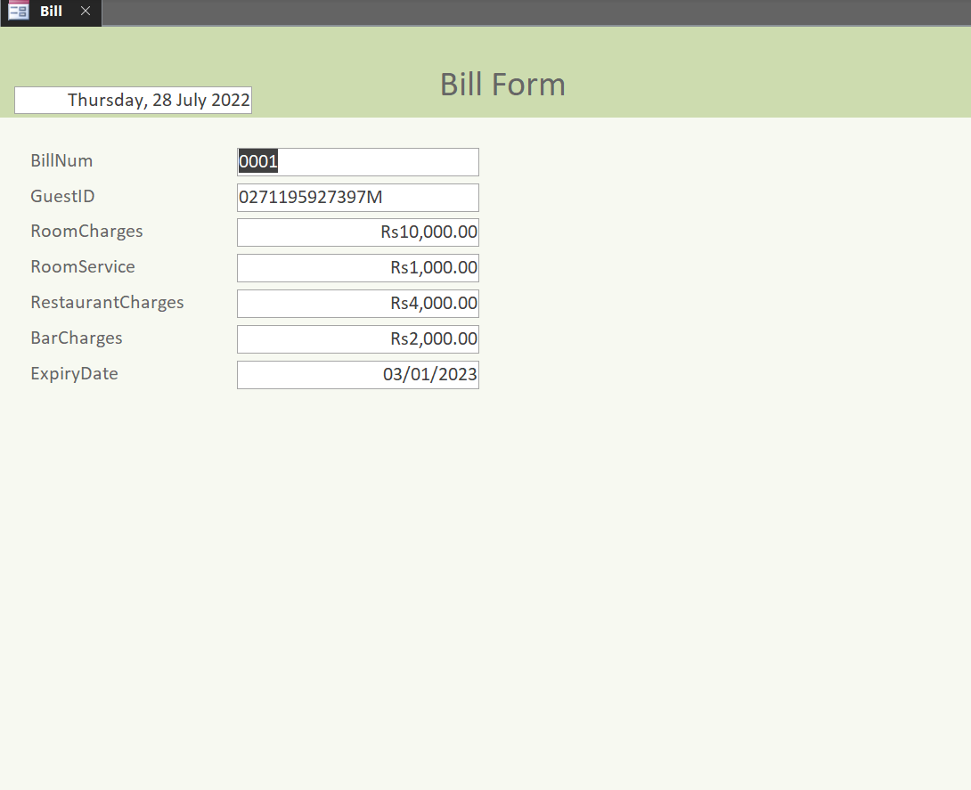

Invoice

Design View

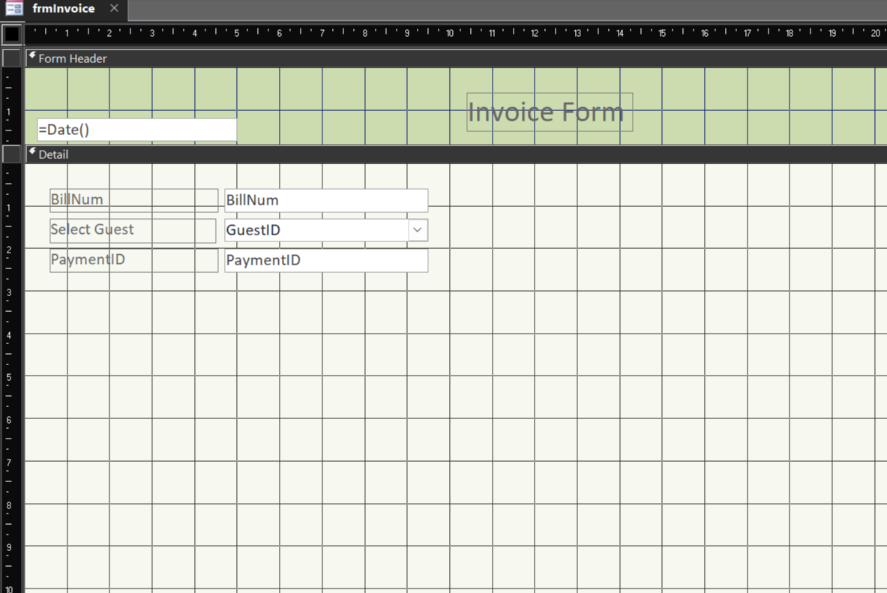

Form View

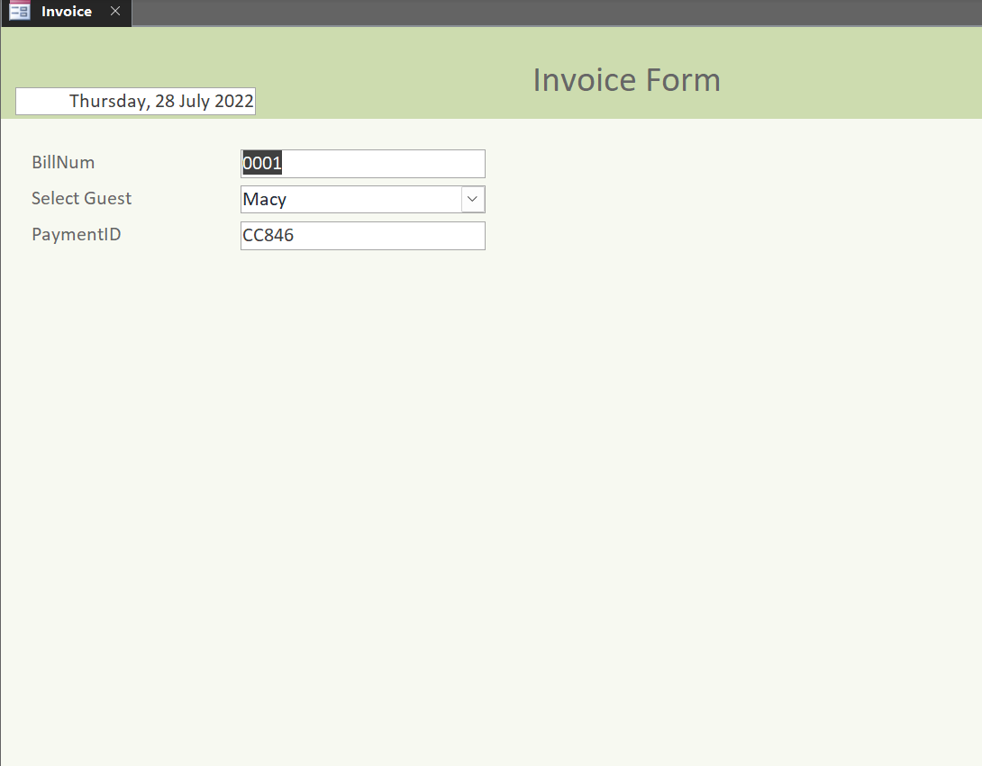

TransactionMode

Design View

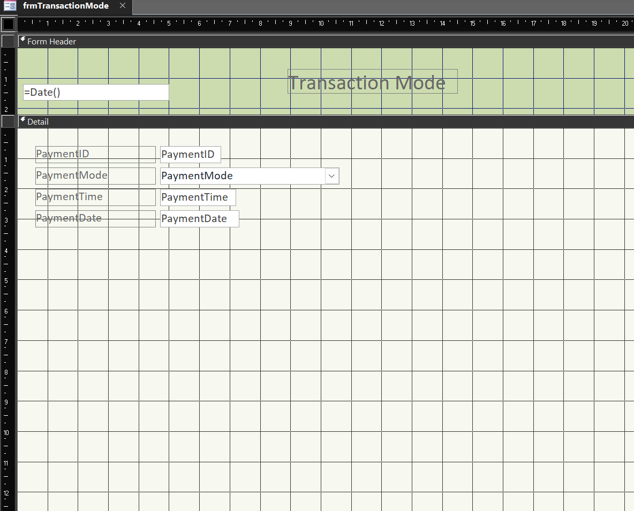

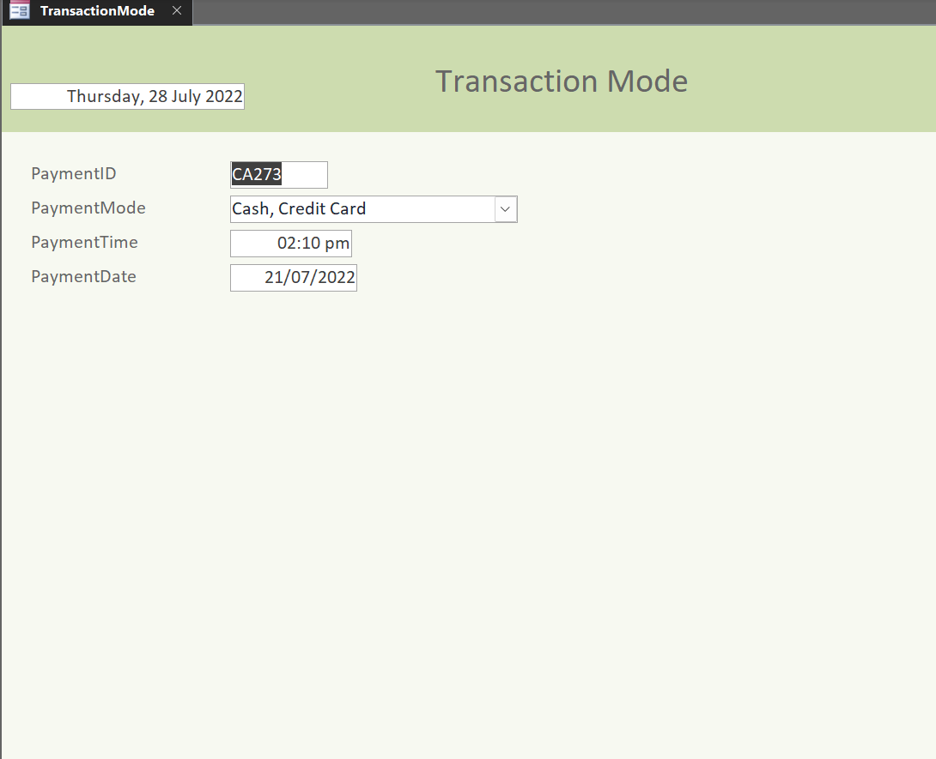Form View

EmployeeRole

Design View

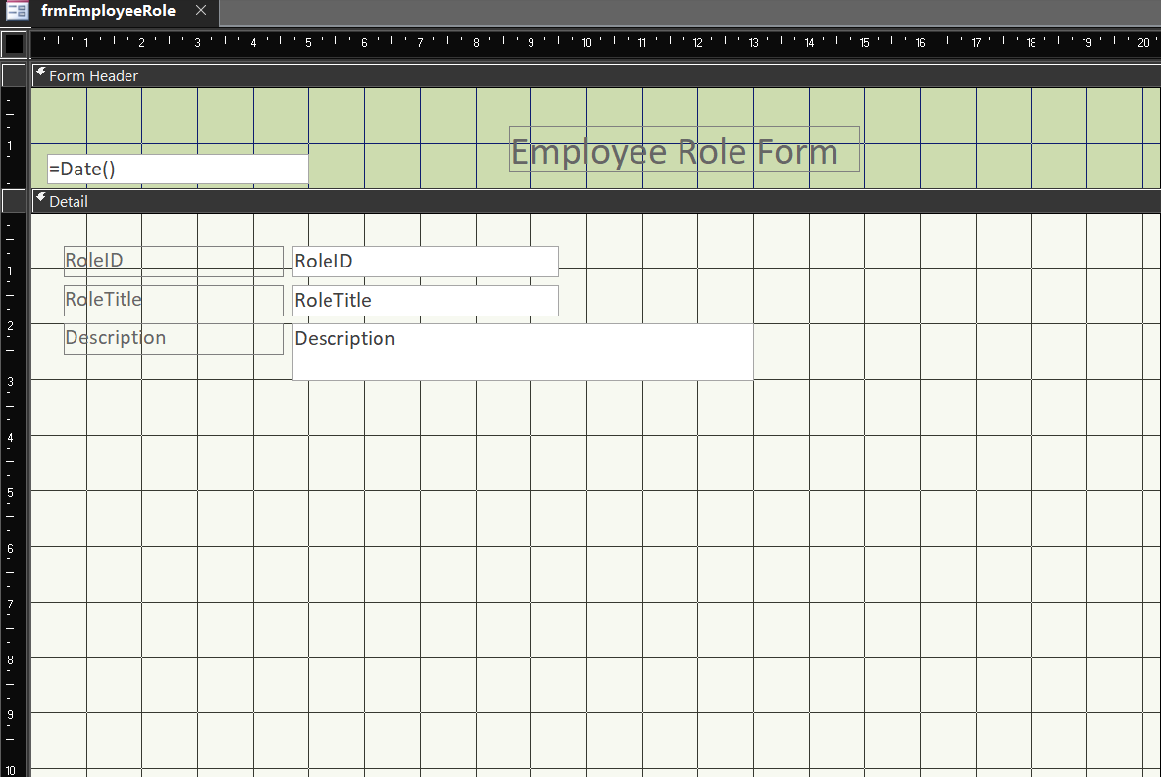

Form View

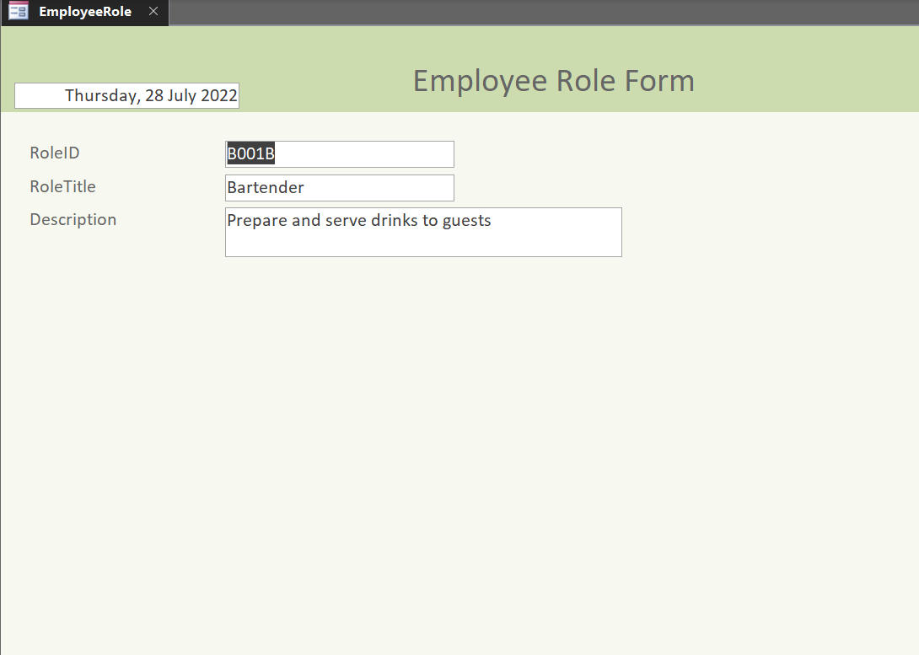

Guest Details

Design view

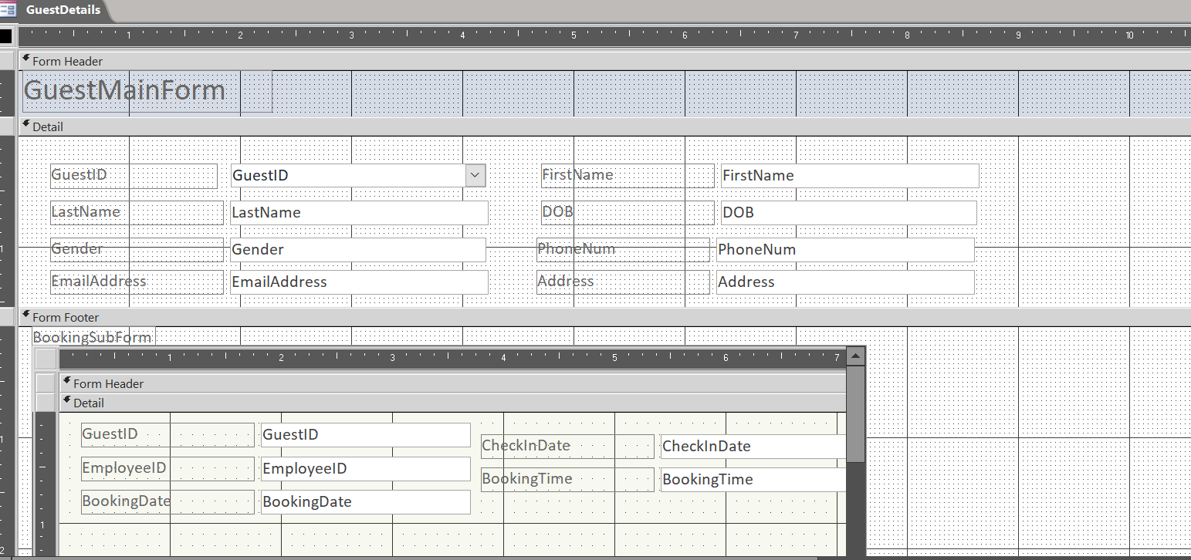

Form view

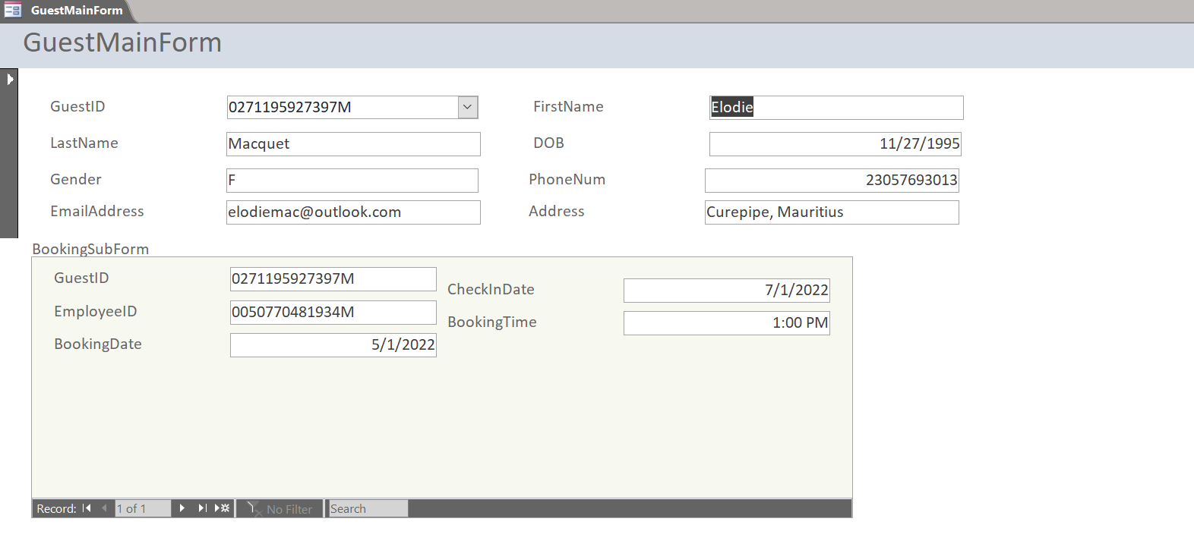

Customer View Form

Design view

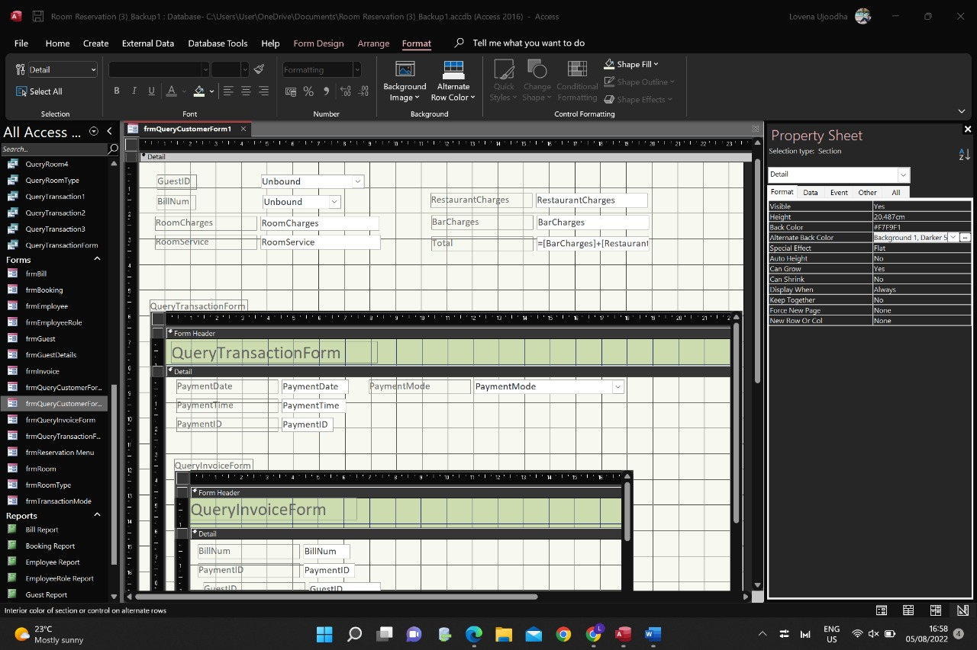

Form view

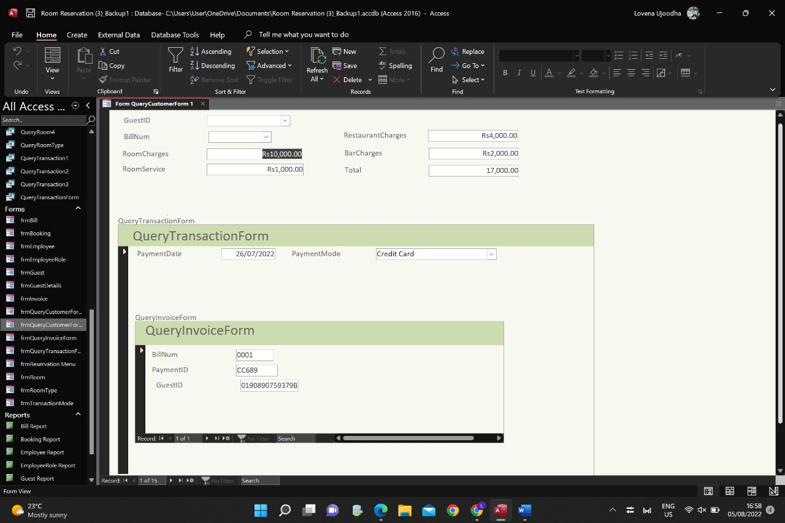

## Query Guest

Database view

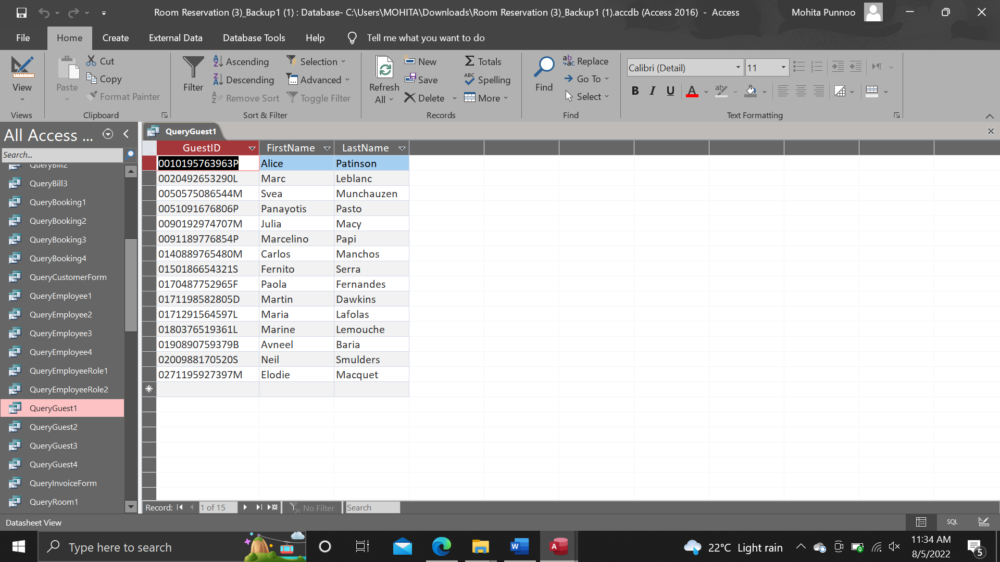

Design view

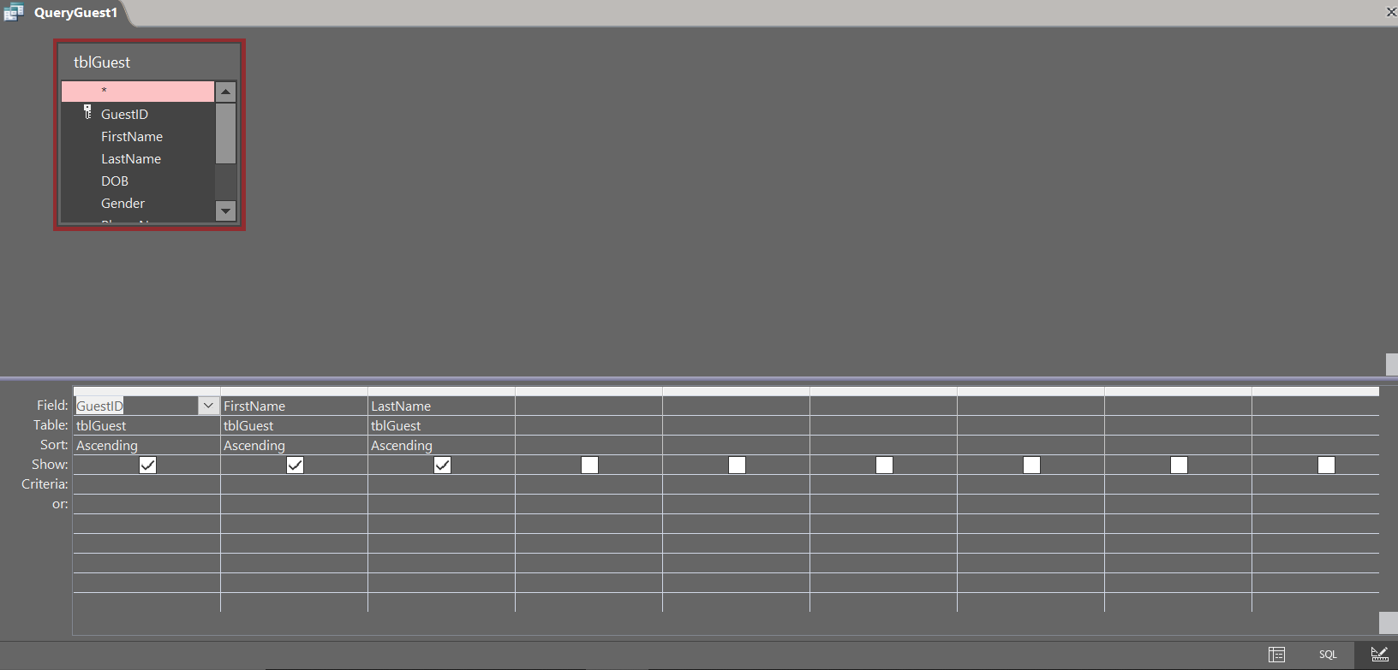

Query Guest

Database view

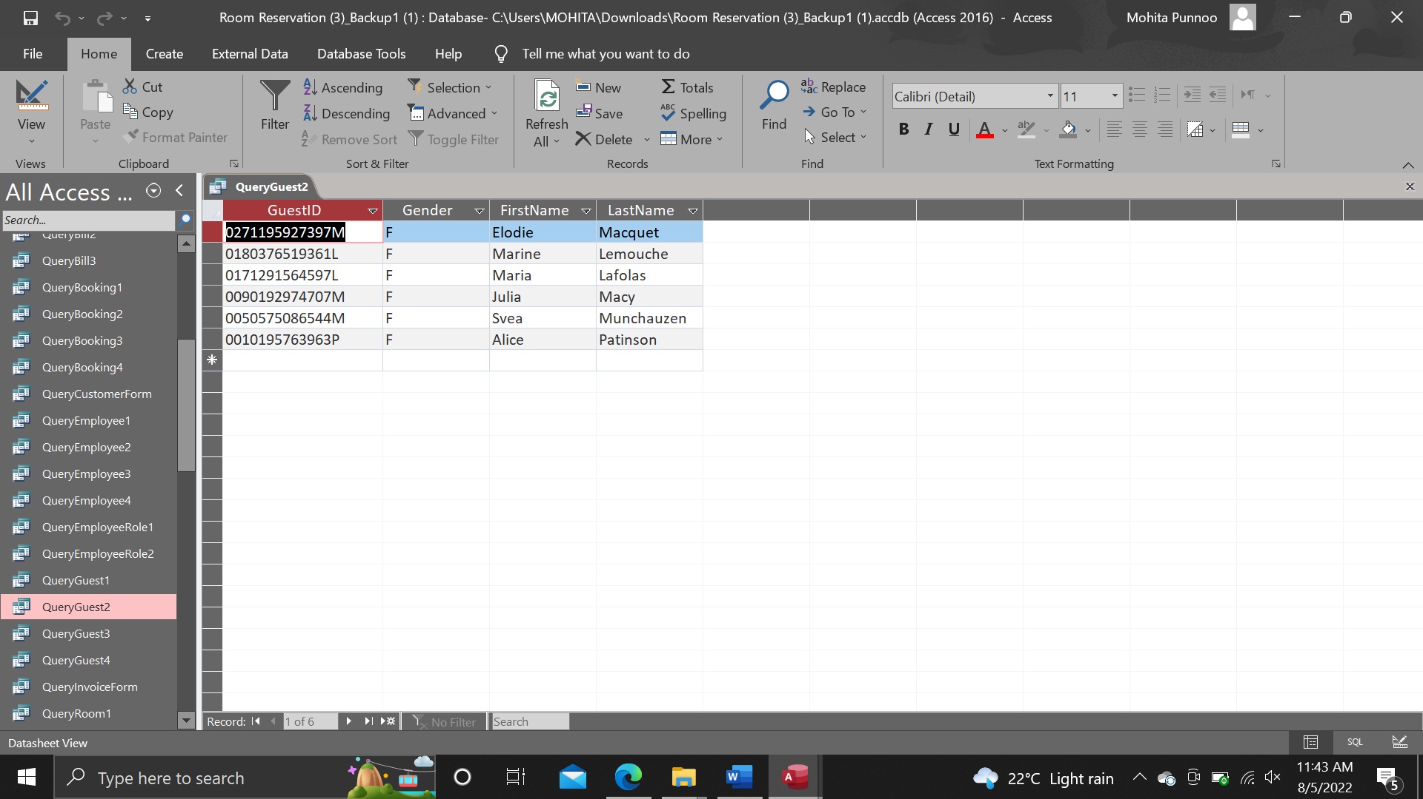

Design view

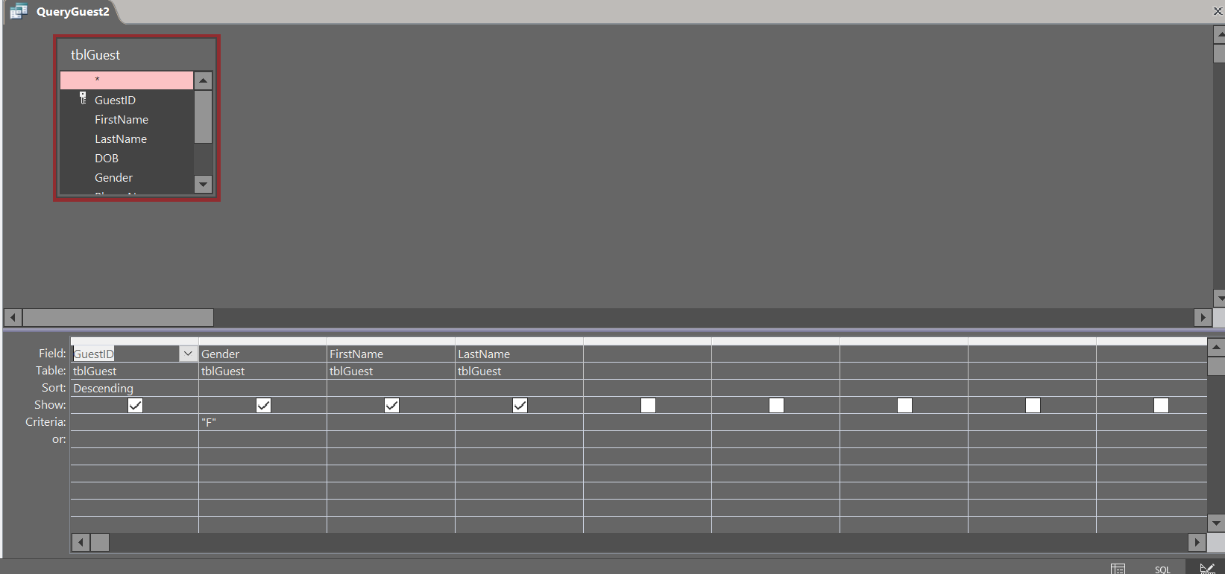

Query guest

Database view

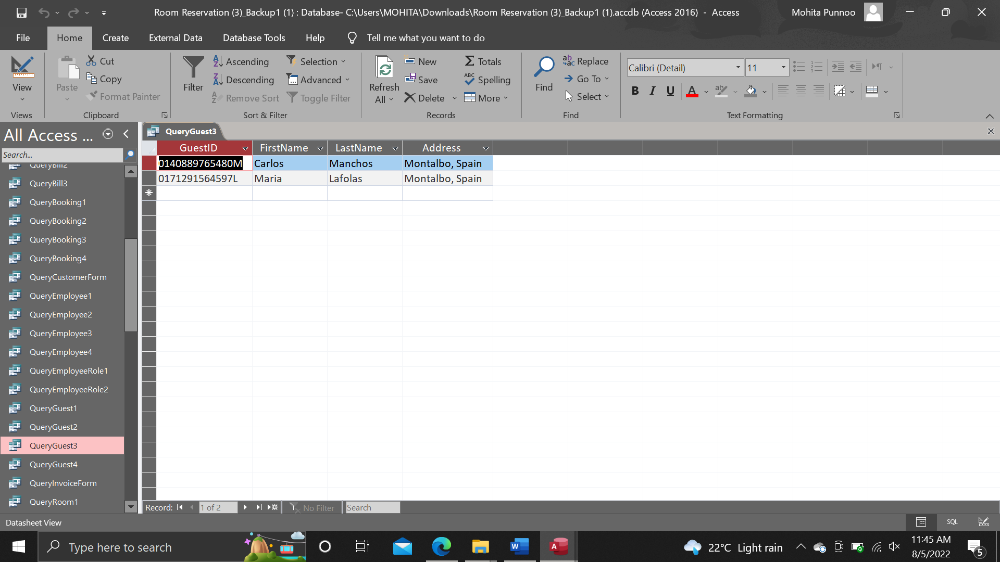

Design view

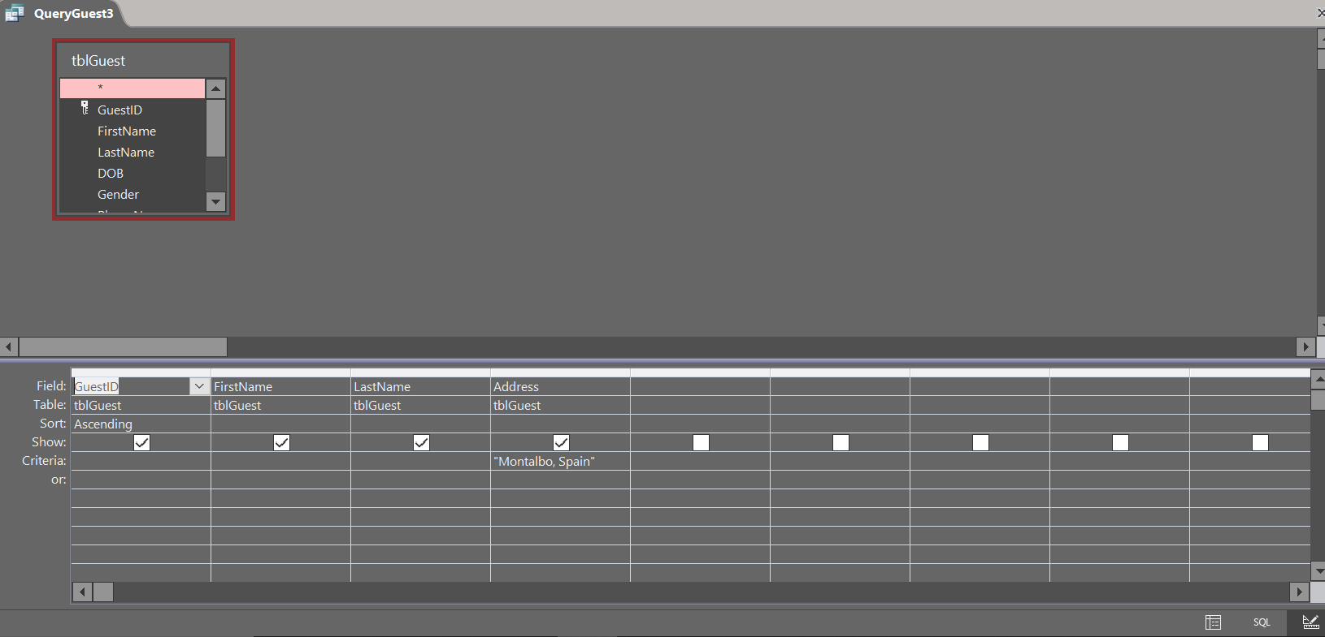

Query Guest

Database view

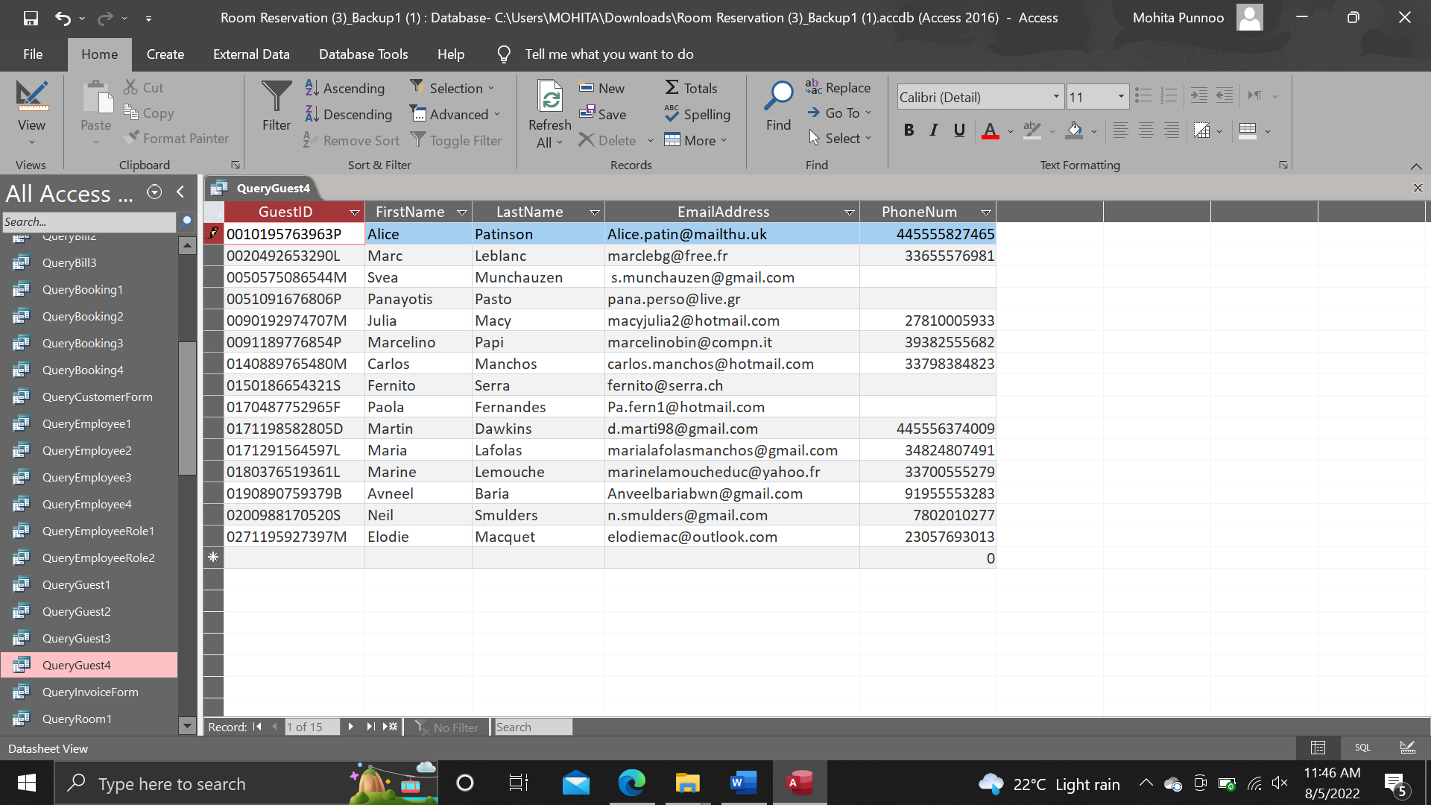

Design view

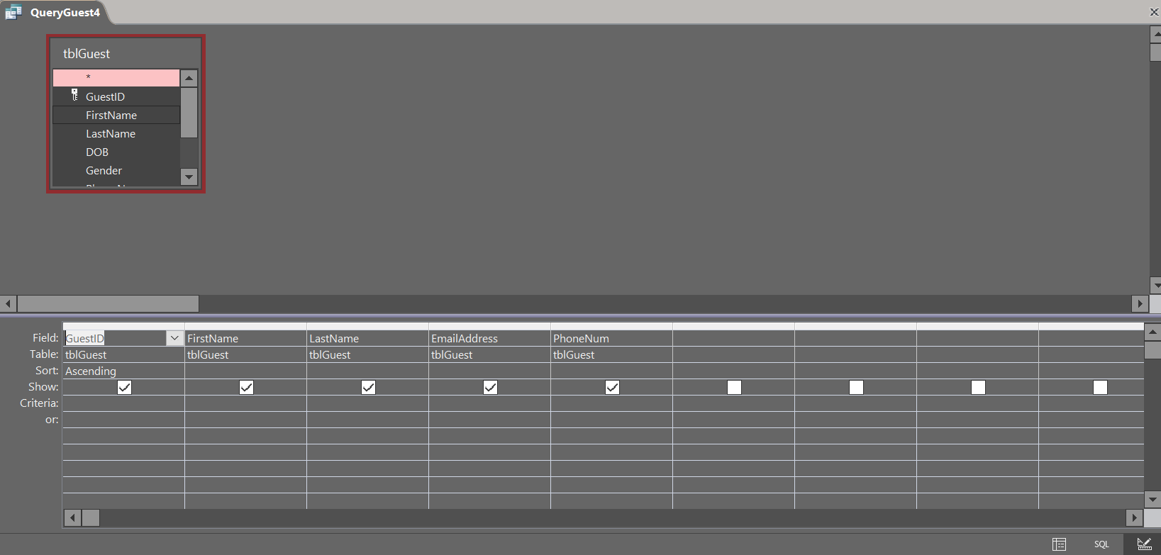

Query Booking

Database view

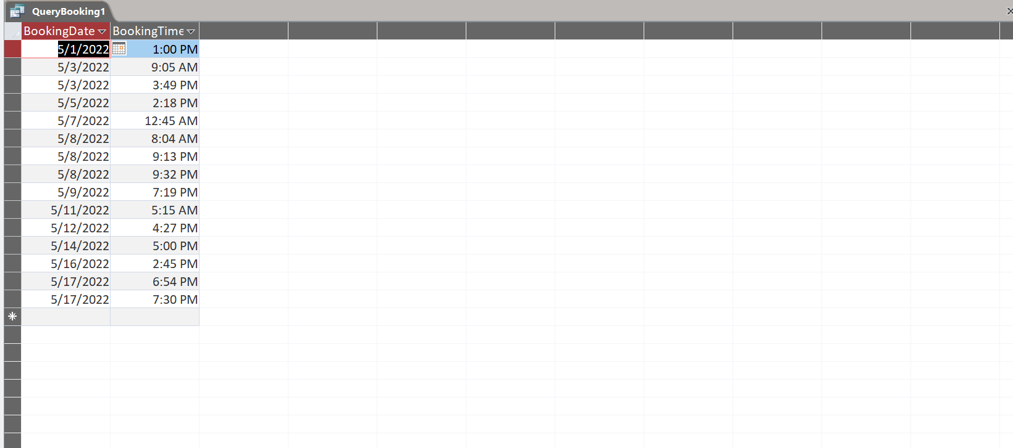

Design view

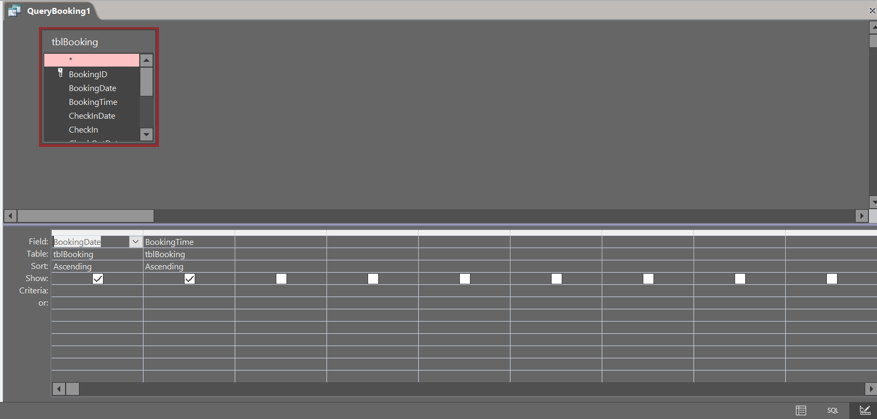

Query Booking

Database view

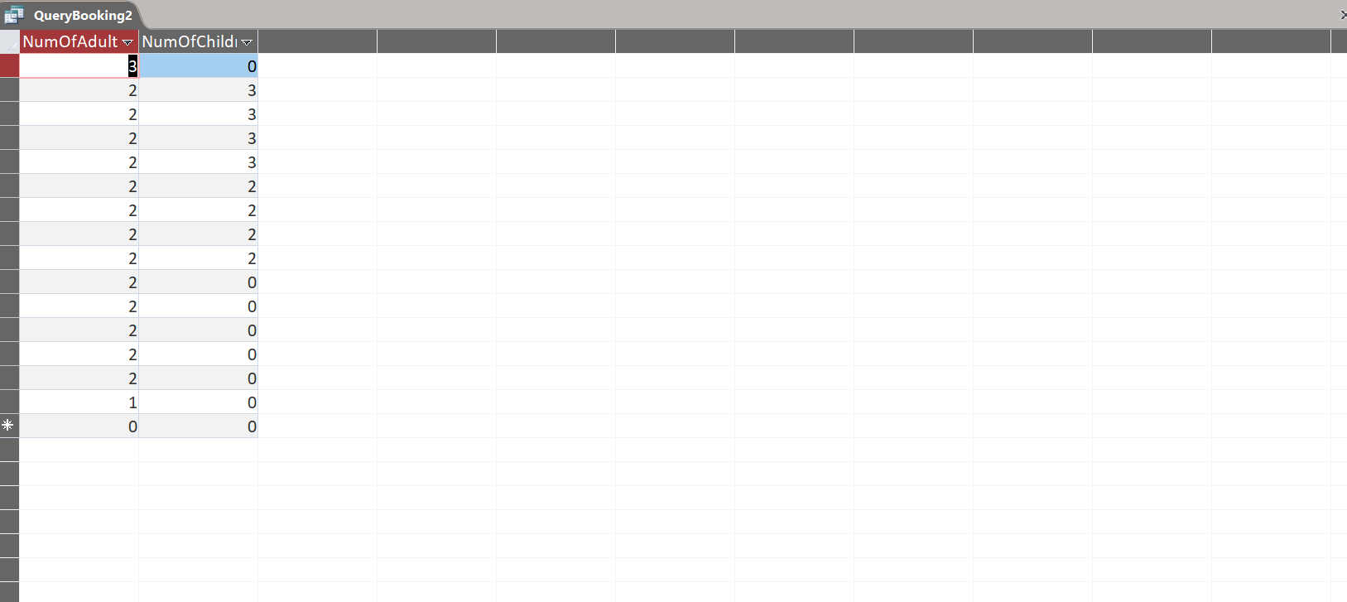

Design view

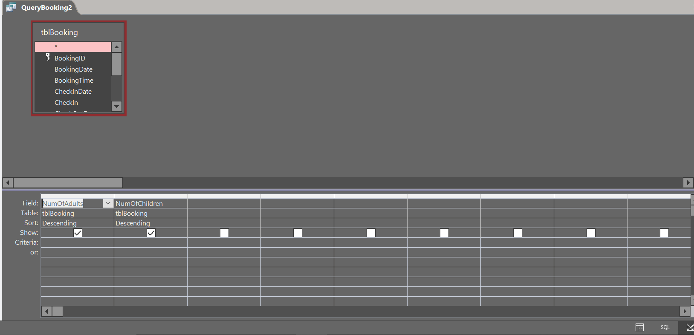

Query Booking

Database view

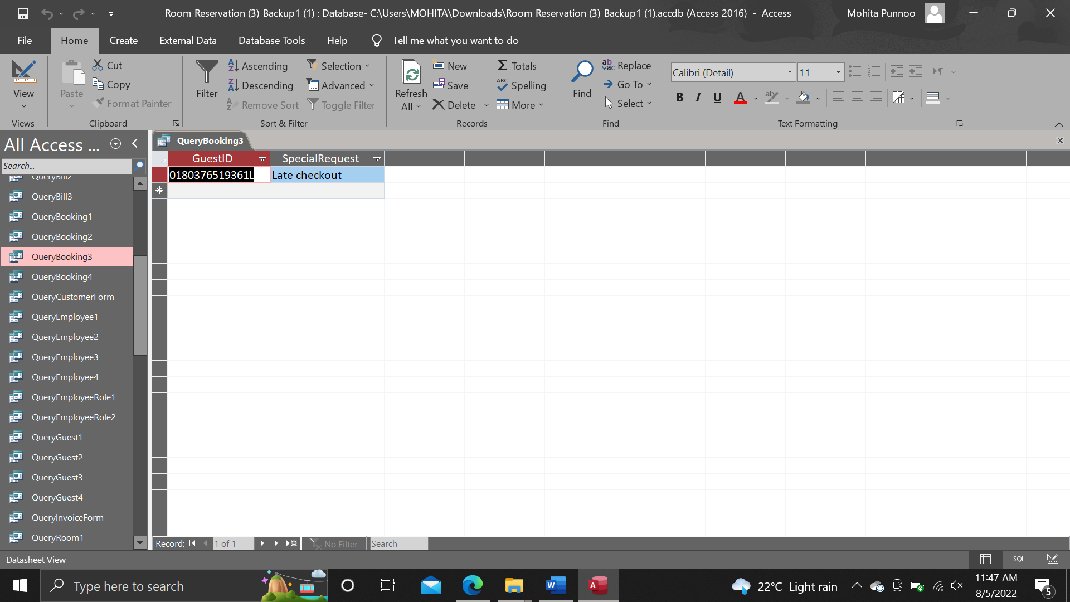

Design view

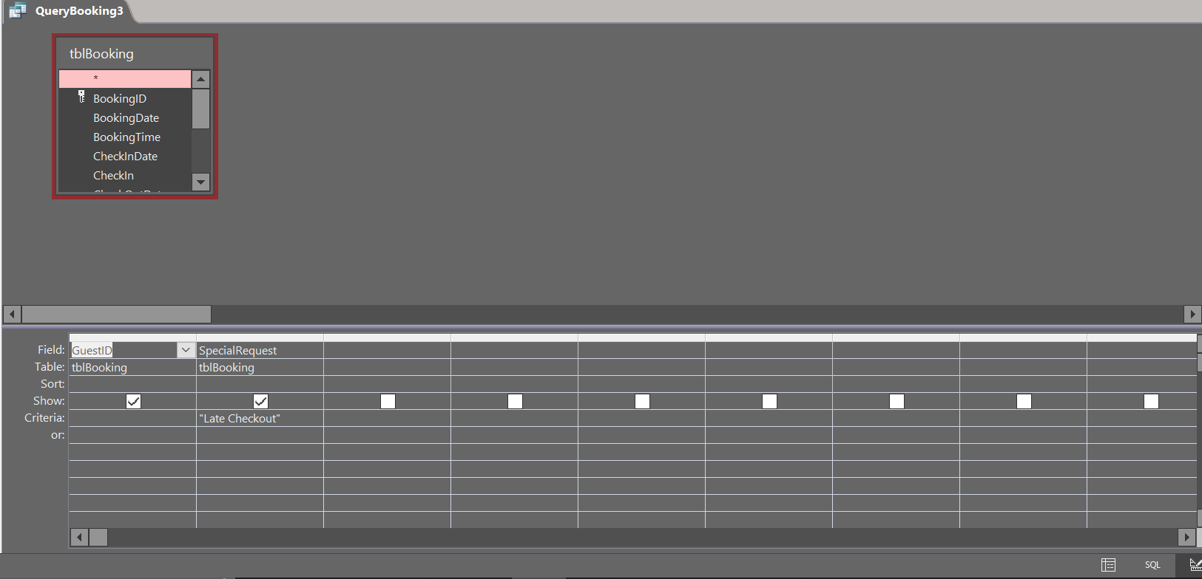

Query Booking

Database view

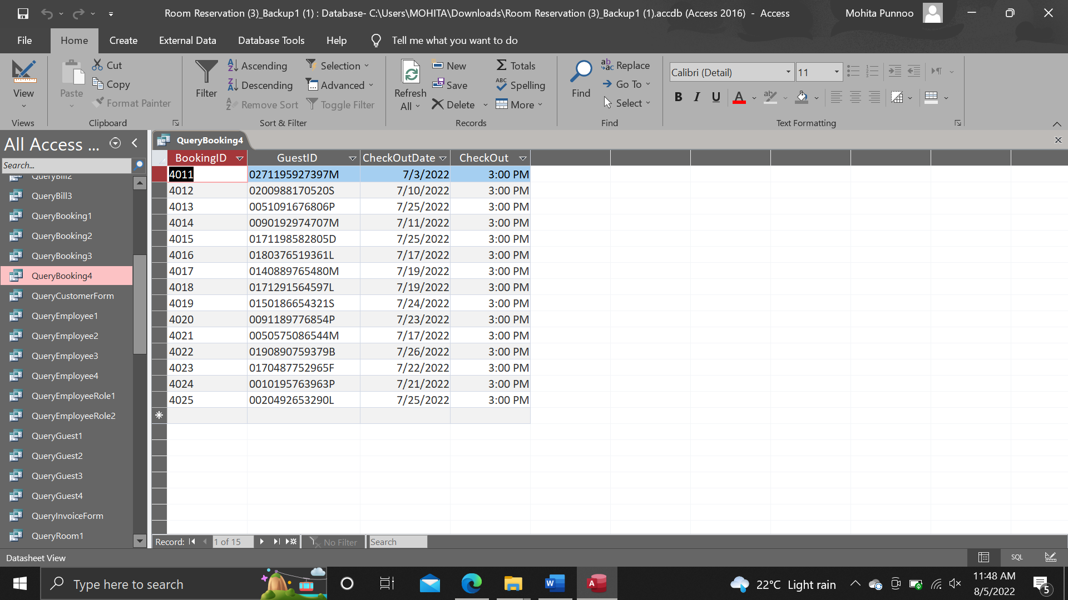

Design view

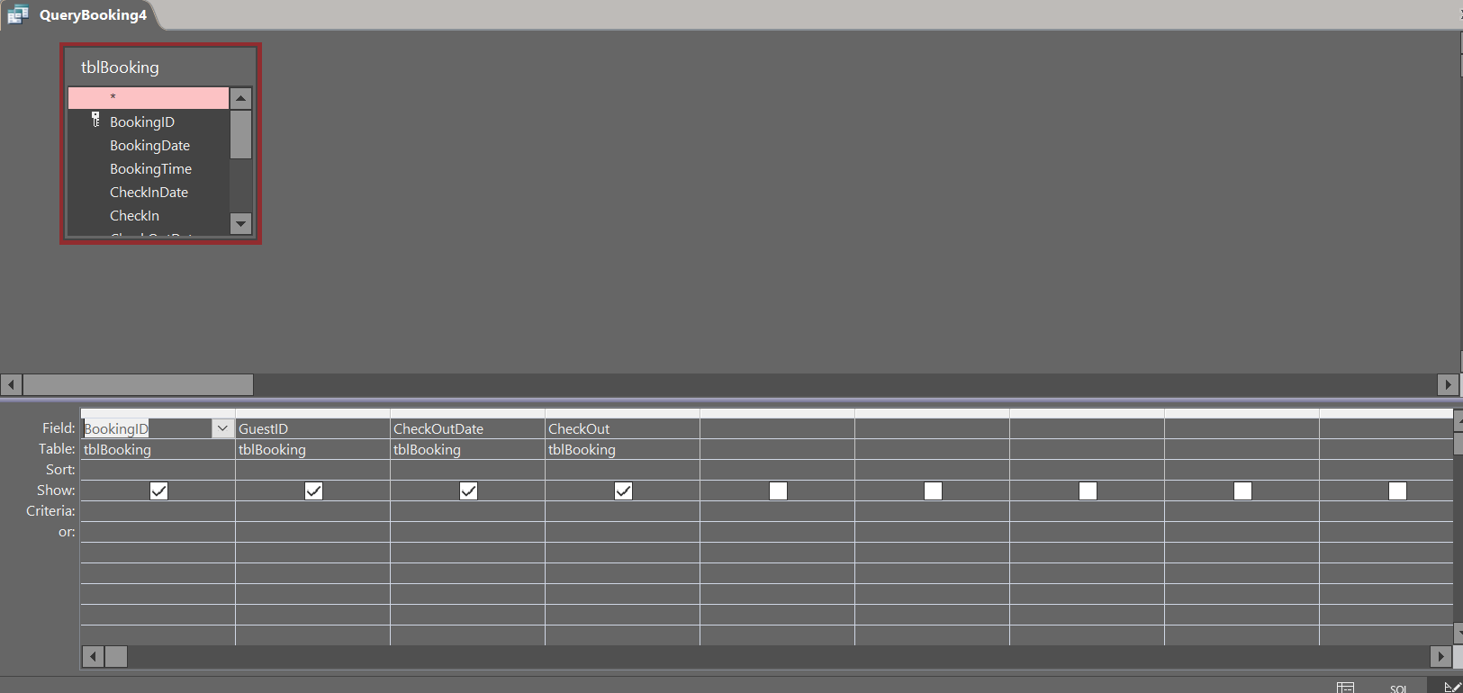

Query Employee

Database view

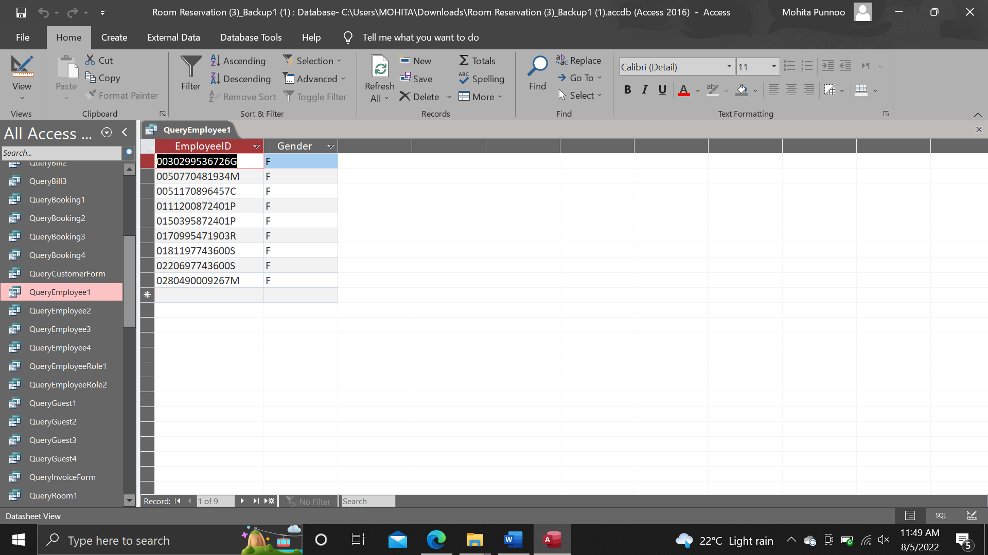

Design view

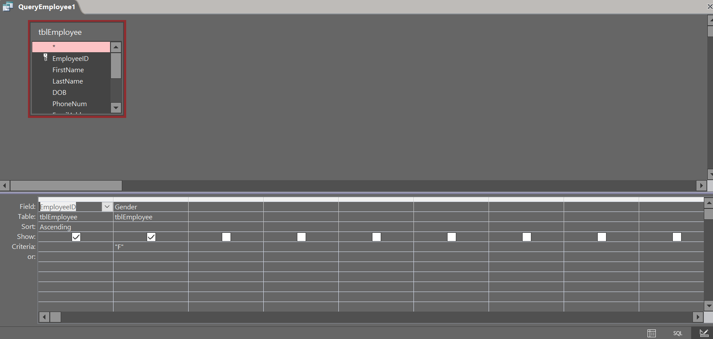

Query Employee

Database view

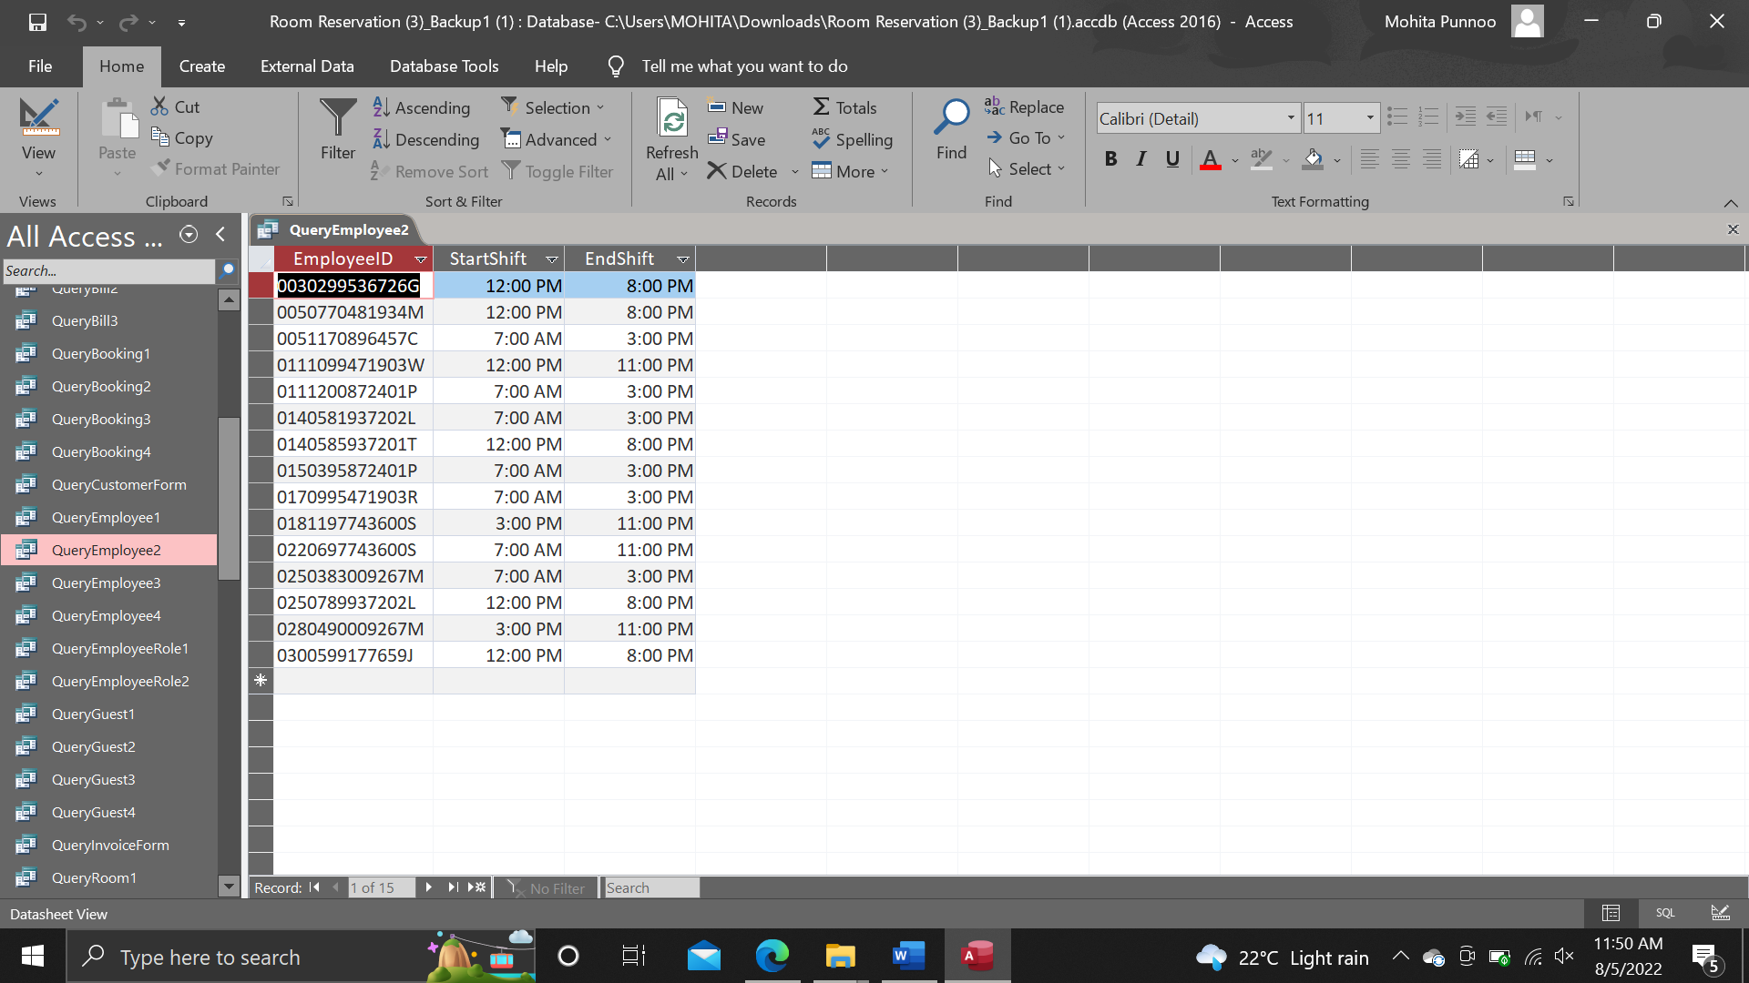

Design view

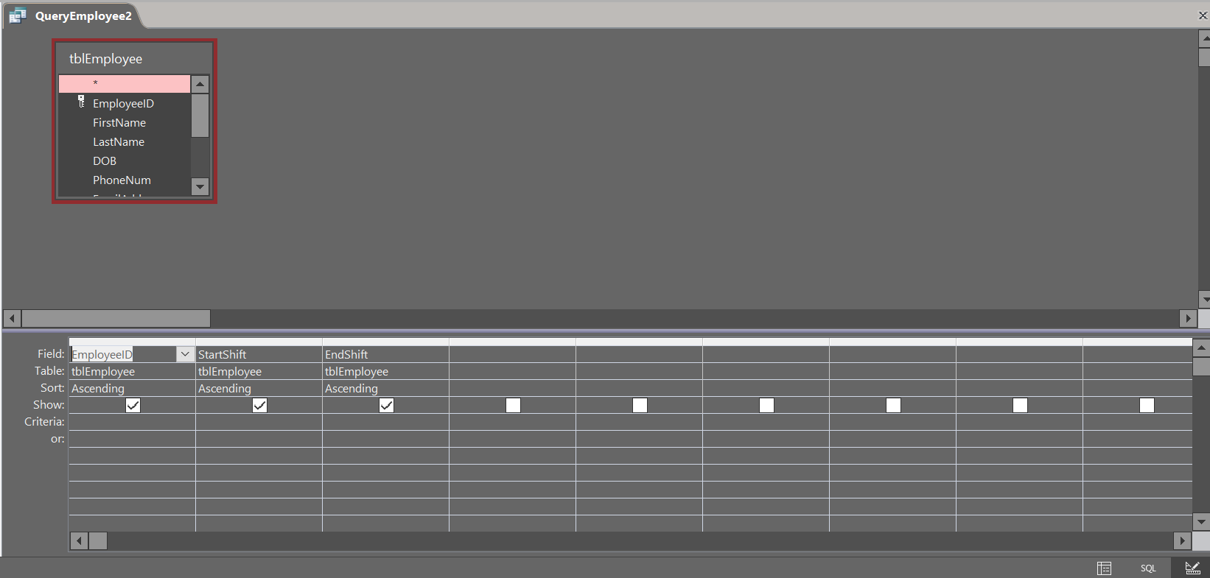

Query Employee

Database view

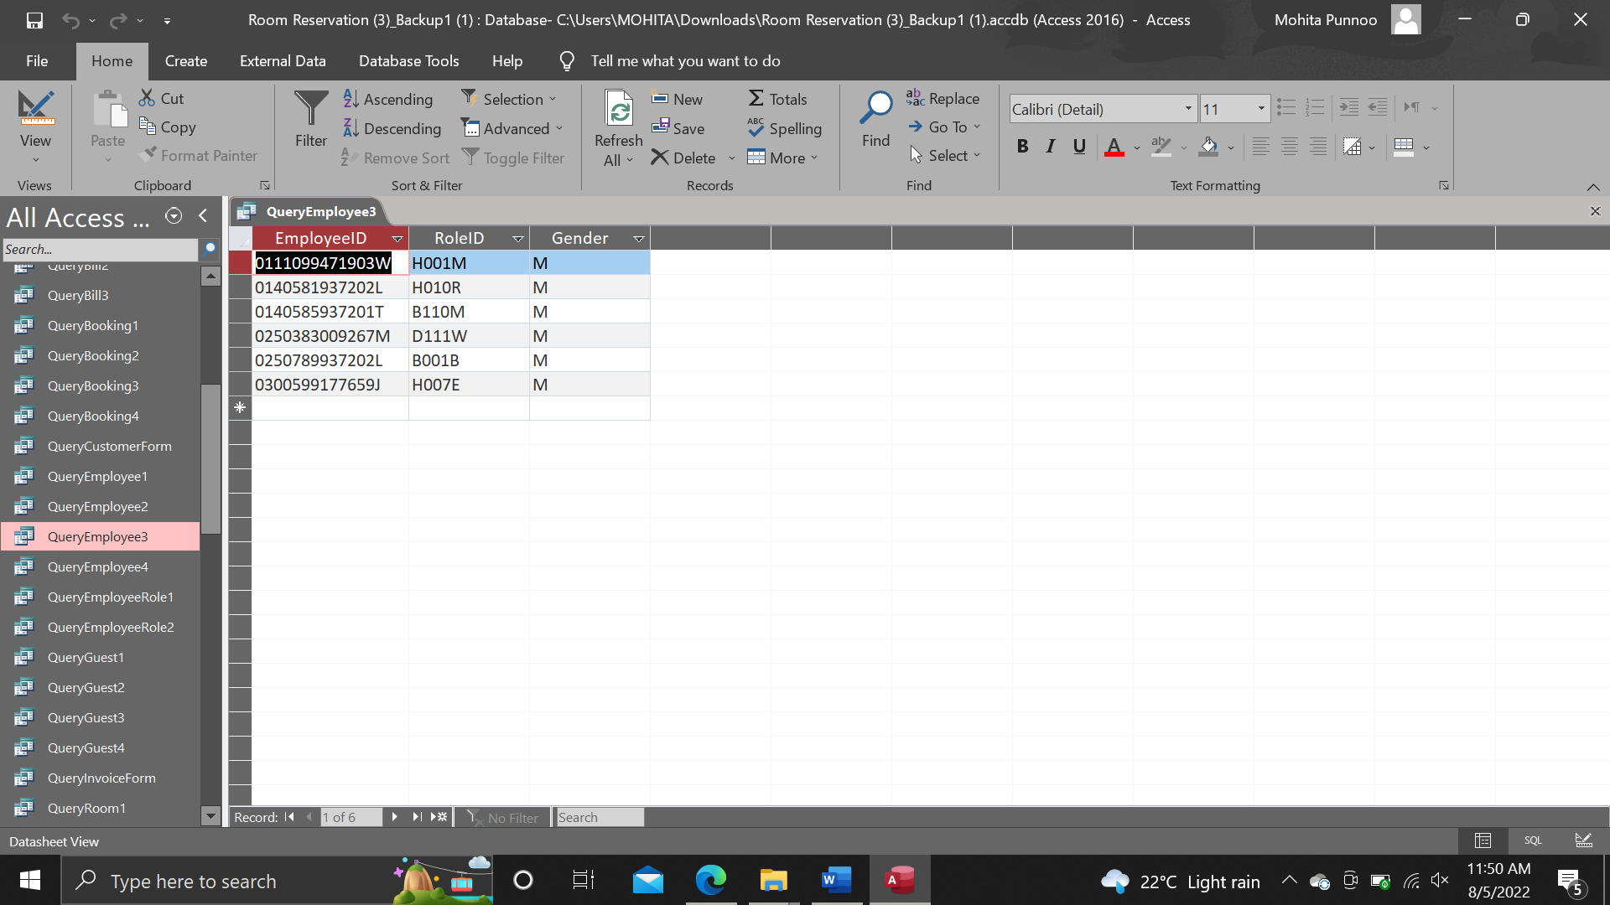

Design view

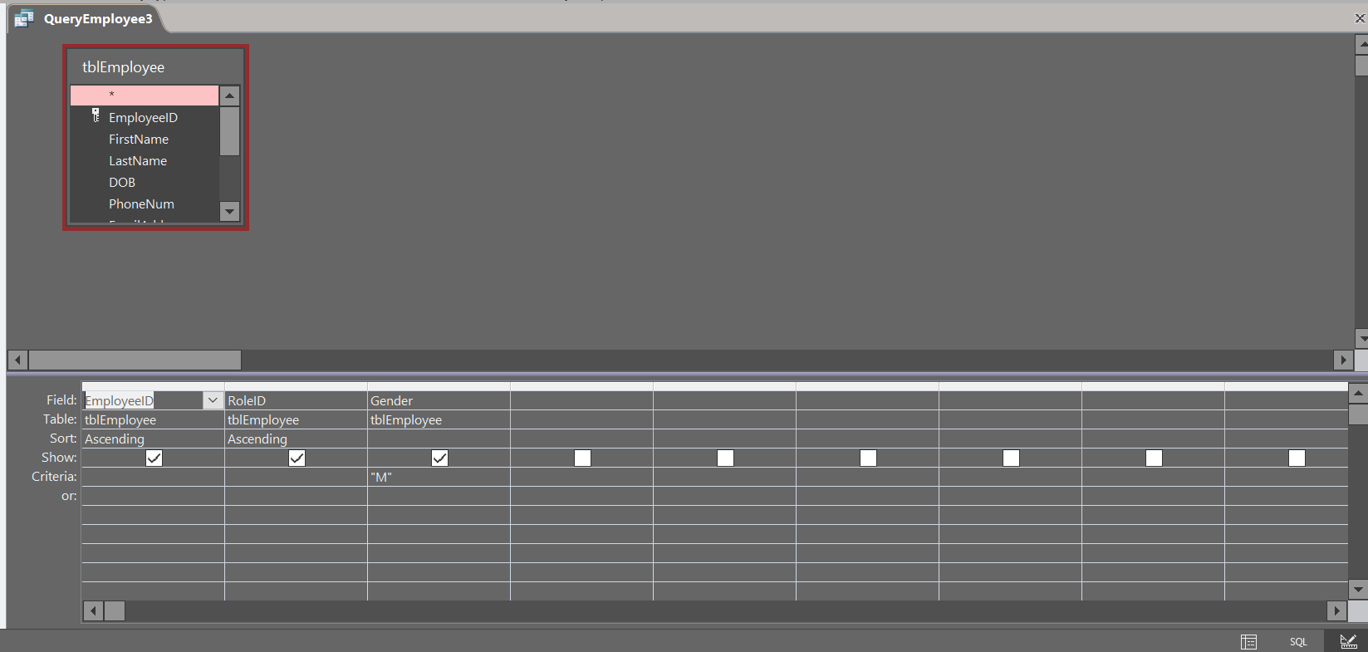

Query Employee

Database view

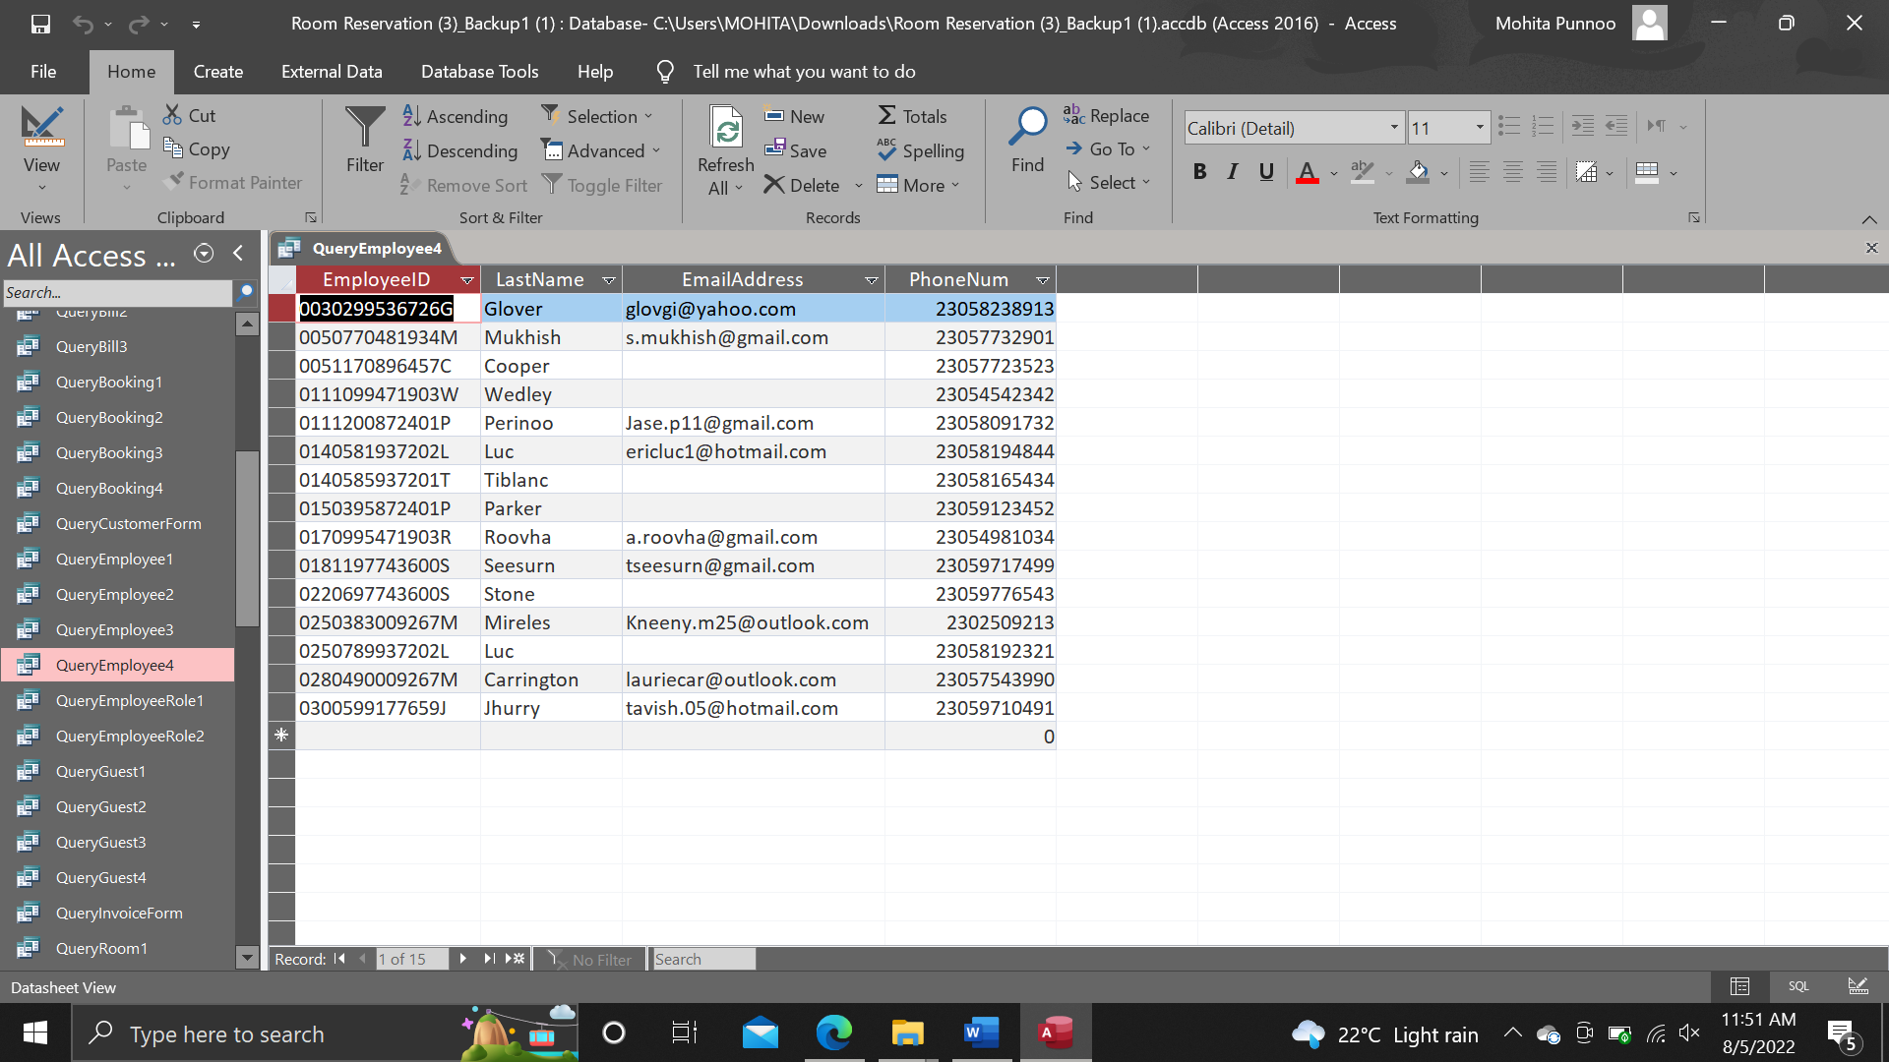

Design view

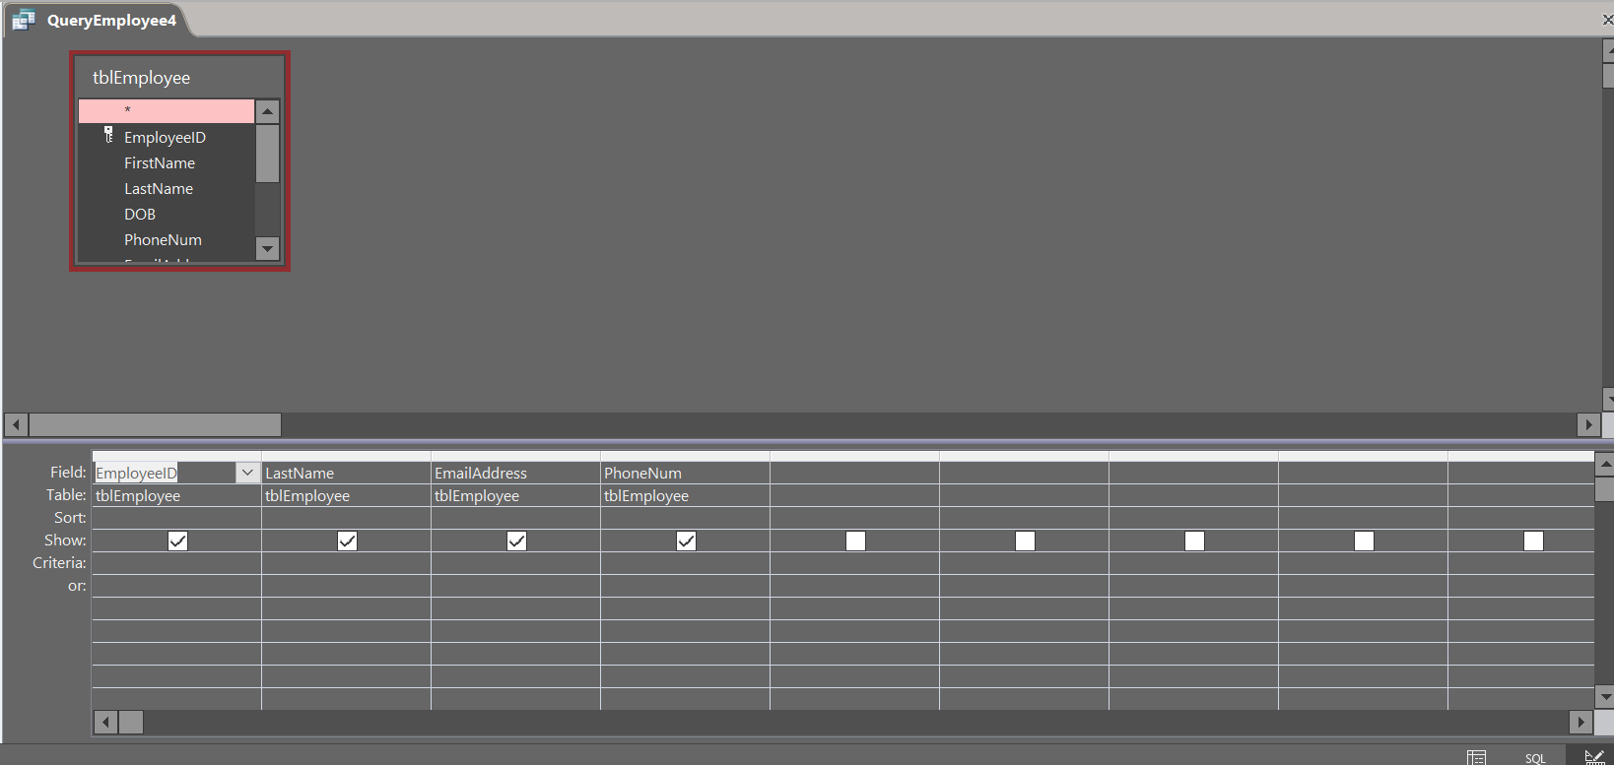

Query Employee Role

Database view

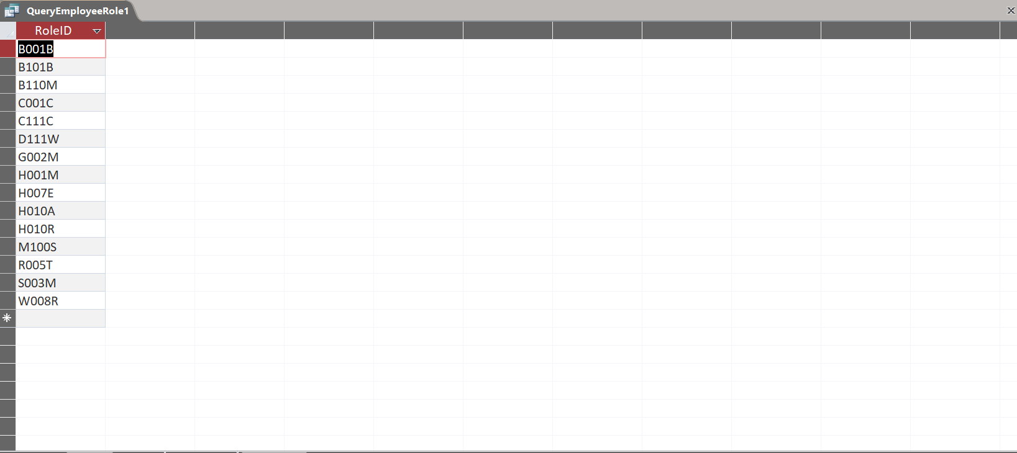

Design view

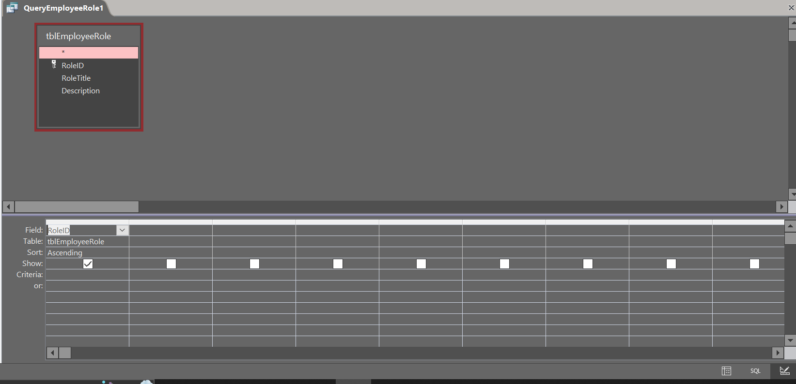

Query Employee Role

Database view

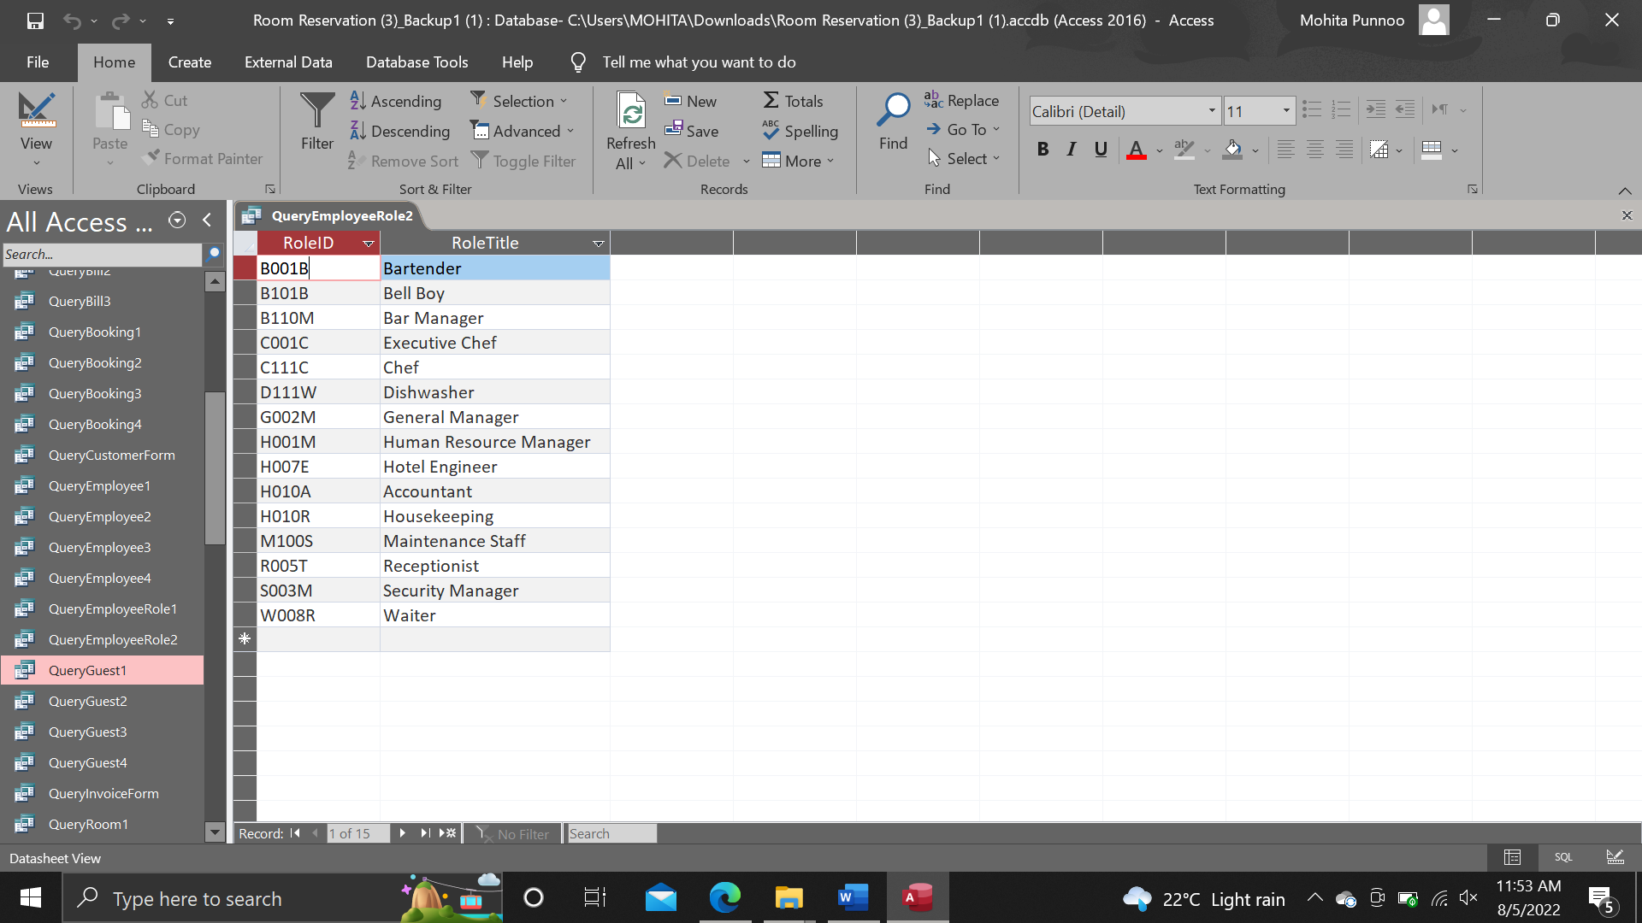

Design view

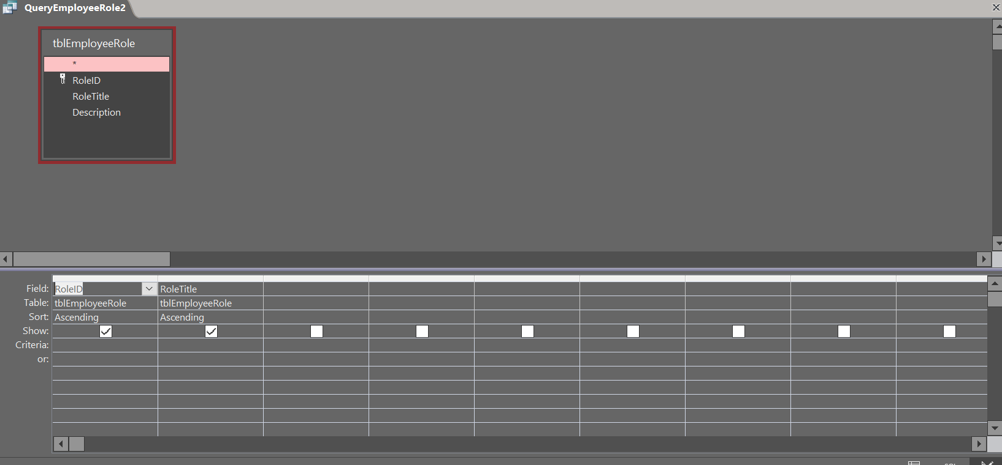

Query Bill

Database view

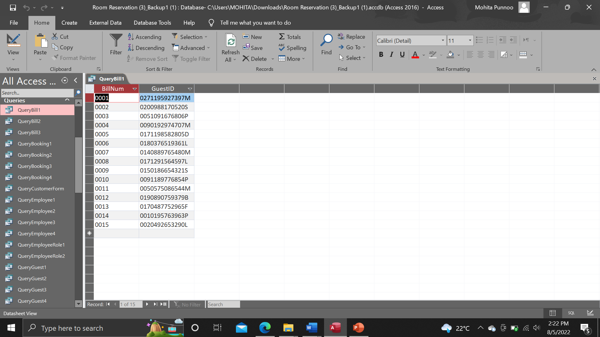

Design view

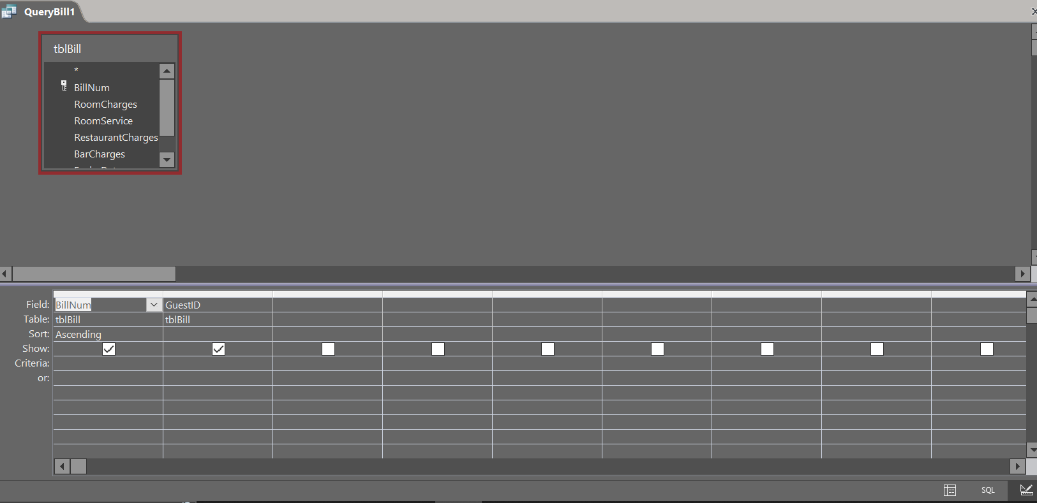

Query Bill

Database view

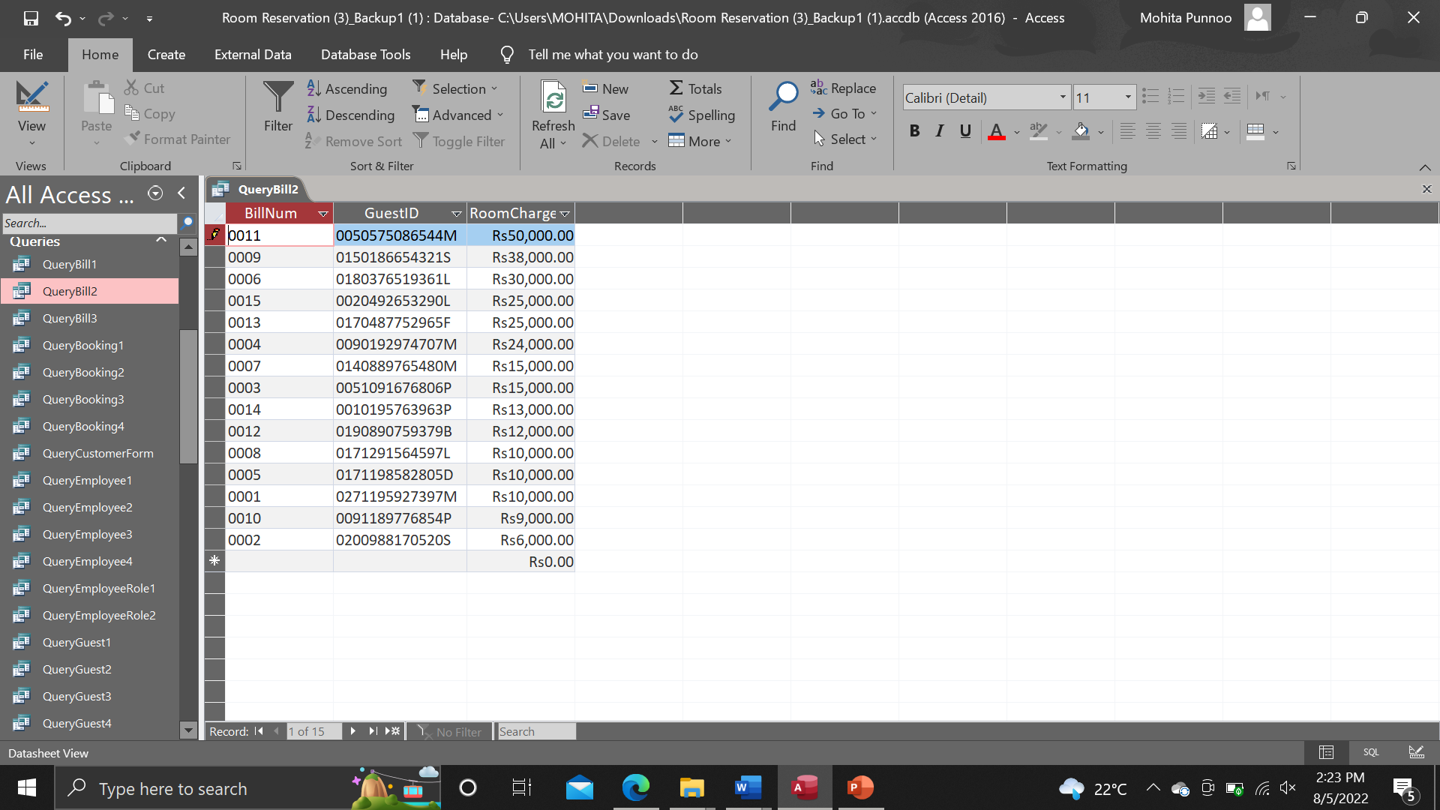

Design view

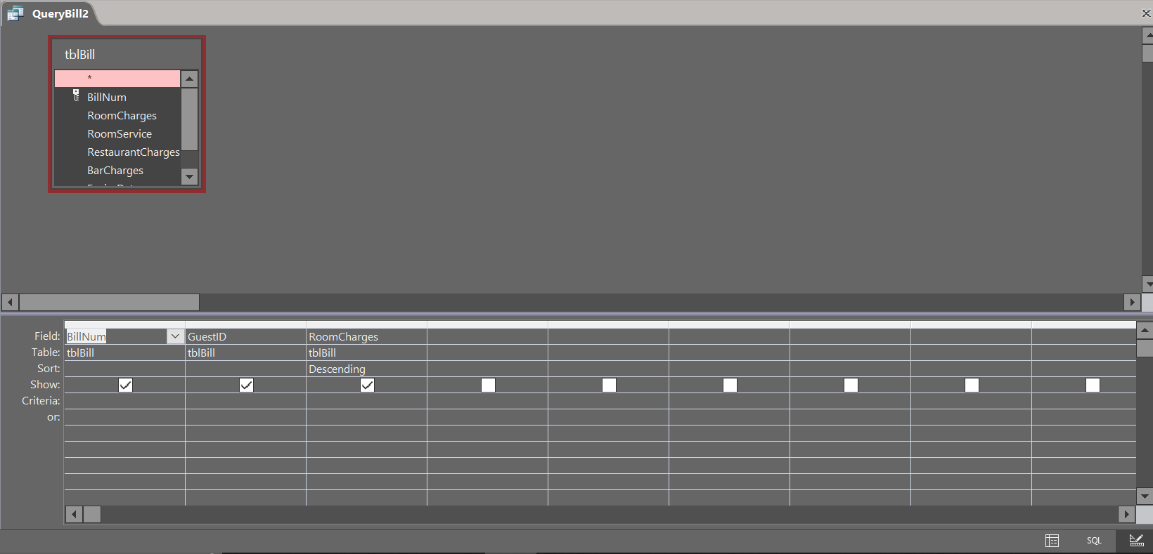

Query Bill

Database view

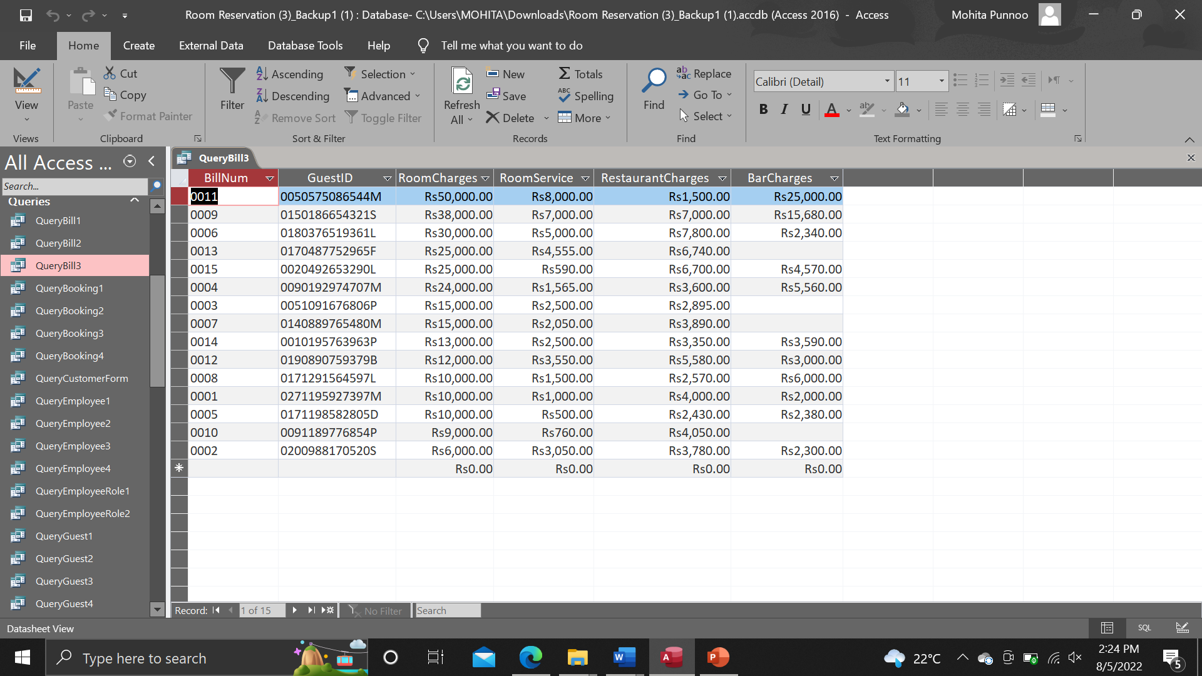

Design view

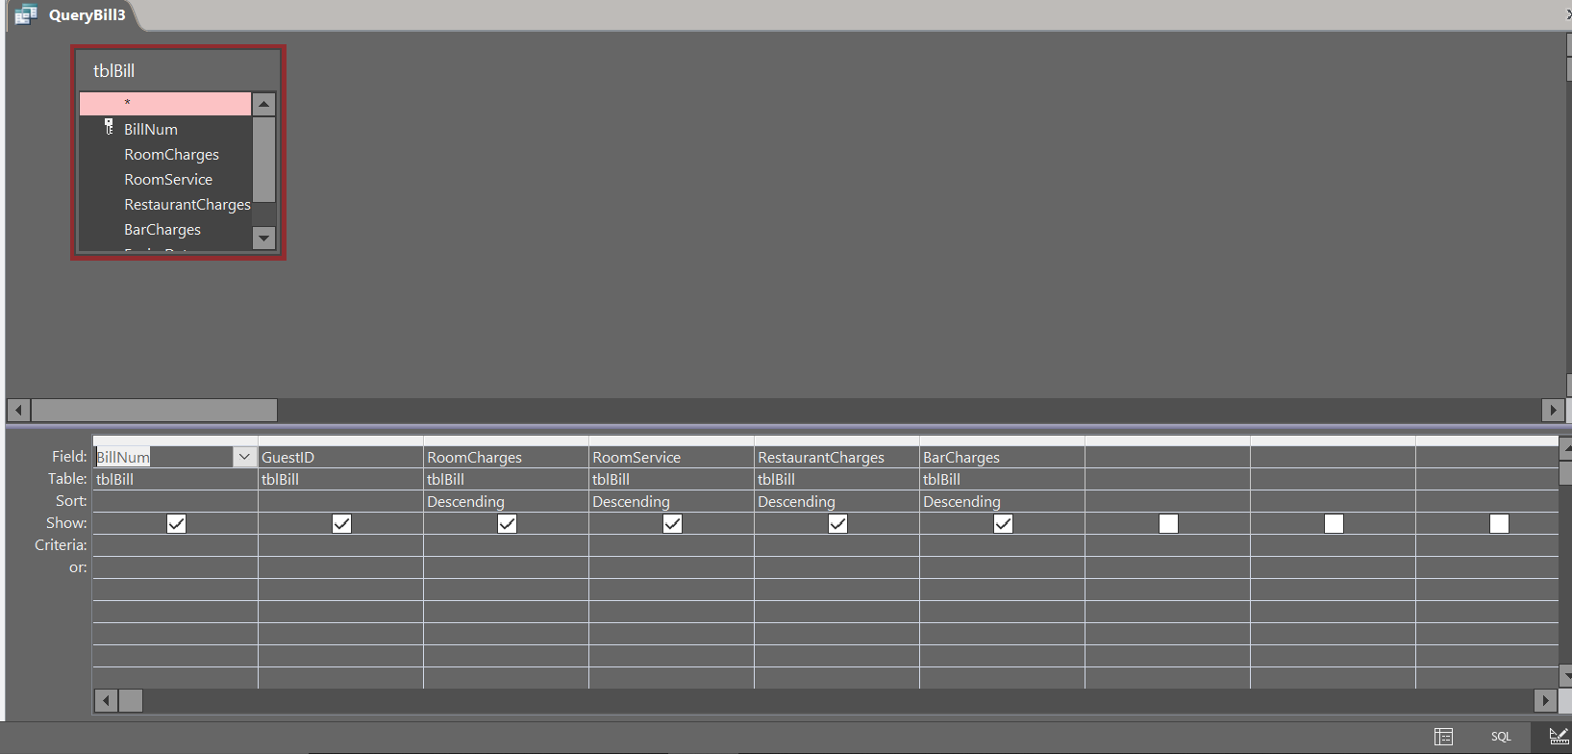

Query Room

Database view

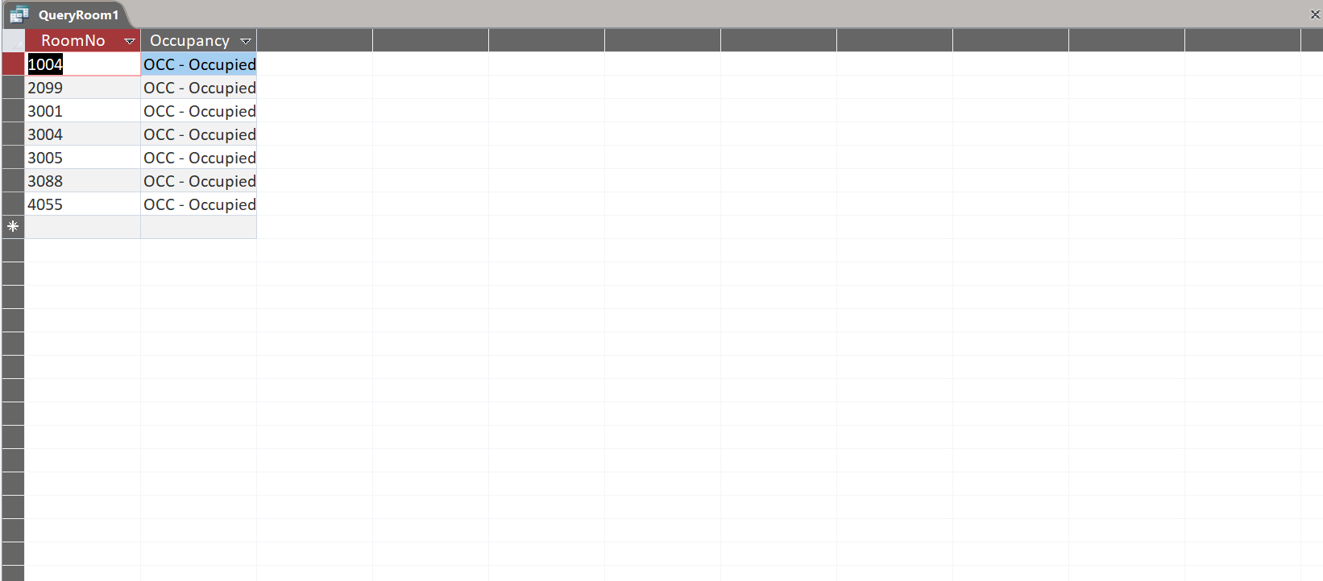

Design view

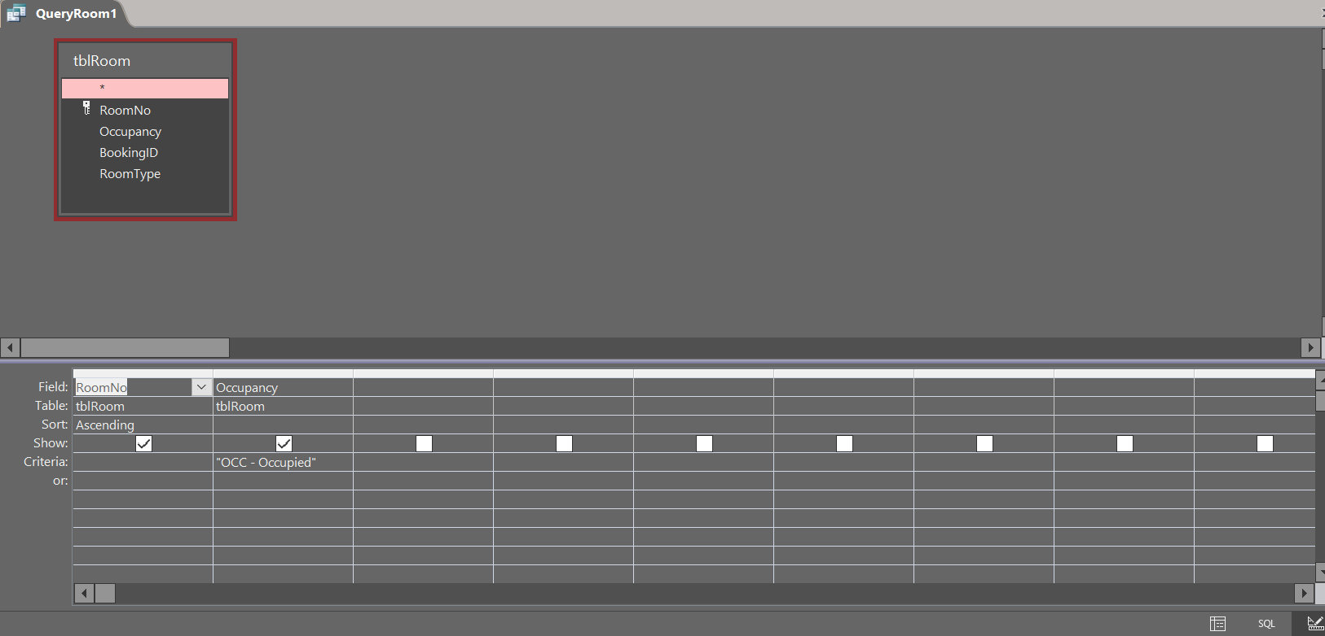

Query Room

Database view

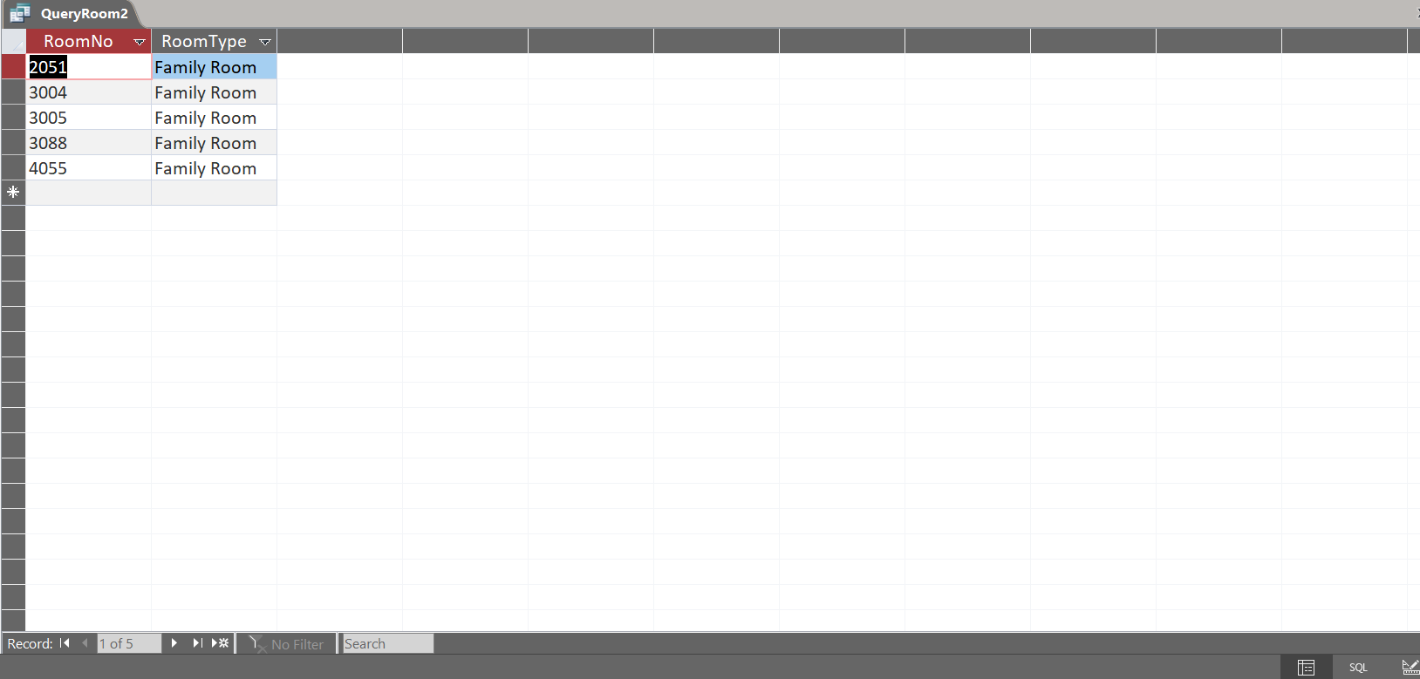

Design view

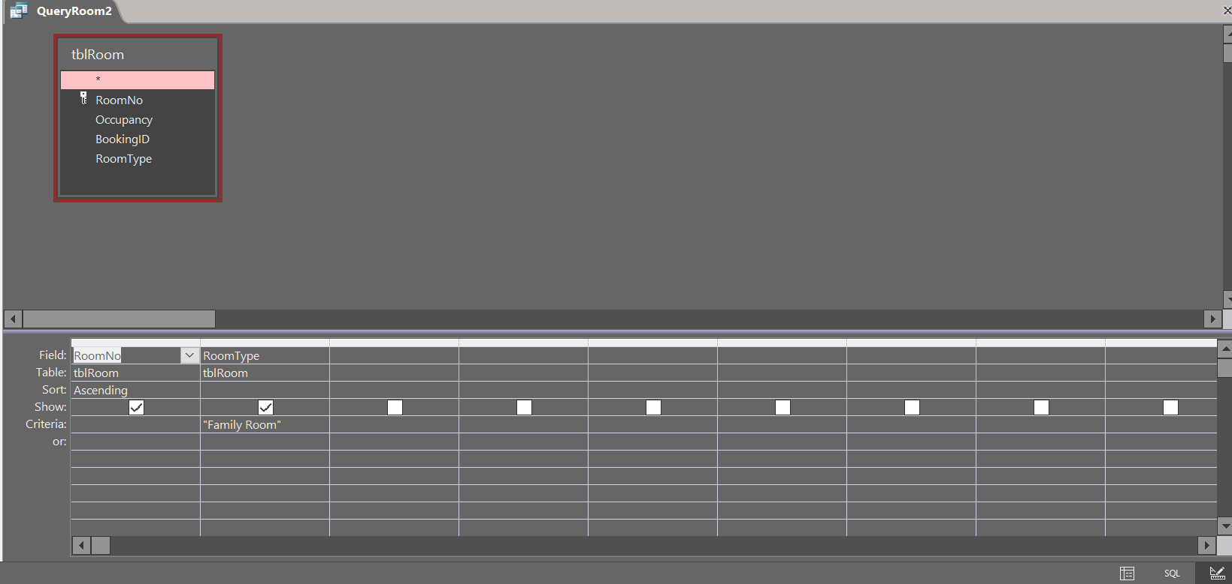

Query Room

Database view

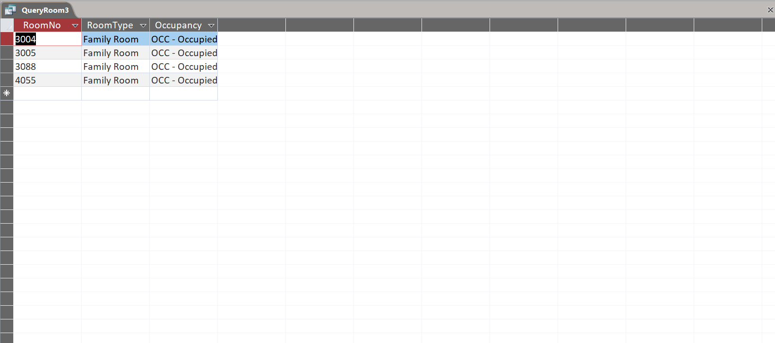

Design view

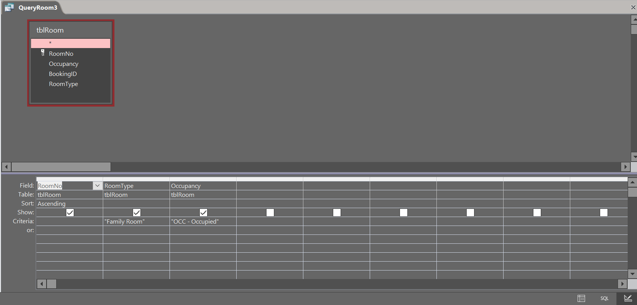

Query room

Database view

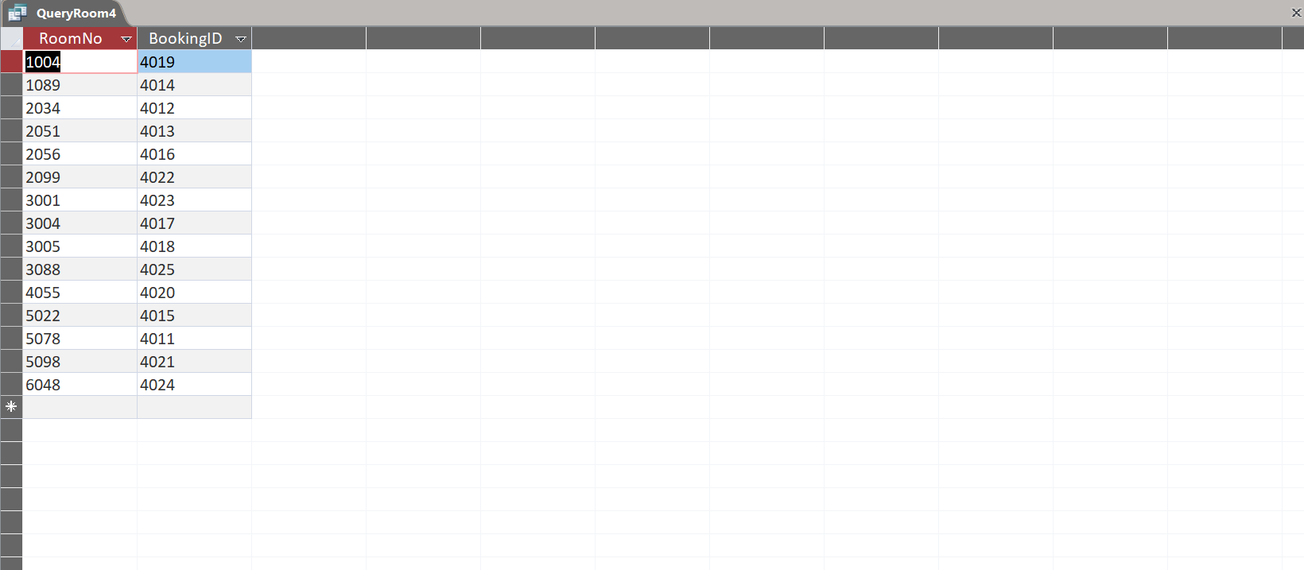

Design view

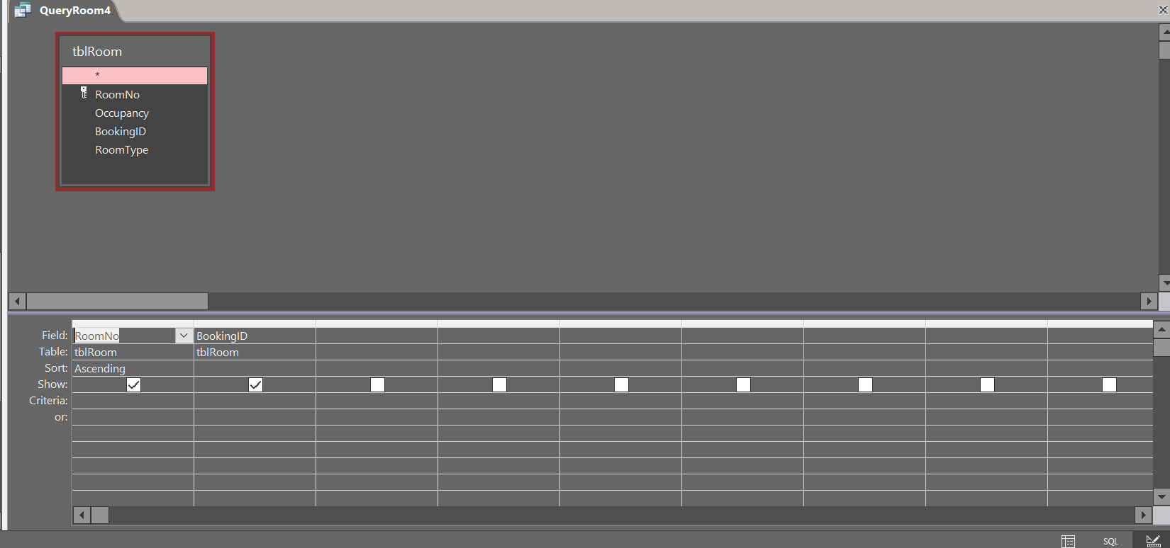

Query Room Type

Database view

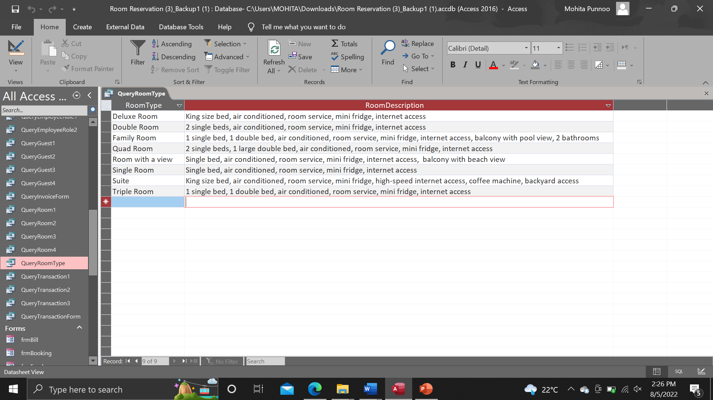

Design view

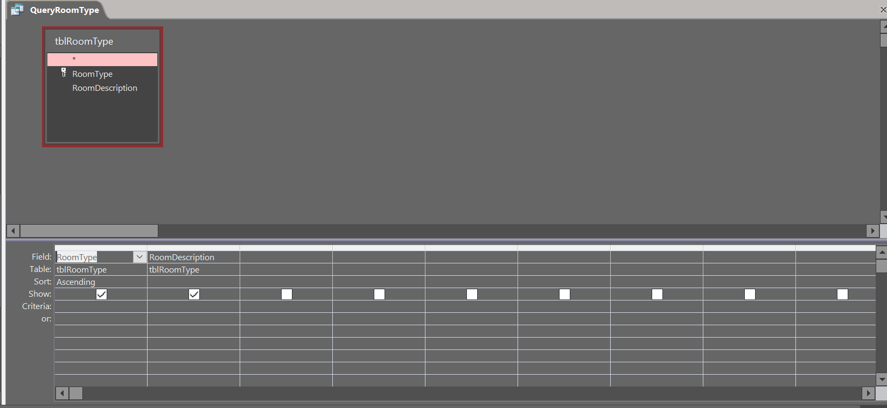

Query transaction

Database view

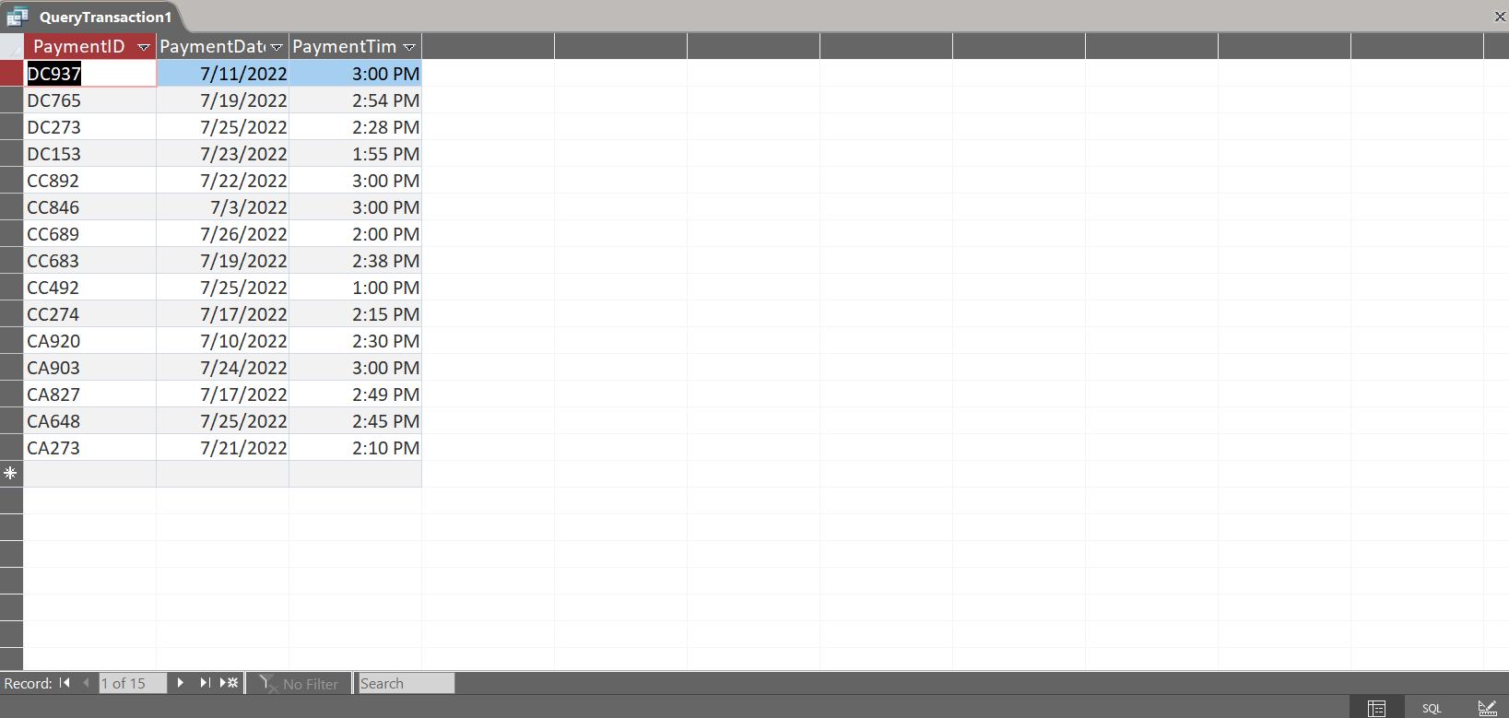

Design view

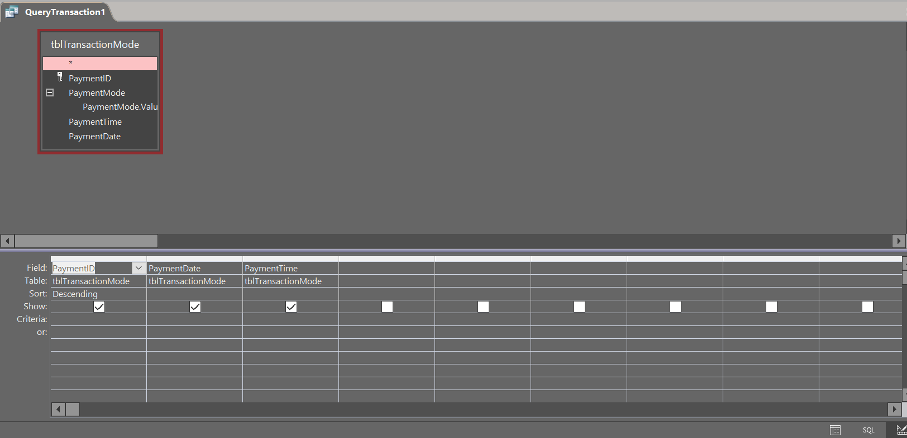

Query Transaction

Database view

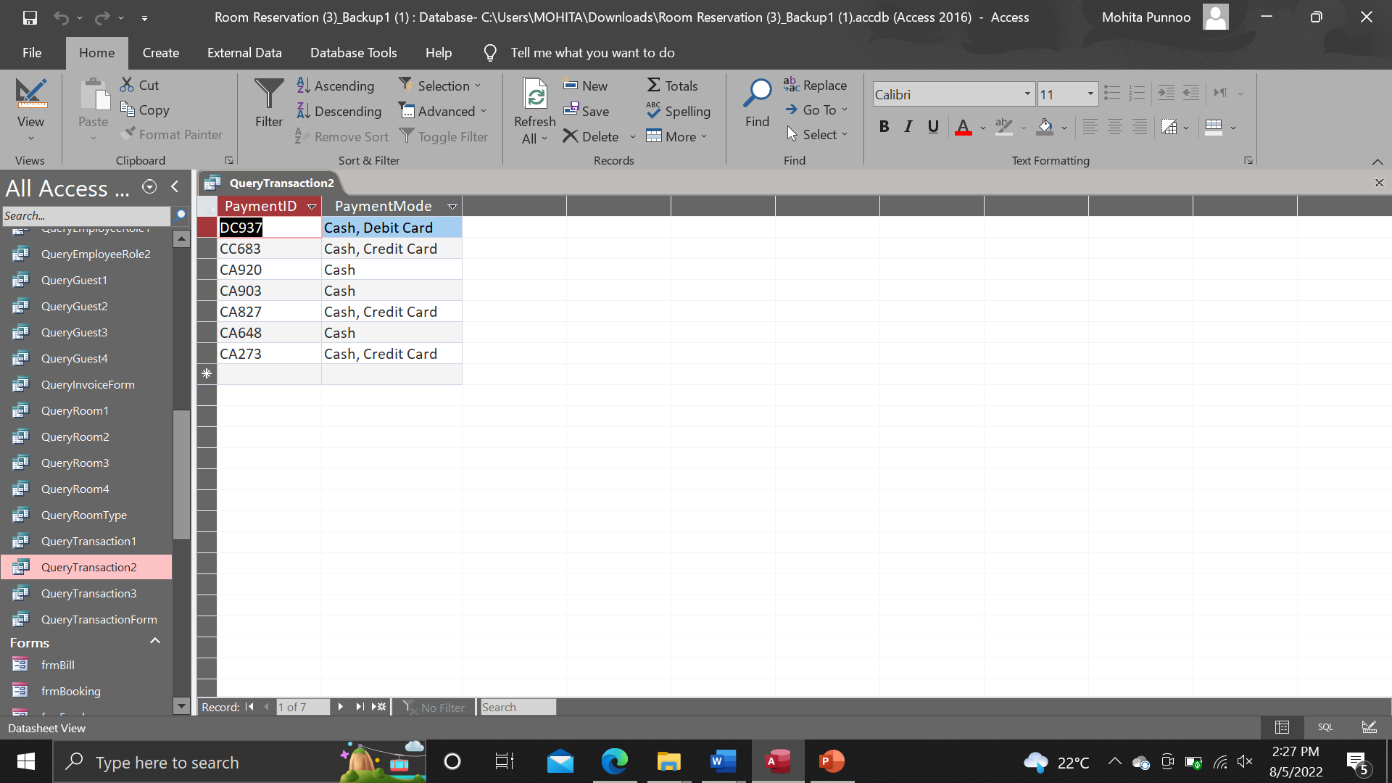

Design view

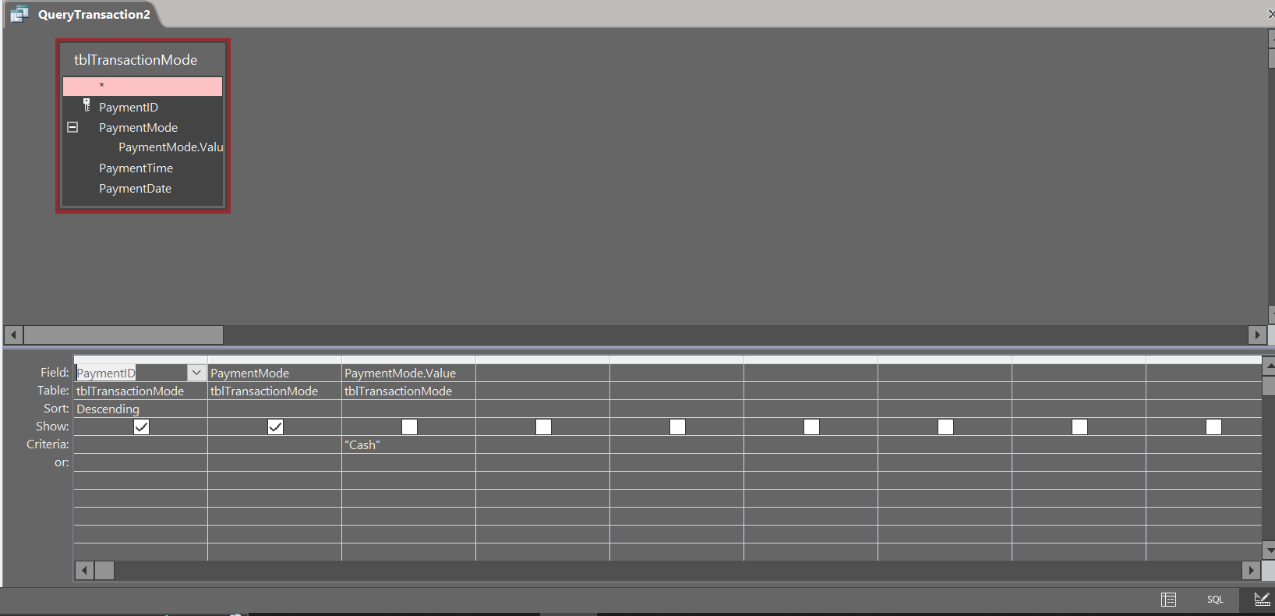

Query Transaction

Database view

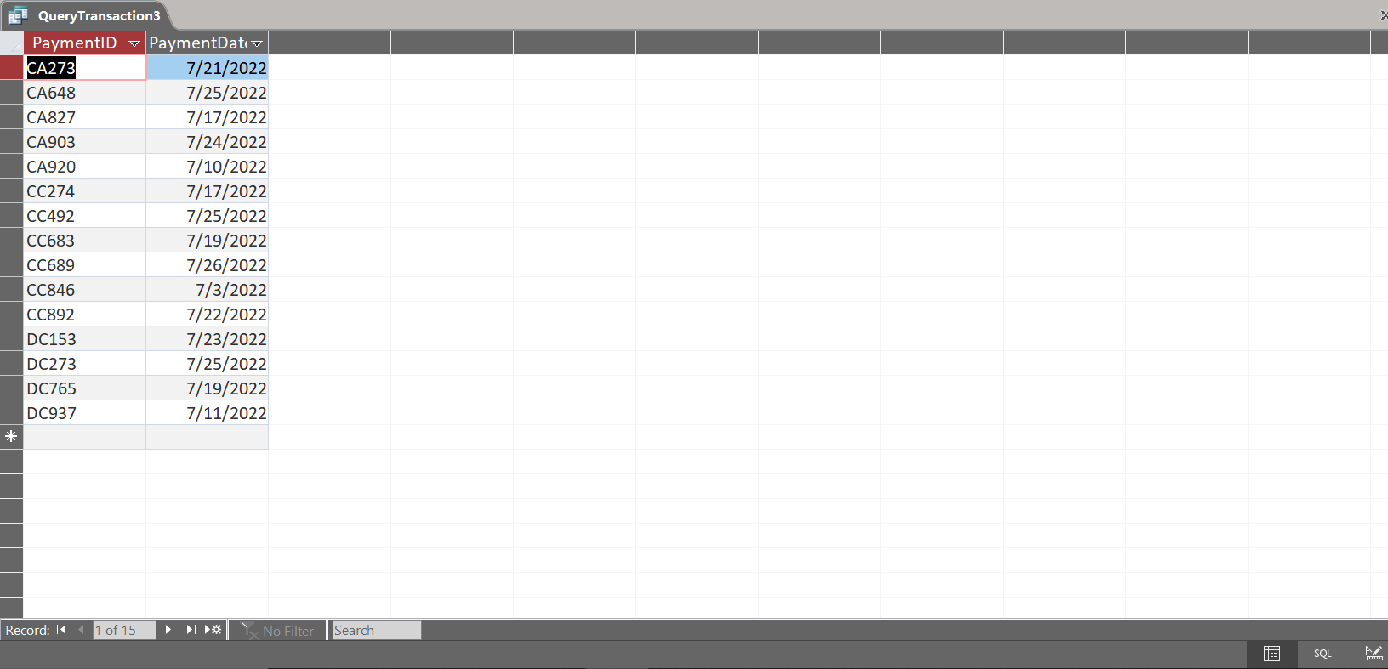

Design view

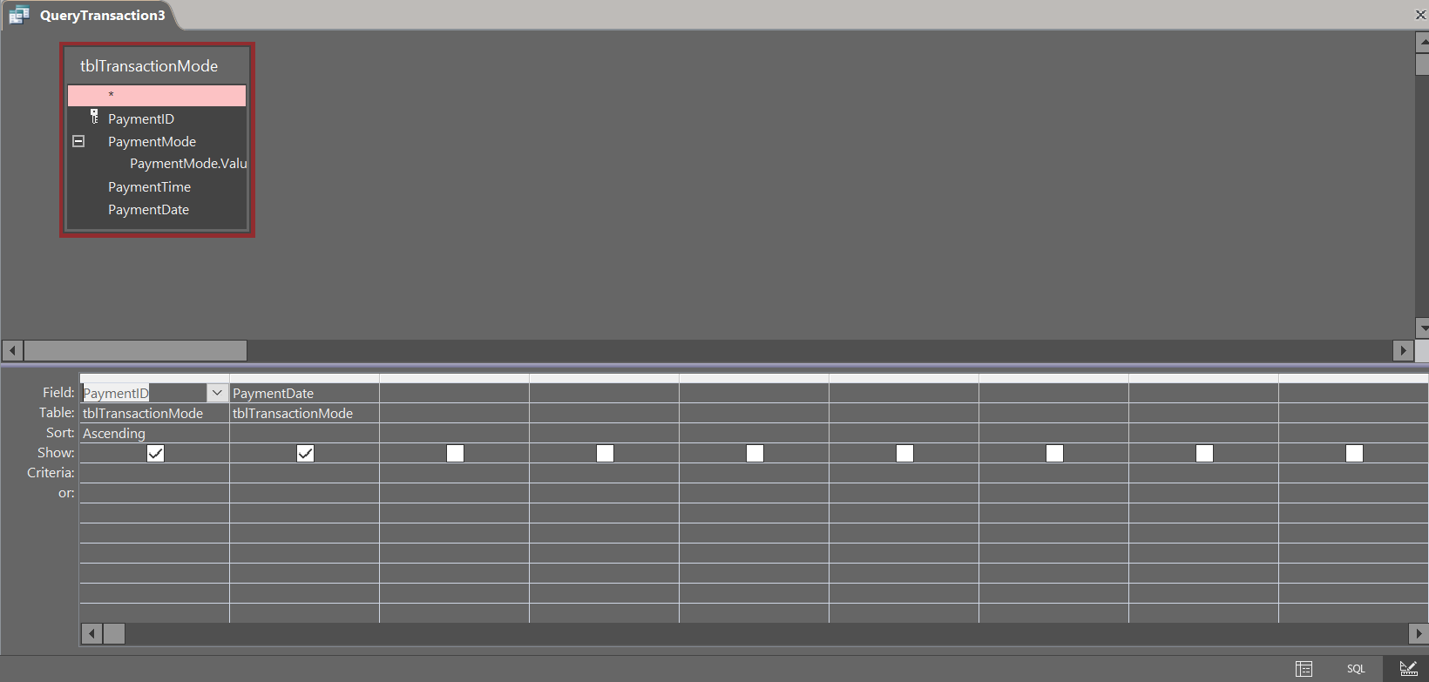

The form below is able to calculate the total for each guest by adding up their room charge, room service fee, restaurant charge and bar charge. The form can also show the guest ID and the bill number for easy identification.

Total

Database view

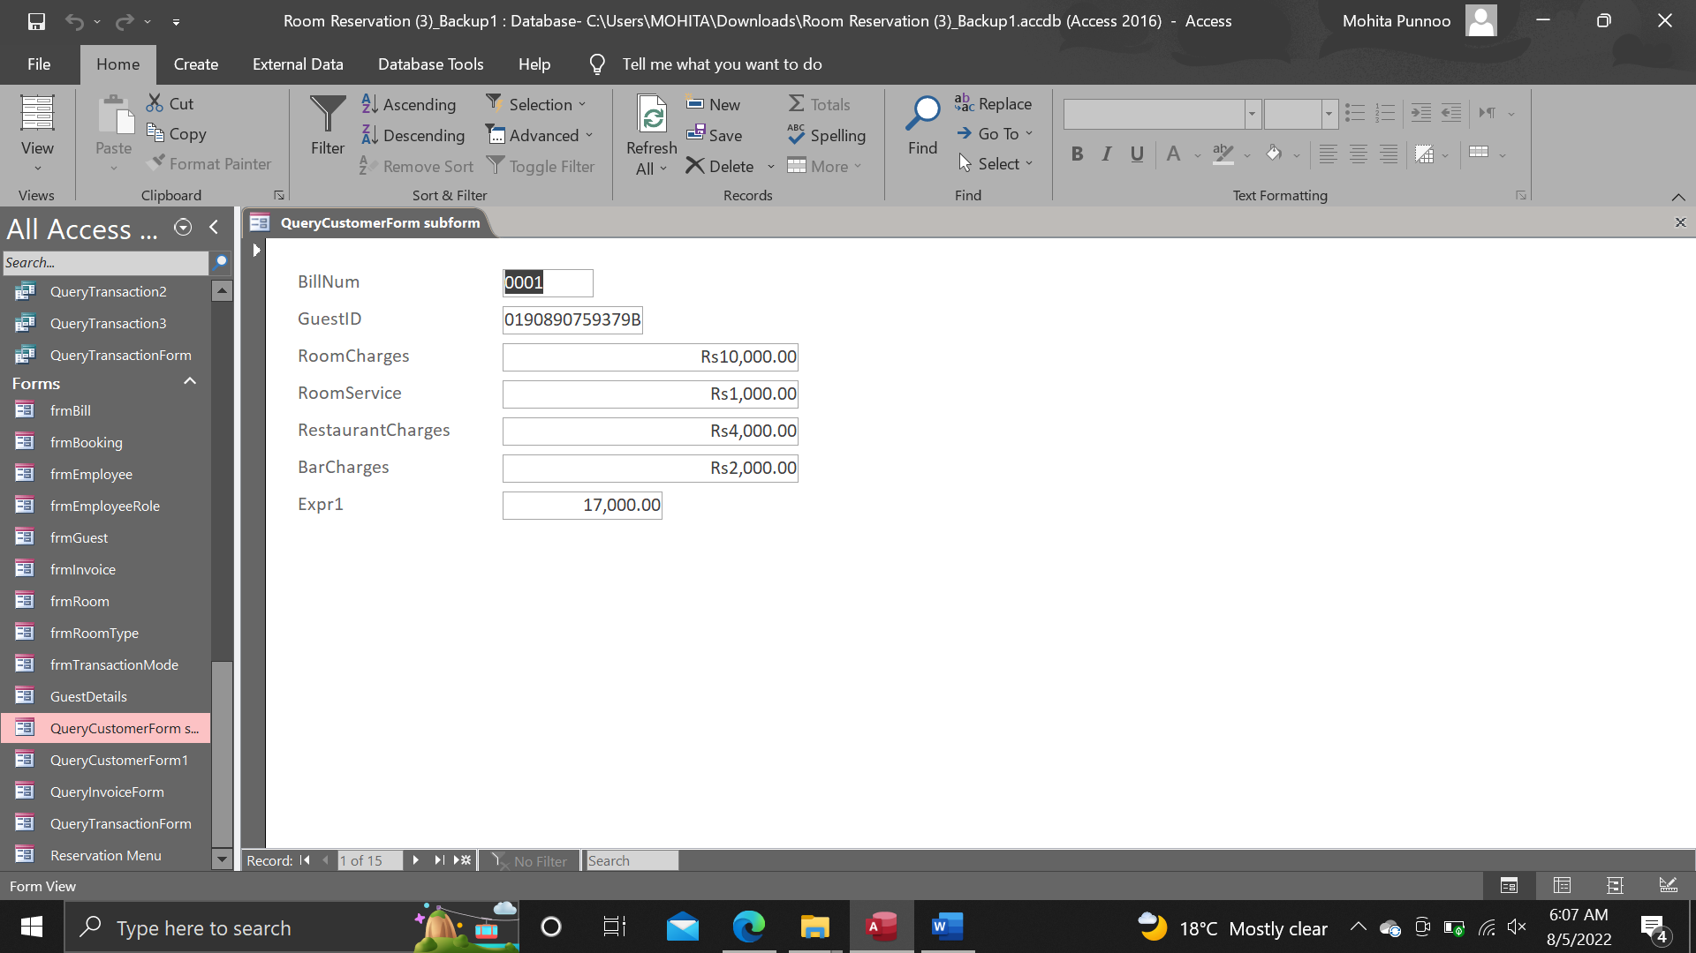

Design view

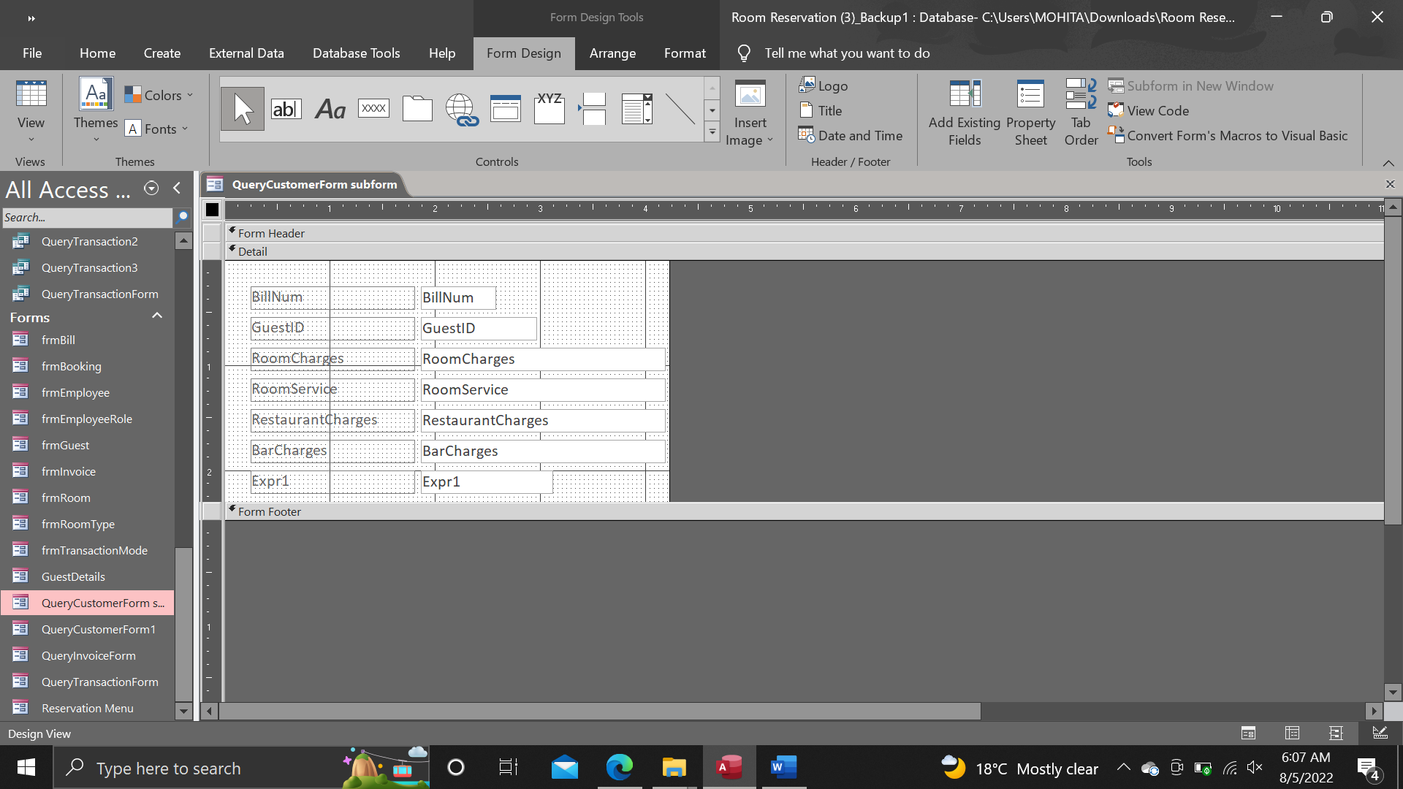

Menu

Database view

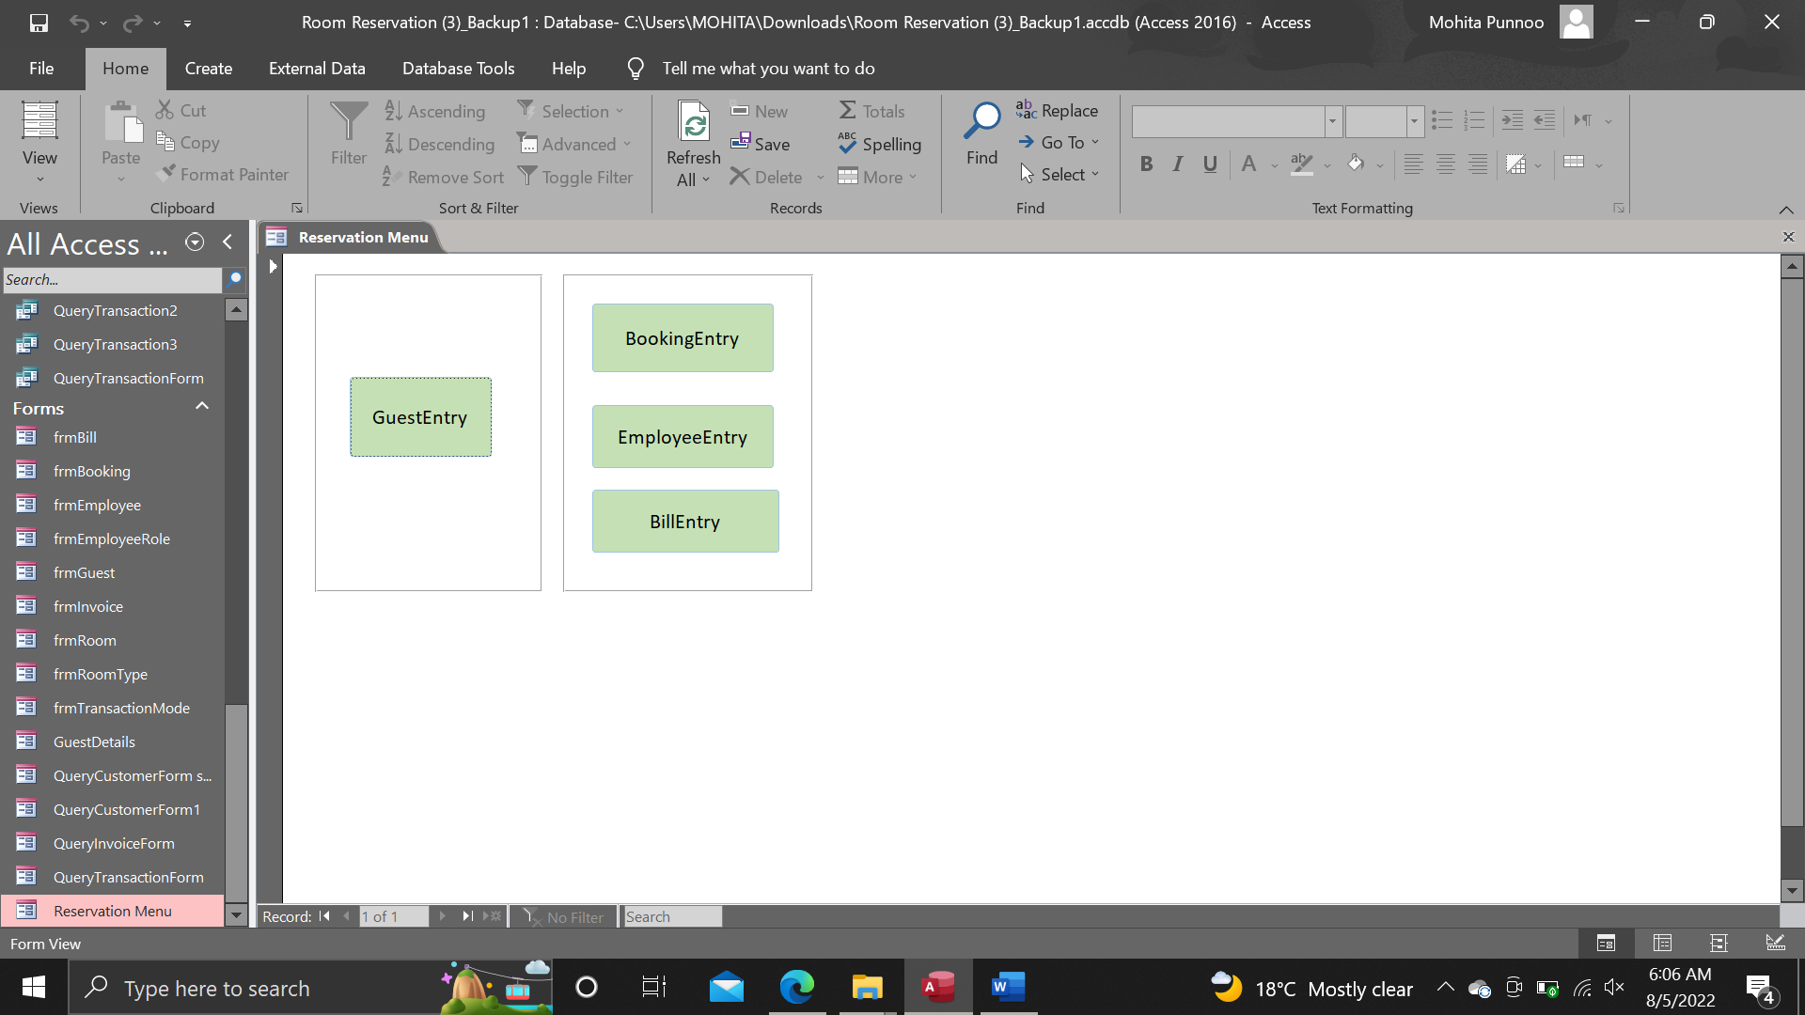

Design view

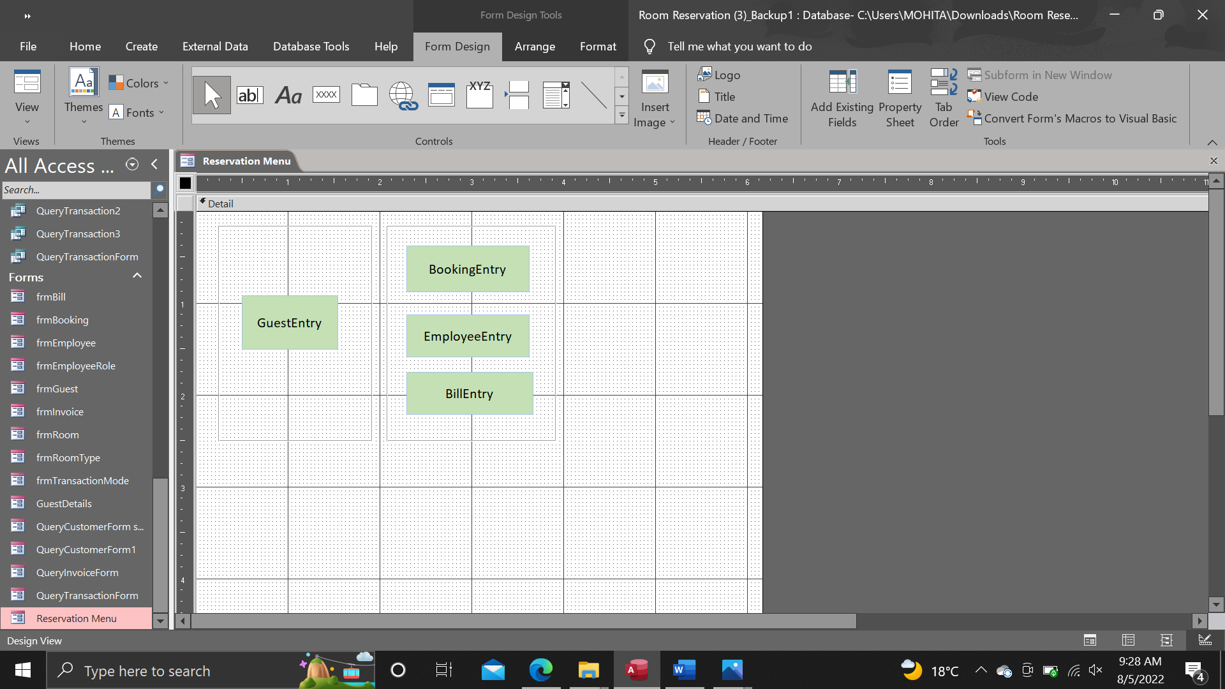

## Report Invoice

Design view

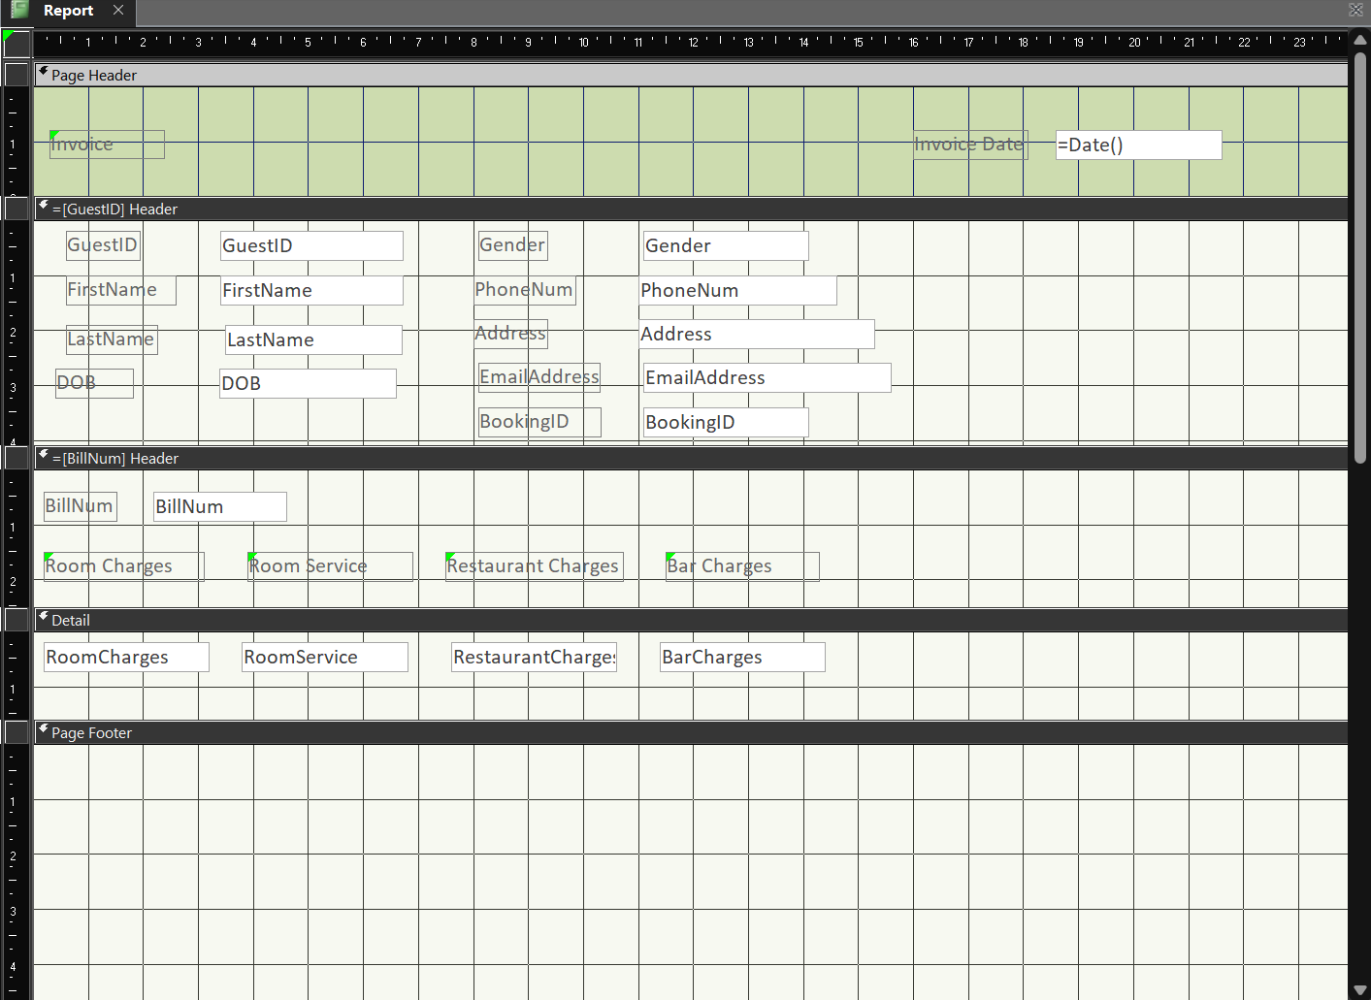

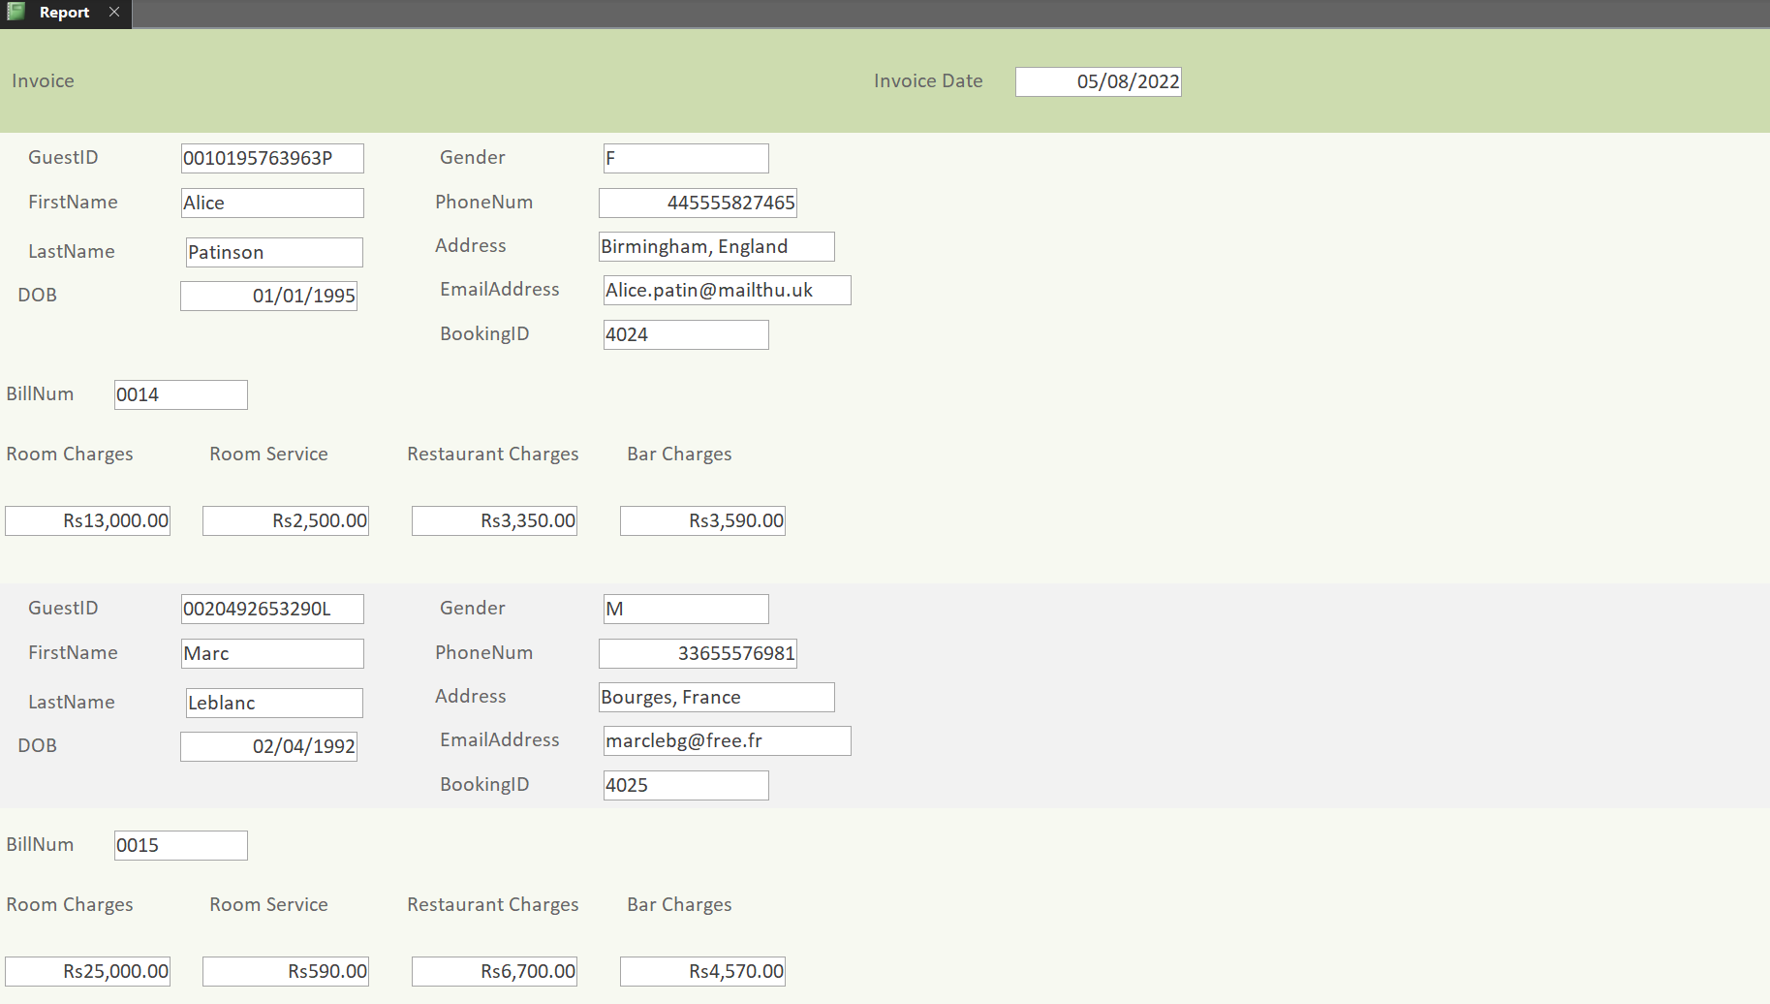Report view

# **Oracle SQL**

Table Booking

CREATE TABLE BOOKING(

BOOKINGID varchar(4) NOT NULL,

BOOKINGDATE date NOT NULL,

BOOKINGTIME date NOT NULL,

CHECKINDATE date NOT NULL,

CHECKIN date NOT NULL,

CHECKOUTDATE date NOT NULL,

CHECKOUT date NOT NULL,

NUMOFADULTS integer NOT NULL,

NUMOFCHILDREN integer NOT NULL,

SPECIALREQUEST varchar(100),

CONSTRAINT BOOKINGID PRIMARY KEY (BOOKINGID)

);

INSERT INTO BOOKING VALUES (4011, TO_DATE('01/05/2022', 'DD/MM/YYYY'), TO_DATE('1:00PM', 'HH:MIAM'), TO_DATE('01/07/2022', 'DD/MM/YYYY'), TO_DATE('2:00PM', 'HH:MIAM'), TO_DATE('03/07/2022', 'DD/MM/YYYY'), TO_DATE('3:00PM', 'HH:MIAM'), 2, 0, 'Birthday Cake for dinner on 09-07-2022');

INSERT INTO BOOKING VALUES (4012, TO_DATE('03/05/2022', 'DD/MM/YYYY'), TO_DATE('9:05AM', 'HH:MIAM'), TO_DATE('05/07/2022', 'DD/MM/YYYY'), TO_DATE('2:00PM', 'HH:MIAM'), TO_DATE('10/07/2022', 'DD/MM/YYYY'), TO_DATE('3:00PM', 'HH:MIAM'), 2, 2, '');

INSERT INTO BOOKING VALUES (4013, TO_DATE('03/05/2022', 'DD/MM/YYYY'), TO_DATE('3:49PM', 'HH:MIAM'), TO_DATE('06/07/2022', 'DD/MM/YYYY'), TO_DATE('2:00PM', 'HH:MIAM'), TO_DATE('25/07/2022', 'DD/MM/YYYY'), TO_DATE('3:00PM', 'HH:MIAM'), 2, 3, 'Anti-allergy bedding');

INSERT INTO BOOKING VALUES (4014, TO_DATE('05/05/2022', 'DD/MM/YYYY'), TO_DATE('2:18PM', 'HH:MIAM'), TO_DATE('06/07/2022', 'DD/MM/YYYY'), TO_DATE('2:00PM', 'HH:MIAM'), TO_DATE('11/07/2022', 'DD/MM/YYYY'), TO_DATE('3:00PM', 'HH:MIAM'), 3, 0, '');

INSERT INTO BOOKING VALUES (4015, TO_DATE('07/05/2022', 'DD/MM/YYYY'), TO_DATE('12:45AM', 'HH:MIAM'), TO_DATE('08/07/2022', 'DD/MM/YYYY'), TO_DATE('2:00PM', 'HH:MIAM'), TO_DATE('25/07/2022', 'DD/MM/YYYY'), TO_DATE('3:00PM', 'HH:MIAM'), 2, 0, '');

INSERT INTO BOOKING VALUES (4016, TO_DATE('08/05/2022', 'DD/MM/YYYY'), TO_DATE('8:04AM', 'HH:MIAM'), TO_DATE('11/07/2022', 'DD/MM/YYYY'), TO_DATE('2:00PM', 'HH:MIAM'), TO_DATE('17/07/2022', 'DD/MM/YYYY'), TO_DATE('3:00PM', 'HH:MIAM'), 2, 0, 'Late checkout');

INSERT INTO BOOKING VALUES (4017, TO_DATE('08/05/2022', 'DD/MM/YYYY'), TO_DATE('9:13PM', 'HH:MIAM'), TO_DATE('12/07/2022', 'DD/MM/YYYY'), TO_DATE('2:00PM', 'HH:MIAM'), TO_DATE('19/07/2022', 'DD/MM/YYYY'), TO_DATE('3:00PM', 'HH:MIAM'), 2, 2, '');

INSERT INTO BOOKING VALUES (4018, TO_DATE('08/05/2022', 'DD/MM/YYYY'), TO_DATE('9:32PM', 'HH:MIAM'), TO_DATE('12/07/2022', 'DD/MM/YYYY'), TO_DATE('2:00PM', 'HH:MIAM'), TO_DATE('19/07/2022', 'DD/MM/YYYY'), TO_DATE('3:00PM', 'HH:MIAM'), 2, 3, '');

INSERT INTO BOOKING VALUES (4019, TO_DATE('09/05/2022', 'DD/MM/YYYY'), TO_DATE('7:19PM', 'HH:MIAM'), TO_DATE('12/07/2022', 'DD/MM/YYYY'), TO_DATE('2:00PM', 'HH:MIAM'), TO_DATE('24/07/2022', 'DD/MM/YYYY'), TO_DATE('3:00PM', 'HH:MIAM'), 1, 0, '');

INSERT INTO BOOKING VALUES (4020, TO_DATE('11/05/2022', 'DD/MM/YYYY'), TO_DATE('5:15AM', 'HH:MIAM'), TO_DATE('12/07/2022', 'DD/MM/YYYY'), TO_DATE('2:00PM', 'HH:MIAM'), TO_DATE('23/07/2022', 'DD/MM/YYYY'), TO_DATE('3:00PM', 'HH:MIAM'), 2, 3, '');

INSERT INTO BOOKING VALUES (4021, TO_DATE('12/05/2022', 'DD/MM/YYYY'), TO_DATE('4:27PM', 'HH:MIAM'), TO_DATE('13/07/2022', 'DD/MM/YYYY'), TO_DATE('2:00PM', 'HH:MIAM'), TO_DATE('17/07/2022', 'DD/MM/YYYY'), TO_DATE('3:00PM', 'HH:MIAM'), 2, 0, 'Early check-In');

INSERT INTO BOOKING VALUES (4022, TO_DATE('14/05/2022', 'DD/MM/YYYY'), TO_DATE('5:00PM', 'HH:MIAM'), TO_DATE('14/07/2022', 'DD/MM/YYYY'), TO_DATE('2:00PM', 'HH:MIAM'), TO_DATE('26/07/2022', 'DD/MM/YYYY'), TO_DATE('3:00PM', 'HH:MIAM'), 2, 2, '');

INSERT INTO BOOKING VALUES (4023, TO_DATE('16/05/2022', 'DD/MM/YYYY'), TO_DATE('2:45PM', 'HH:MIAM'), TO_DATE('14/07/2022', 'DD/MM/YYYY'), TO_DATE('2:00PM', 'HH:MIAM'), TO_DATE('22/07/2022', 'DD/MM/YYYY'), TO_DATE('3:00PM', 'HH:MIAM'), 2, 2, '');

INSERT INTO BOOKING VALUES (4024, TO_DATE('17/05/2022', 'DD/MM/YYYY'), TO_DATE('6:54PM', 'HH:MIAM'), TO_DATE('16/07/2022', 'DD/MM/YYYY'), TO_DATE('2:00PM', 'HH:MIAM'), TO_DATE('21/07/2022', 'DD/MM/YYYY'), TO_DATE('3:00PM', 'HH:MIAM'), 2, 0, 'Room with a view');

INSERT INTO BOOKING VALUES (4025, TO_DATE('17/05/2022', 'DD/MM/YYYY'), TO_DATE('7:30PM', 'HH:MIAM'), TO_DATE('19/07/2022', 'DD/MM/YYYY'), TO_DATE('2:00PM', 'HH:MIAM'), TO_DATE('25/07/2022', 'DD/MM/YYYY'), TO_DATE('3:00PM', 'HH:MIAM'), 2, 3, '');

* SELECT BOOKINGID, TO_CHAR(BOOKINGDATE, 'DD/MM/YYYY') AS BOOKINGDATE, TO_CHAR(BOOKINGTIME, 'HH:MI AM') AS BOOKINGTIME, TO_CHAR(CHECKINDATE, 'DD/MM/YYYY') AS CHECKINDATE, TO_CHAR(CHECKIN, 'HH:MI AM') AS CHECKIN, TO_CHAR(CHECKOUTDATE, 'DD/MM/YYYY') AS CHECKOUTDATE, TO_CHAR(CHECKOUT, 'HH:MI AM') AS CHECKIN, NUMOFADULTS, NUMOFCHILDREN, SPECIALREQUEST FROM BOOKING;

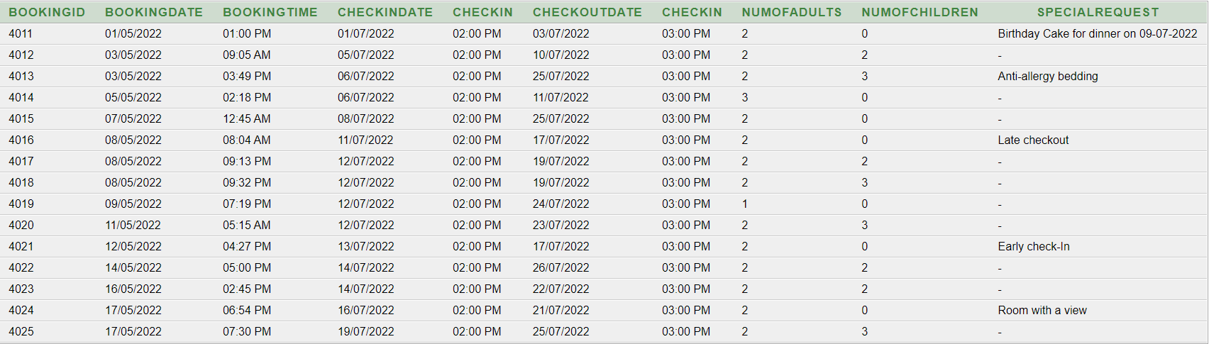

* SELECT BOOKINGID, NUMOFADULTS, NUMOFCHILDREN FROM BOOKING;

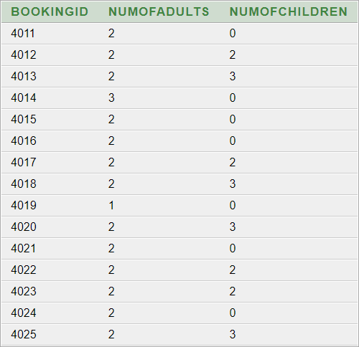

* SELECT BOOKINGID, TO_CHAR(CHECKINDATE, 'DD/MM/YYYY') AS CHECKINDATE, TO_CHAR(CHECKOUTDATE, 'DD/MM/YYYY') AS CHECKOUTDATE FROM BOOKING;

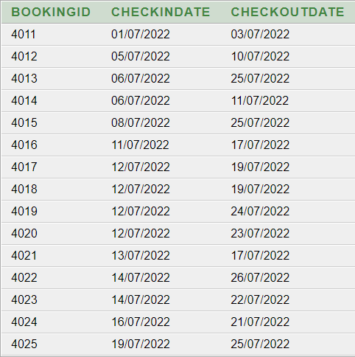

Table Guest

CREATE TABLE GUEST(

GUESTID varchar(14) NOT NULL,

BOOKINGID varchar(4) NOT NULL,

FIRSTNAME varchar(30) NOT NULL,

LASTNAME varchar(30) NOT NULL,

DOB date NOT NULL,

GENDER char NOT NULL,

PHONENUM number(15),

EMAILADDRESS varchar(30) NOT NULL,

ADDRESS varchar(50) NOT NULL,

CONSTRAINT GUESTID PRIMARY KEY (GUESTID),

CONSTRAINT BOOKINGID_FK FOREIGN KEY (BOOKINGID) REFERENCES BOOKING(BOOKINGID)

);

INSERT INTO GUEST VALUES ('0271195927397M', 4011, 'Elodie', 'Macquet', TO_DATE ('27/11/1995', 'DD/MM/YYYY'), 'F', '23057693013', 'elodiemac@gmail.com', 'Curepipe, Mauritius');

INSERT INTO GUEST VALUES ('0200988170520S', 4012, 'Neil', 'Smulders', TO_DATE ('20/09/1988', 'DD/MM/YYYY'), 'M', '', 'n.smulders@gmail.com', 'Bonnyville, Canada');

INSERT INTO GUEST VALUES ('0051091676806P', 4013, 'Panayotis', 'Pasto', TO_DATE ('05/10/1991', 'DD/MM/YYYY'), 'M', 'pana.perso@live.gr', '', 'Athena, Greece');

INSERT INTO GUEST VALUES ('0090192974707M', 4014, 'Julia', 'Macy', TO_DATE ('09/01/1992', 'DD/MM/YYYY'), 'F', '27810005933', 'macyjulia2@hotmail.com', 'Cape Town, South Africa');

INSERT INTO GUEST VALUES ('0171198582805D', 4015, 'Martin', 'Dawkins', TO_DATE ('17/11/1998', 'DD/MM/YYYY'), 'M', '445556374009', 'd.marti98@gmail.com', 'Bristol, England');

INSERT INTO GUEST VALUES ('0180376519361L', 4016, 'Marine ', 'Lemouche', TO_DATE ('18/03/1976', 'DD/MM/YYYY'), 'F', '33700555279', 'marinelamoucheduc@yahoo.fr', 'Aix-en-Provence, France');

INSERT INTO GUEST VALUES ('0140889765480M', 4017, 'Carlos', 'Manchos', TO_DATE ('14/08/1989', 'DD/MM/YYYY'), 'M', '33798384823', 'carlosmanchos@hotmail.com', 'Montalbo, Spain');

INSERT INTO GUEST VALUES ('0171291564597L', 4018, 'Maria', 'Lafolas', TO_DATE ('17/12/1991', 'DD/MM/YYYY'), 'F', '34824807491', 'marialafolasmanchos@gmail.com ', 'Montalbo, Spain');

INSERT INTO GUEST VALUES ('0150186654321S', 4019, 'Fernito', 'Serra', TO_DATE ('15/01/1986', 'DD/MM/YYYY'), 'M', '', 'fernito@serra.ch ', 'Bergamo, Switzerland');

INSERT INTO GUEST VALUES ('0091189776854P', 4020, 'Marcelino', 'Papi', TO_DATE ('09/11/1989', 'DD/MM/YYYY'), 'M', '39382555682', 'marcelinobin@compn.it', 'Pisa, Italy');

INSERT INTO GUEST VALUES ('0050575086544M', 4021, 'Svea', 'Munchauzen', TO_DATE ('05/05/1975', 'DD/MM/YYYY'), 'F', '', 's.munchauzen@gmail.com', 'Hamburg, Germany');

INSERT INTO GUEST VALUES ('0190890759379B', 4022, 'Avneel', 'Baria', TO_DATE ('19/08/1990', 'DD/MM/YYYY'), 'M', '91955553283', 'avneelbariabwn@gmail.com', 'Chandigarh, India');

INSERT INTO GUEST VALUES ('0170487752965F', 4023, 'Paola', 'Fernandes', TO_DATE ('17/04/1987', 'DD/MM/YYYY'), 'M', '', 'Pa.fern1@hotmail.com ', 'Lisboa, Portugal');

INSERT INTO GUEST VALUES ('0010195763963P', 4024, 'Alice', 'Patinson', TO_DATE ('01/01/1995', 'DD/MM/YYYY'), 'F', '445555827465', 'alice.patin@mailthu.uk', 'Birmingham, England');

INSERT INTO GUEST VALUES ('0020492653290L', 4025, 'Marc', 'Leblanc', TO_DATE ('02/04/1992', 'DD/MM/YYYY'), 'M', '33655576981', 'marclebg@free.fr', 'Bourges, France');

* SELECT GUESTID, BOOKINGID, FIRSTNAME, LASTNAME, TO_CHAR(DOB, 'DD/MM/YYYY') AS DOB, GENDER, PHONENUM, EMAILADDRESS, ADDRESS FROM GUEST;

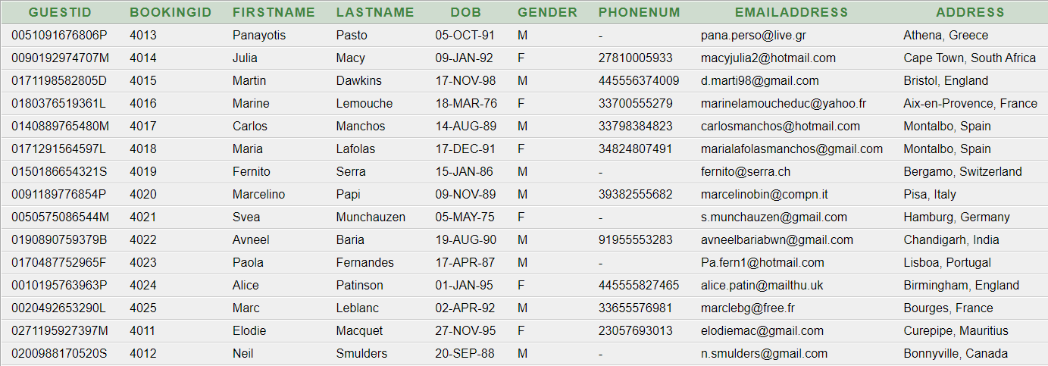

* SELECT GUESTID, FIRSTNAME, LASTNAME FROM GUEST;

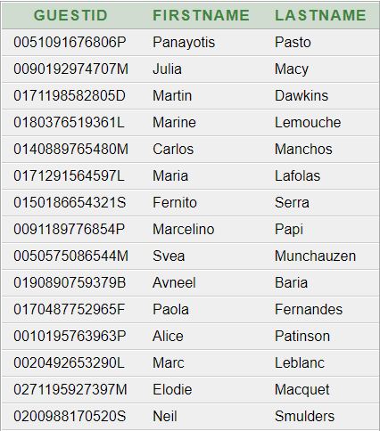

UPDATE GUEST

SET EMAILADDRESS = 'elodiemac@outlook.com'

WHERE BOOKINGID = 4011;

* SELECT GUESTID, BOOKINGID, FIRSTNAME, LASTNAME, TO_CHAR(DOB, 'DD/MM/YYYY') AS DOB, GENDER, PHONENUM, EMAILADDRESS, ADDRESS FROM GUEST WHERE BOOKINGID = 4011;



Table Employee

CREATE TABLE EMPLOYEE(

EMPLOYEEID varchar(14) NOT NULL,

ROLEID varchar(5) NOT NULL,

BOOKINGID varchar(4) NOT NULL,

FIRSTNAME varchar(30) NOT NULL,

LASTNAME varchar(30) NOT NULL,

DOB date NOT NULL,

GENDER char NOT NULL,

PHONENUM number(8) NOT NULL,

EMAILADDRESS varchar(30),

STARTSHIFT date NOT NULL,

ENDSHIFT date NOT NULL,

CONSTRAINT EMPLOYEEID PRIMARY KEY (EMPLOYEEID),

CONSTRAINT ROLEID_FK FOREIGN KEY (ROLEID) REFERENCES EMPLOYEEROLE(ROLEID),

CONSTRAINT BOOKINGID_FK FOREIGN KEY (BOOKINGID) REFERENCES BOOKING(BOOKINGID)

);

INSERT INTO EMPLOYEE VALUES ('0050770481934M', 'R005T', 4011, 'Sheena', 'Mukhish', TO_DATE('05/07/1970', 'DD/MM/YYYY'),'F', 23057732901, 's.mukhish@gmail.com', TO_DATE('12:00PM', 'HH:MI AM'), TO_DATE('8:00PM', 'HH:MI AM'));

INSERT INTO EMPLOYEE VALUES ('0170995471903R', 'B101B', 4012, 'Anusha', 'Roovha', TO_DATE('17/09/1995', 'DD/MM/YYYY'),'F', 23054981034, 'a.roovha@gmail.com', TO_DATE('7:00AM', 'HH:MI AM'), TO_DATE('3:00 PM', 'HH:MI AM'));

INSERT INTO EMPLOYEE VALUES ('0140581937202L', 'H010R', 4013, 'Eric', 'Luc', TO_DATE('14/05/1981', 'DD/MM/YYYY'),'M', 23058194844, 'ericluc1@hotmail.com', TO_DATE('7:00AM', 'HH:MI AM'), TO_DATE('3:00PM', 'HH:MI AM'));

INSERT INTO EMPLOYEE VALUES ('0181197743600S', 'M100S', 4014, 'Tanishta', 'Seesurn', TO_DATE('18/11/1997', 'DD/MM/YYYY'),'F', 23059717499, 'tseesurn@gmail.com', TO_DATE('3:00PM', 'HH:MI AM'), TO_DATE('11:00PM', 'HH:MI AM'));

INSERT INTO EMPLOYEE VALUES ('0250383009267M', 'D111W', 4015, 'Kneeny', 'Mireles', TO_DATE('25/03/1983', 'DD/MM/YYYY'),'M', 2302509213, 'Kneeny.m25@outlook.com ', TO_DATE('7:00AM', 'HH:MI AM'), TO_DATE('3:00PM', 'HH:MI AM'));

INSERT INTO EMPLOYEE VALUES ('0111200872401P', 'R005T', 4016, 'Jase', 'Perinoo', TO_DATE('11/12/2000', 'DD/MM/YYYY'),'F', 23058091732, 'jase.p11@gmail.com', TO_DATE('7:00AM', 'HH:MI AM'), TO_DATE('3:00PM', 'HH:MI AM'));

INSERT INTO EMPLOYEE VALUES ('0250789937202L', 'B001B', 4017, 'Cedrick', 'Luc', TO_DATE('25/07/1989', 'DD/MM/YYYY'),'M', 23058192321, '', TO_DATE('12:00PM', 'HH:MI AM'), TO_DATE('8:00PM', 'HH:MI AM'));

INSERT INTO EMPLOYEE VALUES ('0220697743600S', 'C111C', 4018, 'Grace', 'Stone', TO_DATE('22/06/1997', 'DD/MM/YYYY'),'F', 23059776543, '', TO_DATE('7:00AM', 'HH:MI AM'), TO_DATE('11:00PM', 'HH:MI AM'));

INSERT INTO EMPLOYEE VALUES ('0150395872401P', 'C001C', 4019, 'Jase', 'Parker', TO_DATE('15/03/1995', 'DD/MM/YYYY'),'F', 23059123452, '', TO_DATE('7:00AM', 'HH:MI AM'), TO_DATE('3:00PM', 'HH:MI AM'));

INSERT INTO EMPLOYEE VALUES ('0140585937201T', 'B110M', 4020, 'Paul', 'Tiblanc', TO_DATE('14/05/1985', 'DD/MM/YYYY'),'M', 23058165434, '', TO_DATE('12:00PM', 'HH:MI AM'), TO_DATE('8:00PM', 'HH:MI AM'));

INSERT INTO EMPLOYEE VALUES ('0280490009267M', 'H010A', 4021, 'Laurie', 'Carrington', TO_DATE('28/04/1990', 'DD/MM/YYYY'),'F', 23057543990, 'lauriecar@outlook.com', TO_DATE('3:00PM', 'HH:MI AM'), TO_DATE('11:00PM', 'HH:MI AM'));

INSERT INTO EMPLOYEE VALUES ('0300599177659J', 'H007E', 4022, 'Tavish', 'Jhurry', TO_DATE('30/05/1999', 'DD/MM/YYYY'),'M', 23059710491, 'tavish.05@hotmail.com', TO_DATE('12:00PM', 'HH:MI AM'), TO_DATE('8:00PM', 'HH:MI AM'));

INSERT INTO EMPLOYEE VALUES ('0051170896457C', 'M100S', 4023, 'Sarah', 'Cooper', TO_DATE('05/11/1970', 'DD/MM/YYYY'),'F', 23057723523, '', TO_DATE('7:00AM', 'HH:MI AM'), TO_DATE('3:00PM', 'HH:MI AM'));

INSERT INTO EMPLOYEE VALUES ('0030299536726G', 'G002M', 4024, 'Gina', 'Glover', TO_DATE('03/02/1999', 'DD/MM/YYYY'),'F', 23058238913, 'glovgi@yahoo.com', TO_DATE('12:00PM', 'HH:MI AM'), TO_DATE('8:00PM', 'HH:MI AM'));

INSERT INTO EMPLOYEE VALUES ('0111099471903W', 'H001M', 4025, 'Lian', 'Wedley', TO_DATE('11/10/1999', 'DD/MM/YYYY'),'M', 23054542342, '', TO_DATE('12:00PM', 'HH:MI AM'), TO_DATE('11:00PM', 'HH:MI AM'));

* SELECT EMPLOYEEID, ROLEID, BOOKINGID, FIRSTNAME, LASTNAME, TO_CHAR(DOB, 'DD/MM/YYYY') AS dob, GENDER, PHONENUM, EMAILADDRESS, TO_CHAR(STARTSHIFT, 'HH:MI AM') AS STARTSHIFT, TO_CHAR(ENDSHIFT, 'HH:MI AM') AS ENDSHIFT FROM EMPLOYEE;

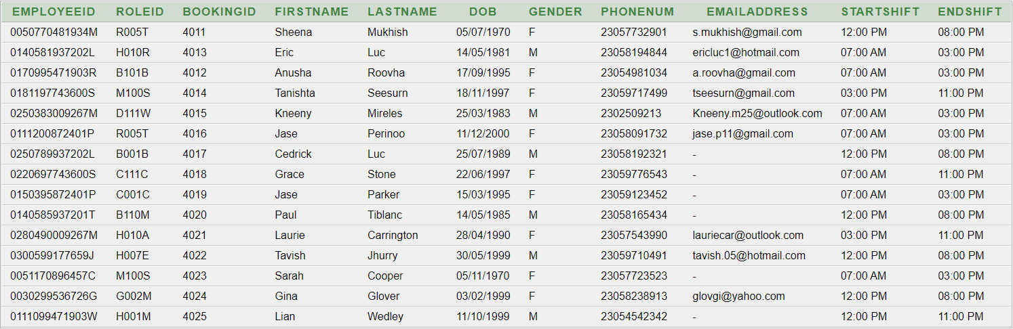

* SELECT EMPLOYEEID, ROLEID FROM EMPLOYEE;

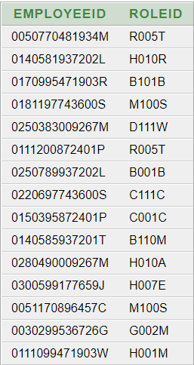

* SELECT EMPLOYEEID, FIRSTNAME, LASTNAME, TO_CHAR(STARTSHIFT, 'HH:MI AM') AS STARTSHIFT, TO_CHAR(ENDSHIFT, 'HH:MI AM') AS ENDSHIFT FROM EMPLOYEE;

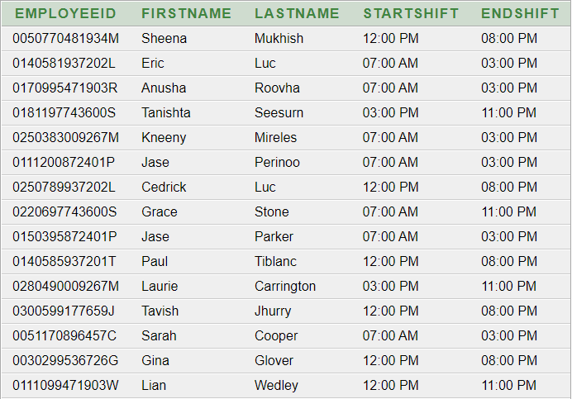

Table Room

CREATE TABLE ROOM(

ROOMNO varchar(4) NOT NULL,

BOOKINGID varchar(4) NOT NULL,

ROOMTYPE varchar(20) NOT NULL,

OCCUPANCY varchar(20) NOT NULL,

CONSTRAINT ROOMNO PRIMARY KEY (ROOMNO),

CONSTRAINT BOOKINGID_RFK FOREIGN KEY (BOOKINGID) REFERENCES BOOKING(BOOKINGID),

CONSTRAINT ROOMTYPE_RFK FOREIGN KEY (ROOMTYPE) REFERENCES ROOMTYPE(ROOMTYPE)

);

INSERT INTO ROOM VALUES(5078, 4011, 'Suite'', 'CO - Check-Out');

INSERT INTO ROOM VALUES(2034, 4012, 'Quad Room', 'CO - Check-Out');

INSERT INTO ROOM VALUES(2051, 4013, 'Family Room', 'OCC- Occupied');

INSERT INTO ROOM VALUES(1089, 4014, 'Triple Room', 'CO - Check-Out');

INSERT INTO ROOM VALUES(5022, 4015, 'Deluxe Room', 'DND - Do Not Disturb');

INSERT INTO ROOM VALUES(2056, 4016, 'Double Room', 'LC - Late Check out');

INSERT INTO ROOM VALUES(3004, 4017, 'Family Room', 'OCC - Occupied');

INSERT INTO ROOM VALUES(3005, 4018, 'Family Room', 'OCC - Occupied');

INSERT INTO ROOM VALUES(1004, 4019, 'Single Room', 'OCC - Occupied');

INSERT INTO ROOM VALUES(4055, 4020, 'Family Room', 'OCC - Occupied');

INSERT INTO ROOM VALUES(5098, 4021, 'Suite', 'EC - Early Check-in');

INSERT INTO ROOM VALUES(2099, 4022, 'Quad Room', 'OCC - Occupied');

INSERT INTO ROOM VALUES(3001, 4023, 'Quad Room', 'OCC - Occupied');

INSERT INTO ROOM VALUES(6048, 4024, 'Room with a view', 'DND - Do Not Disturb');

INSERT INTO ROOM VALUES(3088, 4025, 'Family Room', 'OCC - Occupied');

* SELECT * FROM ROOM;

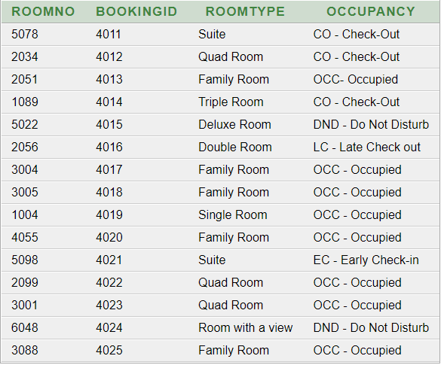

* SELECT ROOMNO, ROOMTYPE FROM ROOM;

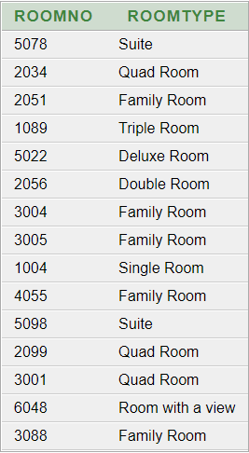

* SELECT ROOMNO, OCCUPANCY FROM ROOM ORDER BY ROOMNO;

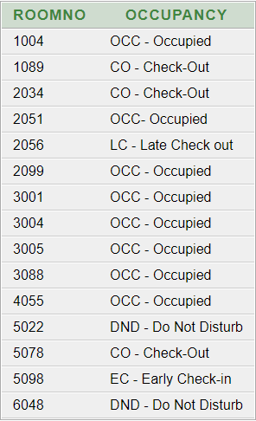

Table RoomType

CREATE TABLE ROOMTYPE(

ROOMTYPE varchar(20) NOT NULL,

ROOMDESCRIPTION varchar(255) NOT NULL,

CONSTRAINT ROOMTYPE PRIMARY KEY (ROOMTYPE)

);

INSERT INTO ROOMTYPE VALUES('Single Room', 'Single bed, air conditioned, room service, mini fridge, internet access');

INSERT INTO ROOMTYPE VALUES('Double Room', '2 single beds, air conditioned, room service, mini fridge, internet access');

INSERT INTO ROOMTYPE VALUES('Triple Room', '1 single bed, 1 double bed, air conditioned, room service, mini fridge, internet access');

INSERT INTO ROOMTYPE VALUES('Quad Room', '2 single beds, 1 large double bed, air conditioned, room service, mini fridge, internet access');

INSERT INTO ROOMTYPE VALUES('Family Room', '1 single bed, 1 double bed, air conditioned, room service, mini fridge, internet access, balcony with pool view, 2 bathrooms');

INSERT INTO ROOMTYPE VALUES('Deluxe Room', 'King size bed, air conditioned, room service, mini fridge, internet access');

INSERT INTO ROOMTYPE VALUES('Suite', 'King size bed, air conditioned, room service, mini fridge, high-speed internet access, coffee machine, backyard access');

INSERT INTO ROOMTYPE VALUES('Room with a view', 'Single bed, air conditioned, room service, mini fridge, internet access, balcony with beach view');

* SELECT * FROM ROOMTYPE;

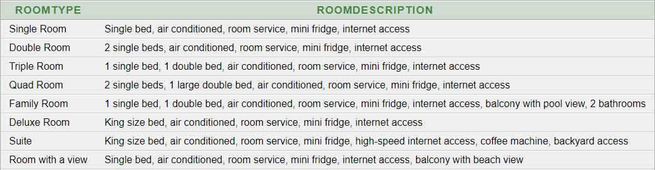

Table Bill

CREATE TABLE BILL(

BILLNUM varchar2(4) NOT NULL,

GUESTID varchar(14) NOT NULL,

ROOMCHARGES number(6) NOT NULL,

ROOMSERVICE number(6) NOT NULL,

RESTAURANTCHARGES number(6) NOT NULL,

BARCHARGES number(6),

EXPIRYDATE date NOT NULL,

CONSTRAINT BILLNUM PRIMARY KEY (BILLNUM),

CONSTRAINT GUESTID_FK FOREIGN KEY (GUESTID) REFERENCES GUEST(GUESTID)

);

INSERT INTO BILL VALUES ('0001', '0271195927397M', '10000', '1000', '4000', '2000', TO_DATE ('03/01/2023', 'DD/MM/YYYY'));

INSERT INTO BILL VALUES ('0002', '0200988170520S', '6000', '3050', '3780', '2300', TO_DATE ('10/01/2023', 'DD/MM/YYYY'));

INSERT INTO BILL VALUES ('0003', '0051091676806P', '15000', '2500', '2895', '', TO_DATE ('25/01/2023', 'DD/MM/YYYY'));

INSERT INTO BILL VALUES ('0004', '0090192974707M', '24000', '1565', '3600', '5560', TO_DATE ('11/01/2023', 'DD/MM/YYYY'));

INSERT INTO BILL VALUES ('0005', '0171198582805D', '10000', '500', '2430', '2380', TO_DATE ('25/01/2023', 'DD/MM/YYYY'));

INSERT INTO BILL VALUES ('0006', '0180376519361L', '30000', '5000', '7800', '2340', TO_DATE ('17/01/2023', 'DD/MM/YYYY'));

INSERT INTO BILL VALUES ('0007', '0140889765480M', '15000', '2050', '3890', '', TO_DATE ('19/01/2023', 'DD/MM/YYYY'));

INSERT INTO BILL VALUES ('0008', '0171291564597L', '10000', '1500', '2570', '6000', TO_DATE ('19/01/2023', 'DD/MM/YYYY'));

INSERT INTO BILL VALUES ('0009', '0150186654321S', '38000', '7000', '1000', '15680', TO_DATE ('24/01/2023', 'DD/MM/YYYY'));

INSERT INTO BILL VALUES ('0010', '0091189776854P', '9000', '760', '4050', '', TO_DATE ('23/01/2023', 'DD/MM/YYYY'));

INSERT INTO BILL VALUES ('0011', '0050575086544M', '50000', '8000', '15000', '25000', TO_DATE ('17/01/2023', 'DD/MM/YYYY'));

INSERT INTO BILL VALUES ('0012', '0190890759379B', '12000', '3550', '5580', '3000', TO_DATE ('26/01/2023', 'DD/MM/YYYY'));

INSERT INTO BILL VALUES ('0013', '0170487752965F', '25000', '4555', '6740', '', TO_DATE ('22/07/2023', 'DD/MM/YYYY'));

INSERT INTO BILL VALUES ('0014', '0010195763963P', '13000', '2500', '3350', '3590', TO_DATE ('21/07/2023', 'DD/MM/YYYY'));

INSERT INTO BILL VALUES ('0015', '0020492653290L', '25000', '590', '6700', '4570', TO_DATE ('25/07/2023', 'DD/MM/YYYY'));

* SELECT BILLNUM, GUESTID, ROOMCHARGES, ROOMSERVICE, RESTAURANTCHARGES, BARCHARGES, TO_CHAR(EXPIRYDATE, 'DD/MM/YYYY') AS EXPIRYDATE FROM BILL;

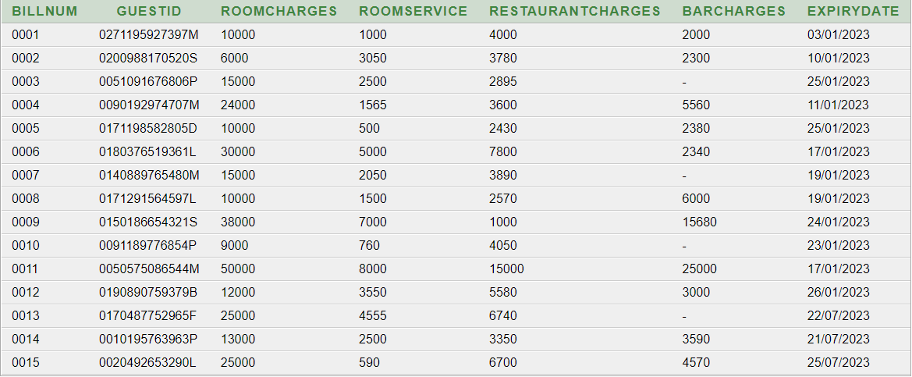

* SELECT ROOMSERVICE, ROOMSERVICE * 1.50 FROM BILL;

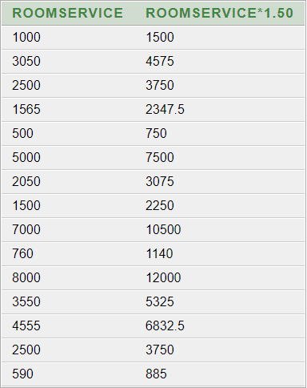

* SELECT ROOMCHARGES, RESTAURANTCHARGES, BARCHARGES FROM BILL

WHERE ROOMCHARGES BETWEEN 5000 AND 15000;

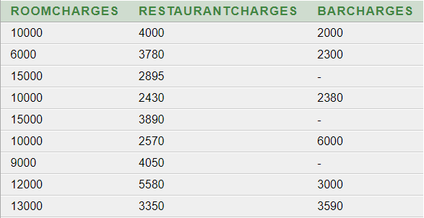

Table Invoice

CREATE TABLE INVOICE(

BILLNUM varchar2(4) NOT NULL,

GUESTID varchar(14) NOT NULL,

PAYMENTID varchar(5) NOT NULL,

CONSTRAINT BILLNUM_FK FOREIGN KEY (BILLNUM) REFERENCES BILL(BILLNUM),

CONSTRAINT GUESTID_BFK FOREIGN KEY (GUESTID) REFERENCES GUEST(GUESTID),

CONSTRAINT PAYMENT_FK FOREIGN KEY (PAYMENTID) REFERENCES TRANSACTIONMODE(PAYMENTID)

);

INSERT INTO INVOICE VALUES ('0001', '0271195927397M', 'CC846');

INSERT INTO INVOICE VALUES ('0002', '0200988170520S', 'CA920');

INSERT INTO INVOICE VALUES ('0003', '0051091676806P', 'CC492');

INSERT INTO INVOICE VALUES ('0004', '0090192974707M', 'DC937');

INSERT INTO INVOICE VALUES ('0005', '0171198582805D', 'CA648');

INSERT INTO INVOICE VALUES ('0006', '0180376519361L', 'CC274');

INSERT INTO INVOICE VALUES ('0007', '0140889765480M', 'DC765');

INSERT INTO INVOICE VALUES ('0008', '0171291564597L', 'DC765');

INSERT INTO INVOICE VALUES ('0009', '0150186654321S', 'CA903');

INSERT INTO INVOICE VALUES ('0010', '0091189776854P', 'DC153');

INSERT INTO INVOICE VALUES ('0011', '0050575086544M', 'CA827');

INSERT INTO INVOICE VALUES ('0012', '0190890759379B', 'CC689');

INSERT INTO INVOICE VALUES ('0013', '0170487752965F', 'CC892');

INSERT INTO INVOICE VALUES ('0014', '0010195763963P', 'CA273');

INSERT INTO INVOICE VALUES ('0015', '0020492653290L', 'DC273');

* SELECT * FROM INVOICE;

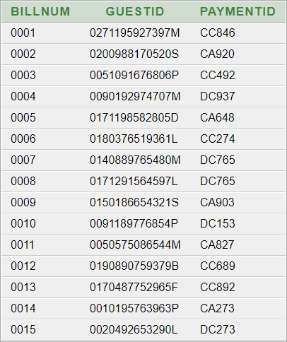

Table TransactionMode

CREATE TABLE TRANSACTIONMODE(

PAYMENTID varchar(5) NOT NULL,

PAYMENTMODE varchar(30) NOT NULL,

PAYMENTDATE date NOT NULL,

PAYMENTTIME date NOT NULL,

CONSTRAINT PAYMENTID PRIMARY KEY (PAYMENTID)

);

INSERT INTO TRANSACTIONMODE VALUES ('CC846', 'Credit card', TO_DATE('03/07/2022', 'DD/MM/YYYY'), TO_DATE('3:00 PM', 'HH:MI AM'));

INSERT INTO TRANSACTIONMODE VALUES ('CA920', 'Cash', TO_DATE('10/07/2022', 'DD/MM/YYYY'), TO_DATE('2:30 PM', 'HH:MI AM'));

INSERT INTO TRANSACTIONMODE VALUES ('CC492', 'Credit card', TO_DATE('25/07/2022', 'DD/MM/YYYY'), TO_DATE('1:00 PM', 'HH:MI AM'));

INSERT INTO TRANSACTIONMODE VALUES ('DC937', 'Debit Card, Cash', TO_DATE('11/07/2022', 'DD/MM/YYYY'), TO_DATE('3:00 PM', 'HH:MI AM'));

INSERT INTO TRANSACTIONMODE VALUES ('CA648', 'Cash', TO_DATE('25/07/2022', 'DD/MM/YYYY'), TO_DATE('2:45 PM', 'HH:MI AM'));

INSERT INTO TRANSACTIONMODE VALUES ('CC274', 'Credit card', TO_DATE('17/07/2022', 'DD/MM/YYYY'), TO_DATE('2:15 PM', 'HH:MI AM'));

INSERT INTO TRANSACTIONMODE VALUES ('CC683', 'Credit card, Cash', TO_DATE('19/07/2022', 'DD/MM/YYYY'), TO_DATE('2:38 PM', 'HH:MI AM'));

INSERT INTO TRANSACTIONMODE VALUES ('DC765', 'Debit Card', TO_DATE('19/07/2022', 'DD/MM/YYYY'), TO_DATE('2:54PM', 'HH:MI AM'));

INSERT INTO TRANSACTIONMODE VALUES ('CA903', 'Cash', TO_DATE('24/07/2022', 'DD/MM/YYYY'), TO_DATE('3:00 PM', 'HH:MI AM'));

INSERT INTO TRANSACTIONMODE VALUES ('DC153', 'Debit Card, Credit Card', TO_DATE('23/07/2022', 'DD/MM/YYYY'), TO_DATE('1:55 PM', 'HH:MI AM'));

INSERT INTO TRANSACTIONMODE VALUES ('CA827', 'Cash, Credit Card', TO_DATE('17/07/2022', 'DD/MM/YYYY'), TO_DATE('2:49 PM', 'HH:MI AM'));

INSERT INTO TRANSACTIONMODE VALUES ('CC689', 'Credit card ', TO_DATE('26/07/2022', 'DD/MM/YYYY'), TO_DATE('2:00 PM', 'HH:MI AM'));

INSERT INTO TRANSACTIONMODE VALUES ('CC892', 'Credit card ', TO_DATE('22/07/2022', 'DD/MM/YYYY'), TO_DATE('3:00 PM', 'HH:MI AM'));

INSERT INTO TRANSACTIONMODE VALUES ('CA273', 'Cash, Credit Card', TO_DATE('21/07/2022', 'DD/MM/YYYY'), TO_DATE('2:10 PM', 'HH:MI AM'));

INSERT INTO TRANSACTIONMODE VALUES ('DC273', 'Debit card ', TO_DATE('25/07/2022', 'DD/MM/YYYY'), TO_DATE('2:28 PM', 'HH:MI AM'));

* SELECT PAYMENTID, PAYMENTMODE, TO_CHAR(PAYMENTDATE, 'DD/MM/YYYY') AS PAYMENTDATE, TO_CHAR(PAYMENTTIME, 'HH:MI AM') AS PAYMENTTIME FROM TRANSACTIONMODE;

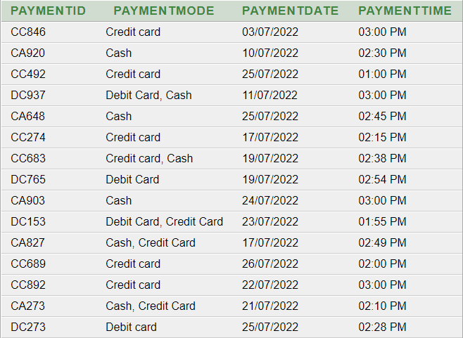

* SELECT PAYMENTID, PAYMENTMODE FROM TRANSACTIONMODE ORDER BY PAYMENTID;

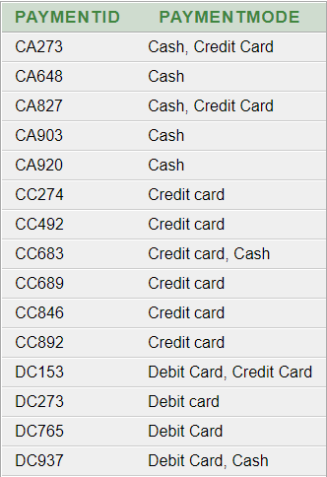

Table EmployeeRole

CREATE TABLE EMPLOYEEROLE(

ROLEID varchar(5) NOT NULL,

ROLETITLE varchar(30) NOT NULL,

ROLEDESCRIPTION varchar(200) NOT NULL,

CONSTRAINT ROLEID PRIMARY KEY (ROLEID)

);

INSERT INTO EMPLOYEEROLE VALUES ('B001B', 'Bartender', 'Prepare and serve drinks to guests');

INSERT INTO EMPLOYEEROLE VALUES ('B101B', 'Bell Boy', 'Carry guests bags to their room');

INSERT INTO EMPLOYEEROLE VALUES ('B110M', 'Bar Manager', 'Manage bar supplies and manage staff member');

INSERT INTO EMPLOYEEROLE VALUES ('C001C', 'Executive Chef', 'Prepare dishes and manage kitchen staff');

INSERT INTO EMPLOYEEROLE VALUES ('C111C', 'Chef', 'Set up menu and prepare high quality dishes');

INSERT INTO EMPLOYEEROLE VALUES ('D111W', 'Dishwasher', 'Ensure dining equipment are clean and prepared for guest');

INSERT INTO EMPLOYEEROLE VALUES ('G002M', 'General Manager', 'Improve and increase departmental profits');

INSERT INTO EMPLOYEEROLE VALUES ('H001M', 'Human Resource Manager', 'Supervise the hotel hiring process');

INSERT INTO EMPLOYEEROLE VALUES ('H007E', 'Hotel Engineer', 'Troubleshoot and repair hotel equipment');

INSERT INTO EMPLOYEEROLE VALUES ('H010A', 'Accountant', 'Makes critical financial decisions and manage hotel finances');

INSERT INTO EMPLOYEEROLE VALUES ('H010R', 'Housekeeping', 'Ensure hotel rooms are cleaned');

INSERT INTO EMPLOYEEROLE VALUES ('M100S', 'Maintenance Staff', 'Inspect and repair various hotel infrastructure');

INSERT INTO EMPLOYEEROLE VALUES ('R005T', 'Receptionist', 'Welcoming guest, check booking details');

* SELECT * FROM EMPLOYEEROLE;

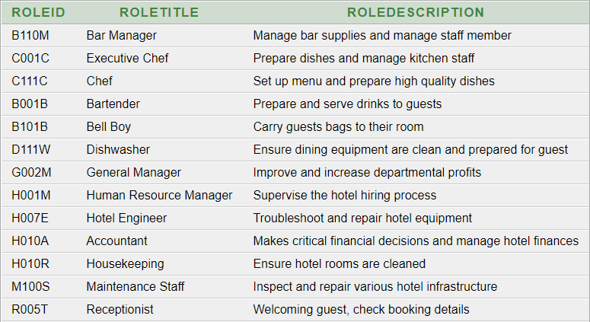

Delete Table

DROP TABLE EMPLOYEE;

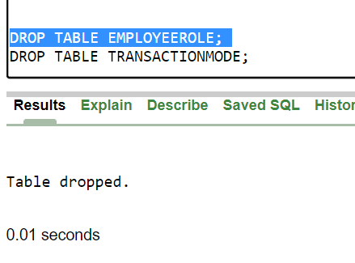

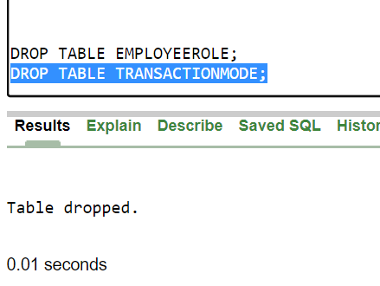DROP TABLE EMPLOYEEROLE;